Governing the (Privatized) Commons: Evidence from the introduction of Water Boards

VERY PRELIMINARY, DO NOT CIRCULATE

Maximiliano Garc´ıa [JMP]* Jose Belmar

October 27, 2023

[Updated frequently. Check here for latest version.](https://maxgarc.github.io/papers/GARCIA_MAXIMILIANO_GOVERNING_PRIVATIZED_COMMONS.pdf)

**Abstract**

Climate change increasingly aggravates the tragedy of the commons in water resources. This paper studies the role of legally empowered users’ organizations when water is allocated through private property in a context of low state intervention. To achieve this goal, we assembled a novel dataset that integrates administrative records, geographic information, and satellite imagery. Using alternative identification strategies, we show that the establishment of such organizations slows down the creation of new property rights and redistributes water from upstream locations to downstream locations, mostly because of improved enforcement of already existing property rights. This redistribution of water increases agricultural yield, allows the adoption of crops that require Summer irrigation, and increases exporting activity among farmers in downstream locations. A sufficient statistics approach suggests that these organizations reduce misallocation caused by the natural advantage of upstream users to over-extract.

# Introduction

Control over natural resources is often presented as a tradeoff between well-defined individual prop- erty rights -where enforcement relies on a fence or wall, and a means of legal recourse if rights are violated- or community management, in which decisions and allocations about resources are made collectively. In practice, there is a wide array of potential arrangements, which may incorporate elements of both community governance as well as enforceable rights in order to address particu- lar circumstances (Ostrom, 1990). These alternatives may allocate to different parties the right to decide how to use a resource, and the task of enforcing that right (e.g. under communal property, while a user may use a plot of land exclusively while cultivating it, the community together may provide protection to the same land after the harvest, Rossignol, Lowes, and Montero, 2023).

Economics has studied extensively how private property rights enhance development by al- lowing a more efficient allocation of resources, but there is limited evidence on who should provide property rights enforcement. We commonly assume that this should be performed by the state, but weak states may not be able, allowing non-state actors to perform this task, or in other cases, leaving the role unperformed (e.g. Baland and Platteau, 1998; Sanchez de la Sierra, 2020). Understanding how various institutions emerge for governing the commons, and understanding their implications for allocative efficiency and equity, is likely to become all the more important as climate change induces greater scarcity in crucial resources, such as water.

We study the economic impacts of community-governed enforcement of private property rights:

* [maxgar@bu.edu](mailto:maxgar@bu.edu)

the establishment of legally empowered boards, elected and funded by the users themselves, on en- forcing water rights -formal private property rights over river waters in Chile. Water rights enjoy constitutional protection against expropriation, are inheritable and fully tradable, and their prop- erty is separated from the land, implying that most of the friction sources studied in other natural resources markets are absent (e.g. Chari, Liu, Wang, and Wang (2021); Manysheva (2022)). To pro- tect users against expropriation, the regulation of water matters and courts in Chile have restrained government action, but at the cost of leaving downstream users unprotected from over-extraction by upstream users.

These boards, called Water Boards (*“Juntas de Vigilancia”*), have the power to enforce water allocation and to adjudicate conflicts among users. The basins governed by such boards -established independently and autonomously over time- are otherwise legally identical to neighboring areas, providing a setting that is well-suited to studying the economic implications of enforcement of prop- erty rights and governance over economic resources. We show how property rights enforcement changes the economic geography, by showing the impacts of Water Boards across the full causal chain of water usage: water boards increase river streamflows, lower reclamations of rivers, increase downstream water consumption and increase usage of summer crops. The redistribution in place, in turn, eliminates differences in the shadow value of water within a basin, implying the reduction of misallocation of water.

First, we use a difference-in-difference design, exploiting the staggered adoption of water boards, to show how enforcement changes the distribution of water in the space. Their adoption increases river streamflows in the dry season -when incentives to over-extract are strongest- by more than 20%, and at upstream locations -where people have more opportunities to over-extract. These results suggest that the lack of enforcement allows over-extraction from upstream users.

In addition, we provide evidence that these boards slow down the rate of reclamation of rivers, by reducing the amount of new water rights created after their establishment. This reduction in the creation of water rights can be attributed to better monitoring of the water source. We decompose the increase in streamflows into the direct effect of water boards -which arguably reflects the effect of introducing enforcement of property rights- and their indirect effect through water rights -i.e. the increase in streamflows caused by the lower rate of water rights creation. We do so by implement- ing a statistical mediation exercise and show that 89% of the increase in streamflows is caused by enforcement and just 11% can be attributed to monitoring.

Second, we present a novel database, containing remote-sensing-based estimates of water con- sumption and agricultural yield for more than 150,000 farms with access to canals across the area of study over 20 years, and including other relevant geographical and administrative information. This dataset allows us to measure effective water consumption at the farm plot level in different locations within a basin. We are able to measure cross-sectional differences in water consumption: downstream farms under the authority of a Water Board consume 5% more water than downstream farms outside them, while upstream farms under the authority of a Water Board consume 9% less water than farms outside boards.

The establishment of a Water Board is endogenous: conflict over water is more likely to happen in areas where water is more scarce. At the same time, it is an asymmetric problem: downstream users may demand the establishment of an authority in charge of distributing water, to ensure water flows to them. Upstream users, instead, would prefer to remain outside their authority, as they re- strict their water consumption. So upstream users do not adopt the establishment of water boards: these local institutions are imposed upon upstream locations by downstream users.

To address this, we construct separate instruments for downstream and upstream locations, based on the costs of establishing a water board: the process of creating a board shall be started in a court located in the most upstream provincial capital city in the basin, in a context where most basins cover several provinces. No other administrative or legal procedure requires people to perform legal or administrative procedures in a different province or capital city. In addition, due to historical reasons, all the basins located in the area of Study run from East -with river heads mostly located in the Andes mountain range- to West -with all river mouths located on the Pacific coast-, while market access for export or local agricultural consumption runs mostly in the North-South axis

-through Panamerican route, to reach either Santiago or the ports of Valparaiso and San Antonio.

Variation in the driving distance to this capital city provides an instrument for the establish- ment of Water Boards. Our instrument for downstream areas will exploit variation in the costs of establishing Water Boards for themselves. For upstream areas, instead, we will design an instrument based on the costs of establishing a Water Board upon by downstream users. These instruments al- low us to estimate Water Boards’ long-term effects at different locations. Our Instrumental Variable estimates show that our cross-sectional results understated the economic consequences of redistribu- tion: Water Boards increase water consumption per unit of area by 49% among farms located in the last third of each basin, while they reduced by 17% consumption among the most upstream farms. We observe similar effects in agricultural yield: an increase of 44% among downstream irrigated farmers, and a decrease of 10% among upstream ones.

By identifying individual land plots, we are able to analyze these distributive impacts across the land distribution, allowing us to address the question of who benefits the most from introducing governance: smaller or larger farms. Our results imply stronger increases in water consumption among larger farms, while upstream reductions are more substantial among smaller farms. Vot- ing power and representation in water boards mimic the structure of water ownership within the jurisdiction, which may be a driver for these distributional effects. In addition, in our difference- in-difference analysis, we show that most of the results regarding increases in streamflow happen among basins with higher land concentration. We explore the distribution of farm size in the space: the largest farms for all locations are located upstream, but downstream farms within Boards are substantially larger than those outside boards. This suggests that larger downstream farms are able to bear the costs of establishing and managing these institutions, in order to stop over-extraction by larger upstream farms, in a situation that can reflect intra-elite conflict. To address some alternative mechanisms apart from power-driven redistribution, we find that larger farms within boards are able to use more efficient irrigation technologies, meaning that our results cannot be explained just by redistribution.

Finally, all these changes in the allocation of this resource, in turn, have economic impacts: the introduction of enforcement reduces misallocation. A market equilibrium should equalize the marginal value of the resource within a market, and deviations from this benchmark would imply a Pareto inefficient allocation in place or unexploited arbitrage opportunities. We design a misal- location test, that compares the shadow value of water at different locations in a basin. We test for the existence of differences in the productivity of irrigation water within a basin, based on the revenue response to rainfall shocks within locations within a year. Our results imply that the av- erage marginal productivity of water is constant within basins governed by water boards. Areas without boards, instead, display increasing marginal productivity of water as we move downstream, suggesting over-extraction by upstream users. This is a measure of economic losses even after taking into account adaptation, entry and exit decisions, and private arrangements taken by agents.

Combined with our IV results, it implies that individual adaptation and markets cannot fully offset the lack of governance over the resource. Our context satisfies the most discussed conditions for the application of Coase Theorem -namely, clearly defined property rights and the presence of externalities-, but does not satisfy one less discussed: property rights enforcement (Coase, 1960; Medema, 2020; Deryugina, Moore, and Tol, 2021). The lack of enforcement is a consequence of a deliberate regulatory design that was intended to rely on decentralized transactions rather than government intervention (Bauer, 2004). Therefore, it reflects an inherent tension in market design: giving more power to users relative to a governing authority may reduce some market frictions, but the presence of externalities without an authority to manage them could ultimately imply net inefficiencies.

This paper, therefore, provides novel insights into how markets allocate resources under private property, and how the success of natural resources privatization relies heavily on the institutions in place. The same decision-making power and infrastructure that allows the government to enforce contracts could be used to expropriate, explicitly or implicitly (e.g. Esp´ın-S´anchez and Truffa, 2020). The protections against expropriation in the Chilean context, instead, effectively left the state pow- erless to enforce private property rights in water matters. The institution of Water Boards partially fills the institutional void left by the state, so we interpret our findings as evidence of the economic effects of governance over privatized natural resources. This paper, therefore, provides evidence of

the tension in market design between effective governance and protections against expropriation.

We also offer new evidence on the distributive effects of institutions. Our results suggest that the introduction of governance works the most in unequal basins, but also that even though most downstream farms benefit from this institution, the benefits are stronger among larger farms, while the costs of redistribution are born disproportionately by the smaller farms. While we cannot con- struct an appropriate counterfactual of a similar institution with a different governance structure -i.e. one where the votes do not reflect directly the ownership over the resource-, it illustrates how policies that increase efficiency, may be doing so because the most powerful agents benefit from its operation.

***Related Literature.*** Our paper contributes to different strands of the literature. We first contribute to the literature in environmental economics on the management of common resources. Water is considered a common pool resource, given the difficulties in enforcing exclusion, and the rivalry on its consumption (Ostrom and Gardner, 1993), implying the emergence of a “Tragedy of the Commons”, where free-riding behavior leads to the over-exploitation of the resource (Hardin, 1968). Traditional approaches to managing common pool resources allocate the decision rights over the resource to either the state or private agents through privatization, but implicitly assign the tasks of monitoring and enforcing the decisions to the state. The literature on the different institutional arrangements over water is extensive; Meinzen-Dick (2007) and Ostrom (2010) provide good reviews and discussions on this topic.

In a classic work, Ostrom (1990) identifies local communities as a third possible managing agent and discusses conditions under which communities can succeed in environments where neither state management nor privatization can, by introducing locally managed monitoring and enforcement and decision-making. Among these conditions, she identifies monitoring capability, availability of sanctions among community members and closed access to outsiders. Most of the related literature has focused on testing these conditions in case studies or lab-in-the-field experiments in small-scale settings (e.g. Cardenas and Carpenter, 2008; C´ardenas and Ostrom, 2004; Henrich, McElreath, Barr, Ensminger, Barrett, Bolyanatz, Cardenas, Michael, Edwins, Henrich, Lesorogol, Marlowe, Tracer, and Ziker, 2006). In the environment we are studying -distribution of water within basins encom- passing several local communities-, these conditions do not apply1. Our results, therefore, extend Ostrom’s by showing how local communities can address free-riding problems in wider environments by relying on tools usually reserved for the state, like the authority to resolve legal disputes or establish legal punishments.

Another strand of the literature focuses on contexts with private property rights over water, opening questions about how water markets work. The prior work closest to our own includes Rafey (2023a), who estimates the gains from trading water rights in the context of Australia, where the government exerts stronger monitoring, control and enforcement of property rights over water across the full country. Studies that compare markets versus others allocation mechanisms include Ryan and Sudarshan (2022), who estimate the efficiency losses from rationing groundwater relative to a counterfactual Pigouvian allocation, and Donna and Esp´ın-S´anchez (2023), who study how liquidity constraints may imply that markets are less efficient than a quota system on allocating water in Spain. This work studies the efficiency gains associated with different institutional arrangements. Our work complements them by exploring how governance and enforcement are preexisting condi- tions for the proper operation of markets.

A related line of research explores the economic consequences of water infrastructure. Duflo and Pande (2007) estimates the productivity and distributional impacts of dams using an instru- mental variable approach, showing that even though the net impacts are positive but modest, they have substantial distributional consequences, with downstream areas getting substantial benefits at the expense of upstream areas. Asher, Campion, Gollin, and Novosad (2022) and Blakeslee, Dar, Fishman, Malik, Pelegrina, and Singh (2021), using different identification strategies based on the local geography, estimate the structural transformation consequences of canals; both papers show

1First, agents cannot observe the actions of people outside their community; second, they cannot exclude others from locating into the basin by purchasing either land or water rights, and finally, people located downstream do not have informal tools to punish upstream people actions, so is not possible the emergence of informal agreements driven by repeated interactions, along the lines of the “Folk’s Theorem”.

that canals increase agricultural productivity but do not affect the productivity of other sectors, which they attribute to labor displacement. The context of all these papers is India, data and do not discuss much of the institutional context. Our contribution is to show how the productivity and distributional consequences of infrastructure -in particular, canals- are shaped by the interaction between institutions and geography.

We contribute to a growing empirical literature on agriculture and adaptation to climate shocks, that increasingly relies on design-based strategies to understand the causal effects of climate shocks and different adaptations. Early contributions include Schlenker, Hanemann, and Fisher (2005), Lobell, Roberts, Schlenker, Braun, Little, Rejesus, and Hammer (2014) and Burke and Emerick (2016), who use different methods to characterize the extent to which adaptation can mitigate the agricultural costs of climate shocks. More recent contributions include Hagerty (2021), who studies short and long-term adaptations to changes in water availability by farmers through crop and op- eration decisions. Our contribution is to show how institutions may shape how farmers adapt, and the effectiveness of such adaptations.

We also contribute to the literature on the economic consequences of natural resources, pri- vatization and misallocation. While this literature is extensive, to our knowledge, this is the first paper to causally estimate the economic impact of enforcement of private property rights, and also over water specifically. Most of the related work identifies misallocation caused by legal limits to the exercise of property rights, which translates into market frictions. We provide evidence of the opposite: how limits to government action -in place to avoid their interference over markets- can also be a source of misallocation (Bauer, 2004).

Related work includes De Janvry, Emerick, Gonzalez-Navarro, and Sadoulet (2015), which finds that land titling enables land reallocation towards more efficient farmers and labor reallocation through migration, and Chari, Liu, Wang, and Wang (2021) that shows how a property rights reform that allows farmers to lease out their land increases productivity and output by reallocating land towards more efficient producers. Our work shows that a necessary condition for the realization of such efficiency gains is the proper enforcement of property rights under trade. A related strand of the literature is the one studying the economic consequences of input misallocation. Recent examples of this literature include Manysheva (2022) who quantifies the efficiency gains from reducing frictions in the land market in the presence of credit constraints, and Gollin and Udry (2020), who improve on previous misallocation estimates by addressing measurement error.

This paper is organized as follows: in Section 2 we present the Chilean system of property rights over water, the institution of Water Boards and how both operate and in Section 3 we present the different datasets we use on our analysis. In Section 4 we present our identification strategy and discuss our implementation, while in Section 4.2 we show the results of our Difference in Difference exercise. In Section 5 we present our farm-level dataset with satellite estimates of water consumption, agricultural production and instrument, and our Instrumental Variable analysis results. Finally, in Section 6 we present our misallocation test and our results.

# Context

We study the introduction of Water Boards, a local governance institution that mainly serves two basic purposes: to manage rivers in periods of relative water scarcity and to solve legal conflicts among users, in a context of private property rights over water. Water Boards, thanks to their local presence -in contrast to most centralized bureaucracies in charge of water management-, have direct knowledge of and interaction with water users. In this section, we provide background information on the study area and the system of property rights over water, which is essential to understanding how the Water Boards affect water allocation.

***Geography.*** The area under study covers latitudes −30 to −38 and the full longitudinal range of Chile in this area (approximately −68 to −72*.*5) as shown in the central panel of figure 2. This area covers 87% of Chile’s population and 85% of the agricultural GDP. The geography is marked

by both the Andes -which defines the eastern border of the country- and Coastal Mountain Ranges

that extend in a North-South axis. Most agricultural activity takes place in the Central Valley that separates both ranges, and most rivers run from the Andes (East) to the Coast (West)(Fern´andez and Giron´as, 2021). This rugged geography makes very costly the construction of infrastructure connecting basins.

The climate in this area is Mediterranean with rainfall increasing in a North-South gradient; and a dry season that goes from November to March. Rivers in this area run from east to west and are mostly fed by both rainfall and snow-melting (Varas and Varas, 2021; CNR, 2018a). This implies that rivers reach their maximum stream levels in the boreal winter and spring, and decline reaching minimum levels in summer and early fall (between February and April). Importantly, longer days make summer a key period for agricultural production, implying that irrigation is most important in the driest months.

***Background on the Chilean System of Private Property Rights.*** Since 1981, Chile has been the only country in the world where perpetual private property rights over water (water rights in what follows) have constitutional protection against expropriation, which has resulted in limited administrative action by governments (Bauer, 2004; World Bank, 2011a, 2021). These rights are fully transferable, separated from land, and they are legally considered real estate; so a legal transaction of water rights is equivalent to a purchase of land (CNR, 2018a)2. These rights are defined in terms of a stream of water (measured in liters per second) to be extracted from a specific location and source and following a monthly schedule; all these attributes are defined during the creation of each water right. Figure 18 in Appendix A presents an example of a water right.

These rights can be claimed for free through public requests to the Directorate of Water (DGA, a national public institution similar to the US Bureau of Reclamation), the technical government institution in charge of assessing water resources and applying the law on water matters. These rights can be created until the DGA declares the river exhausted. The process comprehends the following steps (the process is summarized in figure 1):

**Step 1:** The person or firm interested in claiming the water starts a claim at the DGA.

**Step 2:** The DGA sends a field officer, who will check the physical and legal availability of water in the source.

**Step 3:** The agent interested in the water right has to publish the claim. There is a 30 business days period open for complaints, and for other potential users to express interest in the newly established right (if it is not possible to create rights for the two users).

* Any complaints will be reviewed by a judge; if the judge rules them as valid, the new water right is not created.
* If any other user is interested in the water right, there is an auction.

**Step 4:** The title is created, legalized and registered in a local property registrar.

After a source is declared exhausted, any user needing water rights in the area must purchase them from other users. They can be freely traded among both individuals and firms, without any in- terference by the government, and legally they are considered real estate (Biblioteca del Congreso Nacional, 1981).

The legal body that regulates water matters is the Water Code of 19813. Enforcement in

2The titles also include the property over the infrastructure that allows the distribution of water, but there are legal figures that allow to mandate one user to share the infrastructure with other users that own water rights (CNR, 2018a).

3Before 1981, there were two legal bodies regulating water (Pen˜a, 2021):

* Water Code of 1951: the process of creation of water rights as it exists now was created under the Water Code of 1951, but only for agricultural users, they were tied to a specific land parcel and they could not be traded. The administration of canals was left to Canal Associations, and the administration of rivers under droughts was under the authority of Water Boards wherever there was one in place, or to the state otherwise.
* Water code of 1967: this water code was enacted to harmonize the legal administration of water to the successive Land Reforms implemented between 1962 and 1973. In essence, this code reallocated the management of

principle relies on the actions of the DGA, which is supposed to address water stealing and over- extraction. However, this institution has been overruled and their actions limited systematically by courts (Bauer, 2004). A second enforcement layer is that the infrastructure in place should be built consistent with the water rights owned: the diameter of the pipe -checked by DGA agents at the moment of the reclamation- connecting the farm to the canal or well limits the total extraction capacity (CNR, 2018a). This coarse measure limits over-extraction in normal times by limiting the maximum water intake, but it does not during droughts: while the law establishes that users should limit their water extraction proportionally to the reduction in total streamflow (Biblioteca del Congreso Nacional, 1981), the infrastructure does not adapt accordingly.

***Background on Water Boards.*** Droughts reduce the total stream flow, and the law establishes that these reductions should be prorated proportionally among all users: a reduction of 50% of the total river streamflow should imply a 50% reduction in the maximum extractions by all users. Until recently, public agencies have not been able to intervene effectively in the allocation of water under scarcity, due to restrictions on administrative government action and lack of resources, leaving a void in the enforcement of drought-induced reductions (Bauer, 2004).

In response to droughts, early in the XX century agricultural users created the legal figure of the Water Boards, which legally control rivers and other water bodies when there is increased scarcity (Pen˜a, 2021)4. According to the Water Code of 1981, the legal body that currently regulates all water matters (Biblioteca del Congreso Nacional, 1981), Water Boards have the legal authority

* to determine and enforce water allocations across legal users under extraordinary circum- stances, such as drought,5
* to adjudicate disputes among users within their jurisdiction,
* to keep track of Water Rights claims, and
* to provide common goods such as legal assistance and common infrastructure, and define its own funding sources.

They report only to their constituents -who elect them with votes weighted by their Water Rights streamflow property- during their 2 or 3-year tenure. They are subject to regulation by the DGA, but different courts have overruled them, limiting the scope of administrative intervention. There- fore, Water Boards are effectively the highest legal authority in water-related issues in the basins under their jurisdiction, except for emergency situations6.

The creation of Water Boards is triggered by either an agreement by at least half of the water rights owners within the area under consideration, or a lawsuit by at least one water user. This pro- cess is under the jurisdiction of an ordinary judge housed in the most upstream province capital city within the basin in question7. During this process, each community agrees on the final jurisdiction and statutes, which are subject to restrictions by the Water Code. The location and establishment date of these boards are presented in figure 2.

***Administrative and legal jurisdiction.*** We present in figure 3 flowcharts of how water boards relate to the administrative (figure 3a) and legal institutions (figure 3b) in Chile on water matters. Administrative decisions, such as cutting allotments in the context of drought, will be decided by the

all water bodies to the state, and all water titles in place were replaced by new titles that allocated water proportionally to the plot size. This code was never fully implemented, but it created an administrative disorder and future confusion regarding what titles were valid after the 1981 code was enacted.

4The Civil Procedure Code of 1902 introduced the legal figure of the Water Boards as a representative of the water users (Pen˜a, 2021)

5This was reformed in 2018, allowing the DGA to overrule Water Boards decisions under said circumstances(Riestra, Silva, and Valenzuela, 2021).

6“The President of the Republic, with the DGA report, can declare a zone to be in “extraordinary drought”. In those cases, the DGA can authorize emergency measures regarding water usage, and, eventually, intervene in distri- bution, replacing the role of the surveillance board” (Pen˜a, 2021). In practice, this scenario has never materialized.

7Articles 269*th* and 270*th* of the Water Code of 1981(Biblioteca del Congreso Nacional, 1981).

Water Board, for water rights within their jurisdiction8. If any user wants to dispute this decision, they can appeal to the DGA; however, in practice, DGA’s capacity is limited and its decisions have been overruled by courts in several lawsuits (Bauer, 2004; World Bank, 2011b).

In the case of legal actions, any people and firms owning water rights should ask for a ruling from the Water Board that has jurisdiction over the source9. Part of the duties of a Water Board is to appoint a “Judge of Waters”, who most of the time is part of the board or an employee of the board. This judge has full authority to solve legal disputes and to enforce their ruling, with the authority of the Water Board. In the absence of a Water Board, instead, the only option users face is to initiate legal action on ordinary courts (civil or penal courts, depending on the nature of the conflict). Water Boards substitute ordinary courts on water matters, with additional field expertise.

Appeals to Water Board rulings -or lawsuits against the boards themselves- must be made to the Appeals Courts -which almost in all cases have jurisdiction over Regions, the first level adminis- trative unit in Chile-, and eventually can be escalated to the Supreme Court. Bauer (2004) discusses how higher courts lacked water-specific knowledge and have ignored in their rulings substantive wa- ter issues, focusing exclusively on the legal issues at hand and emphasizing the “letter of the law”. Lastly, the Water Code of 1981 limited Water Boards’ jurisdictions to surface water bodies, leaving groundwater outside their ruling. Governance over aquifers was exerted by a different type of institution called “Comunidades de Agua”, with similar powers and regulations but limited adop- tion. A reform in 2005 expanded the scope of Water Boards to groundwater, leaving the existing Comunidades de Agua under the Water Boards authority (CNR, 2018a; Fern´andez and Giron´as,

2021).

# Data

We gathered a richness of information that reflects the *de jure* and *de facto* allocation of water across space and time, together with detailed agricultural information to measure outcomes and climatic controls. Our analysis has three stages: first, a basin level analysis, then a farm level analysis, and finally our Misallocation Test, implemented using farm level data.

## Basin level analysis

***Water Organizations.*** The information on the jurisdictions and establishment date of Water Boards was provided by the DGA. This institution also provided the maps of the jurisdictions of each board, and also information on the location and jurisdiction of Canal Associations.

***Basins, Streamflows and Climate.*** The DGA publishes the maps of the network of rivers, together with the boundaries of all basins and aquifers identified in the country. Also, the DGA maintains a network of 803 monitoring stations in rivers and canals across the country since 1913. Our main sample is composed of 516 of these stations that have been created before 1980 and op- erated for at least 10 years after this. The Center for Climate and Resilience Research (CR2) has identified the drainage areas of each monitoring station.

In parallel, CR2 has also created daily climatic estimates for the entire Chilean territory at a 70*km* × 70*km* resolution, by calibrating satellite measures with local input from climatic monitor- ing stations (Alvarez-Garreton, Mendoza, Boisier, Addor, Galleguillos, Zambrano-Bigiarini, Lara, Puelma, Cortes, Garreaud, McPhee, and Ayala, 2018). These estimates include precipitation, po- tential evapotranspiration and minimum and maximum temperatures. We aggregate these climatic

8For water rights registered in canals, Water Boards take decisions regarding allotments for the full canal, and the corresponding Canal Association will solve the matter within the canal. Users willing to dispute their Canal Association decisions may direct their complaints to the Water Board.

9If the users under conflict own water rights linked to a canal, their first step is to address their Canal Association, which manages water issues within a given canal. If the agents are unsatisfied with their ruling, they can appeal to their Water Board, or ordinary courts, if there is no Water Board with jurisdiction in the area. Water Boards also have jurisdiction over all conflicts that may arise among canals themselves, as long as they are within the Boards’ jurisdiction.

estimates at the drainage basin or the county level, according to the analysis on which the data is being used.

***Water Rights.*** The DGA has been collecting information on water rights since 2010 across the different local agencies and registrars where the titles have been created. With this input, the DGA publishes a Water Rights Cadaster, that includes detailed information about each water right, including the monthly schedule of extractions, the source (including if the source is a surface water body or groundwater), the name of the original owner of the right and the geographic coordinates of the water intake. From the name of the original owner, we infer if they are people or firms (and in the latter case, their economic sector when it is reflected by the name).

## Farm Level Analysis

***Land plot limits.*** SII (the Chilean Tax Authority) maintains for tax purposes a Land Cadaster, with detailed information on each plot of land in the country. CIREN geocoded the Land Cadaster for 2013. Our sample corresponds to land plots located less than 1km from a canal.

***Satellite information on Evapotranspiration and Greenness.*** EEFlux is a platform that provides Evapotranspiration estimates using the METRIC method (Allen, Morton, Kamble, Kilic, Huntington, Thau, Gorelick, Erickson, Moore, Trezza, and others, 2015) using as input images from Landsat 7, 8, 9 and Sentinel 1 and 2. This method recovers Evapotranspiration from an Energy Balance condition that equates the measured sun radiation on the surface to the calculated surface reflectance, estimated soil heat absorption and Evapotranspiration (which is recovered as a residual)(Allen, Morton, Kamble, Kilic, Huntington, Thau, Gorelick, Erickson, Moore, Trezza, and

others, 2015). We use images captured since the year 2000 using as input Landsat-7 images, with a resolution of 30*m* × 30*m*, a resolution fine enough to allow us to perform farm-level analysis. We also use NDVI and EVI estimates based on Landsat 7 images from the USGS, and so they also have a resolution of 30*m* × 30*m*.

## Farm level, Misallocation Test

***2007 Agricultural Census.*** The misallocation test uses data from the 2007 Agricultural Census, collected by the National Statistic Bureau (INE, the official statistical office of Chile). This Census includes operation-level information on land use and extension, crop choice, capital and employment decisions, managerial characteristics and legal organization. Importantly, includes information on production for more than 20 crops, and self-reported information on the use of irrigation and the sources and legal status of irrigation water, together with affiliation to agricultural organizations (specifically to Canal Associations).

# Basin level analysis

To study the effect of governance, we explore the full causal chain that links board establishment and agricultural outcomes. The first stage is to show that boards cause changes in both the *de jure* allocation of water (i.e. that they modify the rate of creation of water rights) and the *de facto* allocation of water (i.e. streamflows, which reflect where water is being extracted). In the second stage, we show how this affects the actual water consumption by farms, and in our final stage, we show the economic consequences of the reallocation of water caused by the establishment of the boards.

## Identification Strategy

In our first stage of the analysis, we exploit the staggered adoption of Water Boards across basins to estimate the causal impact of property rights enforcement and governance on the allocation of

water. Table 15 in Appendix A presents the year of establishment of Water Boards, and the number of river segments under their jurisdiction -defined by the locations of streamflow monitoring stations in the river network. Given the data available and the institutional design in place, we focus our analysis on the boards established after 198210.

***Sample.*** The establishment of Water Boards is triggered by either an agreement among water users or a lawsuit by one user that perceives their interest to be affected by the lack of governance in the basin. In both cases, there is conflict latent over the resource, driven by both water supply and demand factors. The process is long and irreversible, though, implying that the more likely driver of their adoption is long-term conflict11.

The first challenge in building the counterfactual water availability and reclamation for treated areas is to identify a proper set of control river segments. Two key features of rivers that may determine conflict around them are total streamflow and hydrologic regime . While the first is linked directly to water scarcity, the second attribute is linked to the temporal availability of water over the agricultural cycle. Rivers with a nivo-glacial regime (i.e. the streamflow is high in the seasons when snow and glaciers are melting) will have relatively more water available in the Summer. This season is when water is more needed for irrigation, especially for high-value crops and fruits that need year-round water input.

In figure 4a, we present the monthly pre-1985 streamflow and precipitation medians for all river segments without boards before 1980, separating between those that eventually were under a Water Board (treated segments onwards) and those that are not (control segments). Relative to control river segments, treated segments have lower streamflow and total precipitation, with hydrological regimes less dependent on rainfall and more on snow-melting, which is reflected by having streamflow peaks during the Austral Spring (October and November) instead of the Winter.

To ensure a comparable control group, we identify non-treated units that satisfy three sets of conditions:

**Condition 1:** Common Support: we identify a Common Support condition based on two observable measures in the baseline: average streamflows and total water rights in 198012. For each measure, we identify the support of the distribution for the treated and exclude control segments whose values fall out of it. Since both quantities are non-negative and the minimum values for the treated and control groups are similar and close to zero, this implies excluding segments with streamflows and water rights higher than the maximum observed for the treated group.

**Condition 2**: Only non-yet-treated units: to address non-observable trends, we only consider river segments where water boards were eventually established.

**Condition 3:** No externalities: we exclude all river segments subject to externalities from previously established boards, or water boards established before the 1981 Water Code.

Figure 4b presents streamflows over the year and precipitation for the final sample; treated and control units have comparable streamflows across the whole year, and overall a similar hydrological regime.

To gain power, we take advantage of the staggered adoption of the boards by including seg- ments within the jurisdiction of water boards established in future periods as control segments for board establishment events with a time difference of at least 5 years. Table 1 presents the number

10We consider 4 years before and 4 years after the establishment of the board for our analysis, and so we need to exclude those boards established in 1982. The results are not affected by reducing the number of pre-periods to 3 to include the boards established in 1982.

11There is no systematic documentation of the time length of the full constitution process, but one testimony about the establishment of a water board through a lawsuit in 2015 describes a process of at least two years, with the lawsuit resolution taking the first year and the second year devoted to the execution of the resolution; the organization of the board actually started during this year (CNR, 2018b).

12Water rights claimed by 1980 were claimed under previous Water Code versions, and they were eligible for regularization under the new rules introduced under the 1981 Water Code. They reflect the intensity of extraction of each river before the 1981 Water Code reform.

of river segments in the full sample (excluding those subject to externalities and those with boards before 1981) and those in the Study Sample (i.e. those who satisfy Conditions 1, 2 and 3 above).

Our identification strategy relies on the assumption that the timing of adoption is as good as random, conditional on the set of fixed effects and covariates; such that there are no unobservable trends affecting treated and control units differently around the event. In our case, we argue that all the basins in our sample are facing increasing long-term counterfactual water demand, and so the differences in adoption timing are driven by long-term water availability and possibly short-term observable water availability shocks, but not by short-term unobservable shocks. Economically, this is reasonable: it is a permanent institution, implying permanent monetary costs (in the form of organization fees) and expected loss of control under foreseeable circumstances, such as future droughts. As anecdotal evidence suggests that establishing a Water Board is a slow process even in the case of agreement among users (Andres Arriagada Puentes, Claudia Quiroz S´anchez, Natacha Valenzuela L´opez, Blanca Rivera Flores, Jos´e Contreras Ur´ızar, and Ovidio Melo Jara, 2018), it does not seem appropriate as a tool to deal with temporary shocks, such as a current drought. In particular, droughts in Chile are frequent but not long-lasting (Fern´andez and Giron´as, 2021): while 45 years during XX century can be classified as dry, the longest critical meteorological drought event between 1940 and 1988 lasted only 22 months (Fern´andez, Bonifacio, Gebhardt, A, and Vial JA, 1990).

To support this argument, we present different characteristics of the different areas adopting water boards by year of adoption in figures 5, 20 and 21. Figure 5 presents three different measures of water availability before 1985: precipitations (5a), river streamflow 5b and glacier surface in the basin 5c. We separate the figures for areas where the board was established before 1981 -when the Water Code of 1981 was passed- and after; the distinction is relevant, as it was the Water Code of 1981 that opened the reclamation of rivers and established the water markets we are studying.

Figure 5a shows that even though the average precipitation was higher in areas that established boards before 1981 -areas where agriculture developed earlier-, we can see that for those boards es- tablished after13, there is a trend: higher precipitation in areas where boards were established later. This is consistent with boards facing dryer long-term conditions adopted boards earlier. In figure 5b we see that the average streamflows increase with the year of establishment, too. Finally, we consider the share of the basin that is covered by glaciers at the head of the rivers, in the Andes. This is a measure of the natural availability of water during the Summer: glaciers smooth the relationship of precipitations and streamflows, by accumulating snow during the winters, and slowing down the melting process, allowing solid water to melt and flow downstream during the Spring and Summer. Figure 5c shows that except for the years 1982 and 1983, it seems that the presence of glaciers in- creases as the year of establishment increases. This is consistent with boards being adopted earlier in places with less natural water availability during Summer when water is most needed for irrigation. Figure 20 presents similar figures for the average minimum and maximum temperatures, lati-

tude and longitude of monitoring stations. For basins that adopted boards after the passing of the Water Code of 1981, minimum and maximum temperatures seem to increase with the year of estab- lishment of boards. Latitude and longitude do not display any distinctive pattern. Finally, in figure 21 we present some measures of long-term agricultural activity: agricultural land surface between 1980 and 2010, and water rights established before 1985. While agricultural activity is endogenous to water governance -as we show later in this paper-, most of the increases in water demand and changes in agriculture are a result of intensification and technological change in a fixed agricultural area (Meza, Gil, and Melo, 2021). Basins that adopt boards earlier actually have a lower agricultural land share -at odds with the idea that early adopters might be facing stronger demand driven by extensive agriculture-; and there is no clear pattern regarding the early (i.e. before 1985) creation of water rights.

***Difference-in-Difference Design for Water Rights creation.*** We implement Cengiz, Dube,

13Except for those boards established in 1982, which establishment process was probably started before the passing of the Water Code of 1981.

Lindner, and Zipperer (2019) Stacked DID design to estimate the following baseline equation: Water Rights*gst* = *β*Board*gst* + *γXgst* + *µt* + *ηg* + *εgst* (1)

where WR*gst* denote the total water rights issued in river segment *g* in basin *s* and year *t* and

Board*gt* is an indicator function that equals 1 if segment *g* is within a Water Board jurisdiction. *Xgst* is a vector of covariates that include rainfall, potential evapotranspiration and temperatures, *ηg* correspond to segment fixed effects and *µst* are year fixed effects14. We use detailed georeferenced Water Rights records from the National Water Rights Cadaster, combined with climatic estimates by Alvarez-Garreton, Mendoza, Boisier, Addor, Galleguillos, Zambrano-Bigiarini, Lara, Puelma, Cortes, Garreaud, McPhee, and Ayala (2018) and the geological basin borders identified by CR2.

To address potential pre-trends, we also estimate a dynamic effects specification:

Water Rights*gst* =

4

*βi*Board*gst* × 1 [*t* − *t*∗ = *i*] + *γXgst* + *µt* + *ηg* + *εgst* (2)

L

*i*=−4

where *t*∗ denotes the year where the event of board establishment takes place. This means that *i* = −4*,* −3*,* −2*,* −1*,* 0*,* 1*,* 2*,* 3*,* 4 represent years relative to the event of board establishment. In our specifications, we consider relative year −1 as the baseline period.

The identification assumption in both cases corresponds to parallel counterfactual trends: wa-

ter rights created in treated basins would have grown the same as control basins’ water rights grew around the establishment of a board.

***Difference-in-Difference Design for Streamflow.*** Streamflow effects estimations present the additional challenge of seasonality: rivers and precipitation display seasonal patterns that introduce noise in the estimation, and could potentially bias the estimation of board effects when focusing on the dry season. To address this, we estimate:

*m*−*L*

L

Stream*gmt* =*δ*Board*gt* + *αk*Rain*gskt* + *α*3PET*gmt* + *α*4Water Rights*gmt* + *µt* + *ηgm* + *εgmt*

2

*k*=*m*

(3)

where Stream*gmt* is the streamflow in segment *g* in month *m* and year *t* and Board*gt* is equal to 1 if segment *g* is under the jurisdiction of a Water Board in year *t*. Upstream*g*−1*mt* is the streamflow at the head of the segment, Rain*gsmt*, PET*gmt* and WR*gmt* denote monthly rainfall and potential evapotranspiration, and Water Rights issued in the segment. *µt* and *ηgm* are year and segment-month fixed effects, accounting for seasonality at the segment level. We include *L* lags of precipitation (including the current period precipitation) to account for streamflow fed by snow- melting instead of rainfall runoff.

We also estimate dynamic effects according to the following equation:

Stream*gmt* =

4

*δi*Board*gst* × 1 [*t* − *t*∗ = *i*]

L

*i*=−4

*m*−*L*

L

+ *α*1Upstream*g*−1*mt* + *αk*Rain*gskt* + *α*3PET*gmt* + *α*4Water Rights*gmt* + *µt* + *ηgm* + *εgmt*

2

*k*=*m*

(4)

This specification will allow us to identify pre-trends.

Equations 3 and 4 are derived from a water balance equation, where the inflows equalize outflows in a basin. The equation does not exactly hold, given the use of proxy variables15 and

14Following Cengiz, Dube, Lindner, and Zipperer (2019), the time fixed effects are actually separated by treatment adoption event. This applies to all DID estimates throughout the paper.

15For example, potential evapotranspiration instead of effective evapotranspiration, or rainfall instead of runoff.

measurement error16. However, the most important concern regards the potential endogeneity of upstream streamflow and water rights: while the first can be affected by the establishment of water boards through some formal 17 or informal channels18, the second is literally among the outcomes we are estimating the effect. Our results will not depend on the inclusion or exclusion of these variables.

## Results

In this section, we present estimates of the impact of Water Boards on the creation of water rights and streamflows. Using OLS and Poisson regressions, in subsection 4.2 we show that the establishment of boards decreases the rate of water rights creation by 40% in the 4 years after its establishment. We find limited evidence of displacement of the demand for new water rights from surface to groundwa- ter sources, which are outside the Water Boards’ jurisdiction. Using a similar strategy, in subsection

4.2 we find that streamflows increase by between 5% to 8%, and more than 20% during the dry season. Additional results show these effects are concentrated in upstream locations.

***Water Boards impact on water rights creation.*** In this section, we present the impacts of Wa- ter Boards’ establishment on water rights creation. While water boards are not entitled to prevent the creation of water rights, they can affect their growth indirectly by identifying potential conflicts between new applications for water rights creation with already existing rights. We expect Water Boards to do this faster than the government because they keep detailed updated records of water rights in their jurisdiction19

We present our results on the estimation of equation 1 using Poisson Regression in table 220. Column 1 shows the results for the total streamflow allocated through new water rights within 4 years after the establishment of a water board, while column 2 shows the result for total surface water rights per *km*2 of the surface of the basin: the coefficient implies a reduction of 36% in the reclamation of the river.

We test for the displacement of the demand towards less regulated sources of water in columns 3 and 4, where we present the results for total groundwater rights (column 3) and for groundwater rights per *km*2 (column 4). Aquifers were outside the Water Boards’ jurisdiction until 2005. Before 2005, groundwater governance relied on a different type of institution (“Comunidades de Agua”) with very limited adoption, leaving groundwater extraction in most of the country with poor to null regulation (Pen˜a, 2021). There is an increase in groundwater rights of a similar magnitude to the reduction in surface water rights found in column 2. The coefficients are similar, but they imply an increase of around 55%.

Figure 6 presents estimates of dynamic effects (i.e. equation 2) over total water rights created in the segment, for surface sources and for groundwater sources. There is no evidence of pre-trends for surface rights, and for groundwater rights, anticipation seems limited to the last year before the establishment of the board. Also, the figure shows the reduction in surface water rights and an increase of similar magnitude for groundwater rights but with more noisy estimates.

In Appendix A we include as robustness checks dynamic effect estimates using OLS, by total water rights (figure 19) and water rights created by *km*2 of surface in the basin (figure 22); the results are similar. Tables 17 and 18 present the full set of estimates of dynamic effects over surface and groundwater water rights, both totals and per unit of surface, using OLS and Poisson regression.

16Especially among climatic variables, which are based on a combination of in-ground measures and estimates.

17e.g. if the water board includes the above station, then it is lawful and expected that the board will adjust the amount of water passing from one segment to the other.

18e.g. a board may try to affect the amount of water they received from upstream users through lawsuits or other threats.

19Bauer (2004) points out how the lack of centralized records allowed the reclamation of duplicated water rights by some users: by claiming the same title through more than one channel, they were allowed to duplicate their ownership and to sell them. There is evidence of over-reclamation of rivers, that can be linked to this lack of records (Barr´ıa, Sandoval, Guzman, Chadwick, Alvarez-Garreton, D´ıaz-Vasconcellos, Ocampo-Melgar, and Fuster, 2021).

20We use this method as it allows to deal with heavy right-tails while properly dealing with zeroes(Chen and Roth, 2023). Our data on water rights satisfies both characteristics. We present the results using OLS over streamflow in

levels and using the Inverse Hyperbolic Sine in table **??** Appendix A ; the qualitative results are the same.

Overall, we conclude that water boards reduce the creation of water rights on surface water -where they have jurisdiction-, while there is some non-robust evidence of displacement.

***Water Boards impact on streamflows.*** In this subsection, we present the impacts of the estab- lishment of water boards on river streamflows. This is the most important outcome in this section, given that this reflects the effects of water boards on the *de facto* allocation of water. We expect that enforcement will cause increases in the streamflow, as this would reflect previous extraction by agents located upstream of a monitoring station, that once is stopped by the water board, allows more water (i.e. water that otherwise would have been consumed upstream of the station) to flow. We do not expect this effect to be uniform across the agricultural production cycle, though.

Irrigation does not have the same intensity across months, as in wet months it is possible to rely only on precipitation (and so irrigation may even be damaging), and so the incentives to over-extract will be strongest in the dry season. At the same time, the mandate of Water Boards to guarantee access to water to their lawful users may not require any actions under normal circumstances, and would only require their intervention in the dryest seasons and years.

Table 3 presents the results of estimating equation 3 for 4 years after the establishment of the board, for the full year. Panel A presents the results for the Common Support sample: the boarding establishment increases the average streamflow between 4% to 10%, but the increase is not significant.

The former results ignore the fact that most irrigation takes place in the dry season. Table 4, therefore, estimates the same models but only for the months of January and February, when water is more scarce and there is more irrigation, and so, incentives to over-extract are stronger. The estimated effect is stable across specifications: water boards increase the streamflow between

0*.*96 and 1*.*46 *m*3*/s*, which represents an increase between 23% to and 34% of the average seasonal streamflow.

To understand better the results in tables 3 and 4, we estimate equation 3 but interacting the Board establishment dummy with dummies per month. These coefficients will reflect the impact of Water Boards on streamflow for each month. We present the results of this exercise in figure 7.

For both samples, we find increases in the streamflow for the dry season, while in the months with the highest streamflow due to snow-melting (October and November) we observe zero effects or even nonsignificant reductions in streamflow. The increase in the Summer streamflows is almost 45% for January and 30% for February for the Event Study sample, while the increments in the middle of the year (July - August) are just around 13%, and during the Spring (October - November) the

effects are nonsignificant and between 0 and −10%. Figure 23 in Appendix A presents the results using Poisson regression.

***Dynamic effects.*** In this subsection, we present estimates of dynamic effects using equation 4 using OLS. The intra-segment-inter-year variance in streamflows is high for Central Chile, due to short-term cycles with droughts of varying intensity every 2 to 7 years -mostly associated with the ENSO (El Nin˜o-Southern Oscillation cycle)(Fern´andez and Giron´as, 2021). Given this challenge, we estimate dynamic effects binning relative years to gain power. The results are presented in figures 8a for the full year and 8b for the dry season. We fixed as the baseline period the bin containing the two years prior to the board establishment event.

In both figures, there is no evidence of pre-trends in years prior to the establishment of the board, and the specifications that control only for the set of fixed effects and contemporaneous cli- matic variables display persistent effects across all years post-board establishment. While for the full year (figure 8a) there is weak evidence of increases in the first 2 bins(years 0 to 3), for the dry season (figure 8b) the evidence is clear, with all specifications giving statistically and economically significant increases in streamflows. In the third bin (years 4 and 5 after board establishment), instead, the results are mixed, so effects continue to be significant in the model that do not control for lags of precipitation or water rights.Tables 19 in Appendix A present the full set of estimates of dynamic effects over streamflows during the full year and in the dry season. Overall, we conclude that the boards have a short-term positive effect on streamflows.

***Redistribution within the basin.*** Increases in streamflow reflect more water flowing downstream from a given point where we measure water. If there are no lawful users downstream of a location, then there is no incentive nor (non-environmental) reason to keep water flowing after that point. Therefore, we expect to find a stronger effect upstream, as river segments located downstream will have relatively fewer lawful users located below them.

Figures 9a, 9b and 9c illustrate why we expect higher streamflow increases in upstream loca- tions: in normal times (figure 9a), the infrastructure itself restricts users from over-extracting water. In a drought, the total streamflow available for distribution is reduced, and so the law established proportional reductions for all users. Figure 9b presents this case when no board is in charge of enforcing water rights: as the infrastructure is not binding anymore, the users upstream are able to over-extract, leaving not enough water for downstream users. Figure 9c shows how this situation changes in the presence of water boards: enforcement by the water boards implies increased stream- flows between upstream and downstream locations. The increase in streamflow will be captured by the monitoring stations located between the users that would over-extract in the absence of a board, and those who receive water thanks to the board.

Table 5 presents estimates of heterogeneous effects, by interacting the treatment variable with dummy variables for river segments closer to the coast (below the median of the distribution of distances to the coast, in degrees) or farther away from the coast. Columns 1 and 2 consider the full year, while columns 2 and 4 only include the dry season.

The results show that the coefficients are higher for upstream locations in the full year, and for the dry season when we control for precipitation lags. Also, the coefficients are strongly significant for the dry season only for upstream locations, while for downstream locations are significant only at the 10% when controlling for precipitation lags. Finally, the table reaffirms the previous results that the effect is economically and statistically significant only for the dry season.

***Land Concentration and Water Boards.*** Water boards allocate power according to property: each water rights owner have a vote that is proportional to their streamflow ownership. This is a departure from conventional democratic rules that may imply improved economic outcomes (e.g Alesina and Rodrik, 1994), but also could reinforce elite capture dynamics (Bardhan and Mookher- jee, 2000; Banerjee, Mookherjee, Munshi, and Ray, 2001).

In table 6 we compare the impacts of the establishment of Water Boards in basins with higher versus lower land concentration. Using 2013 data on farm size, we measure land concentration for all the river segments under analysis21.

Our results suggest that most of the observed impacts of Water Boards are driven by areas with higher land concentration. Columns 1 and 2 show that the reduction in the creation of water rights is similar for areas with low and high land concentration (although the effect is not significant in areas with higher land concentration due to higher standard errors). Columns 3 and 4, instead, show that all the increase in groundwater rights (i.e. the displacement of the demand) happens in basins with higher land concentration. Finally, columns 5 and 6 show that the streamflow increase in the irrigation season is significant and higher for areas with higher land concentration, while for lower land concentration this does not happen.

One interpretation for the former results is that the presence of local elites -associated with higher land concentration- enhances the performance of water boards: local elites may be able to discipline more effectively the team managing the river22. It is possible, too, that these aggregate results hide heterogeneous distributional impacts, and so these improvements in property rights en-

21In principle we could directly measure water rights ownership concentration. In practice, this was not possible due to the low quality of the geolocation of water rights in the period under study.

22In a simple agency model with liquidity constraints (available upon request), the presence of agents with enough resources to start litigation against a “shirking” Water Board is a necessary condition for an equilibrium where water boards effectively enforce property rights, as the board is disciplined by the threat of a lawsuit by water rights users affected by over-extraction. The Water Board does not exert effort (and so, property rights are not enforced in equilibrium) if lawsuits are unaffordable for all users that do not have water access as a consequence of over-extraction in an equilibrium without enforcement.

forcement are beneficial only for local elites2324. We are exploring further data sources to obtain more conclusive results on the interactions between property rights enforcement and the concentra- tion of property.

***Monitoring and Enforcement.*** So far, we have argued that water boards affect the allocation of water through two main mechanisms:

**Monitoring:** water boards, by keeping track of the creation of water rights, are in a better position than both the state and the water users to identify interference by new water rights, and so introduce more complaints to stop the creation of rights.

**Enforcement:** water boards reallocate water according to the legal mandate to enforce the existing water rights.

Our results in sections 4.2 and 4.2 suggest that both mechanisms are working, opening the question of their relative roles in shaping the allocation of water in the space.

In order to disentangle the relative roles of both mechanisms, we apply a statistical mediation argument (Baron and Kenny, 1986; Valeri and VanderWeele, 2013) to estimate the direct causal effect of water boards on streamflows, and their indirect effect, mediated by their effect on water rights. Statistical mediation exercises rely on several assumptions, but the Difference-in-difference design already assumes part of them25.

To formalize the argument, let’s consider a simplified version of equation 2 i.e. our models for water rights:

WR*gst* = *β*1Board*gst* + *β*2*Xgst* + *µt* + *ηg* + *εgst* (5)

With this definition, we can define the counterfactual expected water rights under water boards and without water boards as respectively:

WR(Board = 1) = E [WR*gst*|Board = 1] = *β*1 + *β*2*Xgst* + *µt* + *ηg*

WR(Board = 0) = E [WR*gst*|Board = 0] = *β*2*Xgst* + *µt* + *ηg*

Now, we can extend our model for streamflows, allowing water boards to affect also the relationship between water rights and streamflows:

Stream*gmt* =*α*1Board*gt* + *α*2WR*gmt* + *α*3Board*gt* × WR*gmt*

+ *α*4X*gsmt* + *µt* + *ηgm* + *εgmt*

(6)

Then, from estimates of equations 5 and 6, we can recover the effect of water boards on streamflows, mediated by water rights. Following Baron and Kenny (1986) and Valeri and VanderWeele (2013), we define

* + 1. Natural Direct Effect of Water Boards on Streamflows:

E [Stream|Board = 1*,* WR(Board = 0)] − E [Stream|Board = 0*,* WR(Board = 0)]

= *α*1 + *α*3E [WR|Board = 0]

23We are addressing this in parallel work.

24Another possibility is that baseline levels of over-extraction are higher in basins with higher land concentration,

i.e. there is no issue to be addressed by a Water Board in places with lower land concentration. Given the scale of the basins under study -longer than 100*km*, serving thousands of users-, this possibility seems less plausible, though. 25Statistical mediation exercises in a causal environment rely on four assumptions: (1) no unmeasured treatment- outcome confounding, (2) no unmeasured mediator-outcome confounding; (3) no unmeasured treatment-mediator confounding, and (4) no mediator-outcome confounder affected by treatment (Valeri and VanderWeele, 2013). While assumptions (1) and (3) were already assumed on running the Difference-in-difference analysis, assumptions (2) and (4) are non-standard, and imply in this setting a causal interpretation to the relationship between streamflows and water rights claimed, conditional on the set of fixed effects and controls. Providing evidence of such a causal relationship is currently under development, but the results so far do not contradict this assumption: the coefficient of water rights

on streamflow is negative and in the same order of magnitude, as expected.

* + 1. Natural Indirect Effect of Water Boards on Streamflows, mediated by Water Rights

E [Stream|Board = 1*,* WR(Board = 1)] − E [Stream|Board = 1*,* WR(Board = 0)]

= (*α*2 + *α*3) × (E [WR|Board = 1] − E [WR|Board = 0]) = (*α*2 + *α*3) × *β*1

The Natural Indirect Effect will be our estimate of the effect of Monitoring over streamflows. If water boards affect streamflows only through these two channels, then the Natural Direct Effect reflects the role of Enforcement.

In table 7 we present the results of the mediation exercise. The Natural Indirect Effect of water boards mediated by water rights is an increase of just 0*.*097*m*3*/s*; the Natural Direct effect is 0*.*842*m*3*/s*. Taken together, these results imply that just 10*.*3% of the total effect of water boards on streamflows is mediated by water rights. This suggests a limited role of Monitoring in increasing streamflows, compared to the effects of Enforcement.

# Farm level Analysis

In this section, we present estimates of the impact of Water Boards on the effective water access of farms in the long run. We show here that our previous results -a short-term increase in streamflows to downstream locations during Summers- translate effectively into increased water access for parcels located downstream, by using a novel Instrumental Variable for the costs of establishing boards.

Our analysis relies on a novel database, containing more than 75*,* 000 parcels located less than 1km away from a canal in the whole area of study (i.e. regions *IV* to *IX*, in Central Chile). We estimate parcel-level water consumption using EEFlux, a new LANDSAT-based product that pro- vides estimates of Evapotranspiration at a 30m resolution(Allen, Tasumi, and Trezza, 2007; Allen, Morton, Kamble, Kilic, Huntington, Thau, Gorelick, Erickson, Moore, Trezza, and others, 2015) every 16 days since 199926. In addition, we also estimate agricultural yield using Enhanced Vegeta- tion Index (EVI) estimates from LANDSAT 727(Burke and Lobell, 2017; Blakeslee, Dar, Fishman, Malik, Pelegrina, and Singh, 2021).

Our conceptual framework implies the existence of heterogeneous effects of Board Establish- ment according to the location where water users are located. Lawful water users located down- stream under the jurisdiction of a Water Board should see increases in water access relative to a counterfactual situation without a Water Board, primarily driven by the introduction of property rights enforcement. This corresponds to redistribution from upstream users able to over-extract, to downstream users. The effects over lawful upstream users are less clear: we expect to observe a decrease in water consumption, associated to the same redistribution discussed above, but there might be efficiency gains from other public goods provided by Water Boards, such as legal security and assistance, better records, or improved infrastructure.

We will first document cross-sectional differences across locations, to then run a regression anal- ysis exploiting the richness of data available to us. To address endogeneity concerns, we will finally implement an Instrumental Variable approach based on the legal costs of establishing a Water Board.

***Cross-sectional variation in Water Access.*** We first start documenting differences in water access across locations within basins, depending on whether farms are subject to a Water Board au- thority or not. Figures 10a,10b and 10c provide us a first look at how Water Boards may redistribute water at the farm level. Figure 10a corresponds to a Kernel regression of average Evapotranspiration per unit of surface28 and the distance to the coast, as a measure of exposure to over-extraction by users located upstream. We can see a decline in the average evapotranspiration as we get closer

26This tool is currently used by DGA when performing water consumption audits to farms, and also is being increasingly used on water research (e.g. Carrasco-Benavides, Ortega-Far´ıas, Gil, Knopp, Morales-Salinas, Lagos, de la Fuente, L´opez-Olivari, and Fuentes, 2022).

27LANDSAT 7 is a satellite program launched in 1999 by the US government. This program provides pictures of all across the globe every 16 days, with a resolution of 30 meters. These images are managed by USGS. More detailed information is available at <https://www.usgs.gov/landsat-missions/product-information>

28The unit used corresponds to *mm* of water evaporated per pixel, with pixels measuring 30*m*2. Evapotran- spiration includes both evaporation of water from the soil and transpiration from the vegetation; as we are in-

to the river mouth, reflecting over-extraction by upstream users; however, while basins with Water Boards have a lower average Evapotranspiration, there is no discernible difference in trends between basins with and without Water Boards.

Figure 10b presents a measure of total water consumption per parcel, incorporating the het- erogeneity in farm operations. The figure now illustrates the main mechanism described in this paper: in the absence of Water Boards, upstream farms extract more water than farms within the jurisdiction of Water Boards, while this relationship reverses downstream, with farms without Water Boards extracting less water than their counterparts subject to a Water Board authority.

This difference in the spatial distribution of Water Consumption translates into differences in hydric stress for crops. Following Allen, Morton, Kamble, Kilic, Huntington, Thau, Gorelick, Erickson, Moore, Trezza, and others (2015), we construct a Water Availability Index by dividing the actual Evapotranspiration by estimates of vegetal biomass using NDVI29; this is a measure of how much water is actually receiving the vegetation within an area. We create this index at the farm level, and figure 10c presents a kernel regression between Water Availability and distance to the coast. Water Availability is constant in areas under the authority of a Water Board, but for areas without any Water Board, there is decreasing Water Availability as we advance towards the coast.

In table 8 we present summary statistics of the farms under analysis. There are no salient differences between treated and control farms, except for the fact that farms under water boards seem to face dryer climates, and to have better market access (i.e. being closer to the ports of Valparaiso and San Antonio, and to Santiago, the largest internal consumption market). This is consistent with the idea that Water Boards are adopted in areas where the competition for water is stronger, due to scarcity or higher demand. Farms within Water Board jurisdictions seem to be larger, too; we will revisit this later.

***OLS regressions.*** We further explore these patterns by running OLS regressions of water consump- tion (i.e. Evapotranspiration) during Summer and agricultural yield30 per area versus an indicator of being under the jurisdiction of a Water Board, interacted with dummies by quantile of basin loca- tion, which we measure as the distance to the river mouth through the river network. We include as

controls indicators by quantiles of farm surface, precipitation during the full year and the summer, and we also include different cells of fixed effects: at the basin, at 1-degree×1-degree grid cell, and sub-basin level.

We present the results of the former exercise in figures 11a and **??** for water consumption (i.e total estimated evapotranspiration within the farm divided by the farm area, and the logarithm of the total estimated evapotranspiration, respectively). These results are also presented in table A21. Farms with water boards located upstream consume less water per unit of area, but not significantly less total water consumption, than farms located outside Water Board jurisdictions but in similar locations. Farms located downstream, instead, consume more water per unit of area, and moreover, more total water.

This redistribution of water has economic consequences: figure 11b and **??** present results for agricultural yield (average EVI per pixel within the farm, and the logarithm of the sum of EVI within the farm respectively. These results are also presented in table A22. Farms within Wa- ter Boards located upstream have lower yield per area than farms in similar locations but outside Water Board jurisdictions but total yield is not significantly different. Meanwhile, farms located downstream within Water Boards jurisdictions have more yield per area and total yield than those

cluding in our sample farms located close to canals in agricultural regions, transpiration will originate mostly from cultivated vegetation. Evaporation, in turn, may happen as long as there is soil moisture available for evaporation; this moisture may come from natural sources -such as rainfall- or artificial ones -such as irriga- tion. Therefore, Evapotranspiration could be considered an upper bound for water consumption, unless we can measure accurately natural sources of soil moisture; in this paper, we address that by controlling for rain- fall during the year and during the summer. A good introduction to Evapotranspiration may be found here <https://www.usgs.gov/special-topics/water-science-school/science/evapotranspiration-and-water-cycle>

29Allen, Morton, Kamble, Kilic, Huntington, Thau, Gorelick, Erickson, Moore, Trezza, and others (2015) present this index as a Hydric Stress Index, with lower values reflecting more hydric stress; we renamed it for the sake of interpretability.

30proxied by the maximum EVI index reached during the potential Harvest season, between October and February

farms in similar locations but outside.

The increase in water access in downstream locations benefits farmers in those locations, while the reduction in upstream locations does not seem to affect the total water consumption and agri- cultural output of upstream farms.

## Instrumental Variable analysis

The former analysis suffers from endogeneity, as locations may adopt water boards based on non- observable characteristics that may affect also how water is distributed in the space. Figure 2 illustrates a first example of this: there is a non-linear relationship between Water Boards establish- ment and water availability. Locations where water is too scarce do not attract enough agricultural activity, and so the demand for water is too low to trigger any conflict; while locations where water is too abundant may attract agricultural activity, but conflict may not escalate under abundance. Similar phenomena may arise from different heterogeneities, such as agricultural suitability, land quality or climate. To address these concerns, we will construct an instrument based on the costs of establishing a new water board in a basin. In this section, we will discuss the legal foundations of this instrument, and later the results of its implementation.

We exploit a unique feature of the process of establishment of water boards: the Water Code explicitly states that board establishment may be triggered by an agreement of users or a lawsuit, which shall be presented in front of a judge in the province capital city where the water source is located if a water source is contained within just one province, or in the most upstream province capital city in case the water source crosses province boundaries (Biblioteca del Congreso Nacional, 1981).

In principle, a new Water Board will have jurisdiction over the full extent of the basin31 over which it is being established. However, the legal process will define endogenously the borders of the potential new Water Board, for example, by users arguing about the starting and ending points of said river32. To address this, we consider the costs of establishing a water board in the full geological basins (i.e. the area that drains to the river mouth of the sea coast), which in all cases run from the Pacific Ocean in the West to the Andes Mountains in the East33. As almost all basins will cross province borders, we can identify the most upstream Province Capital City by finding the most eastward province capital city within each basin.

***Instrument by location.*** Before defining our instrument, is worth remarking an asymmetry that pervades the problem of establishing governance under our setting: only upstream users are able to over-extract, and so only downstream users can be worse-off due to the lack of enforcement34. While downstream users may demand the establishment of a water board, upstream users will not. More important is the fact that the institution is demanded explicitly to impose enforcement over those able to over-extract (i.e. the upstream users). Therefore, while downstream users will demand the establishment of a water board, upstream users will be forced to join it: the institution is imposed upon them.

The former argument implies that lowering the cost of establishing water boards faced directly by users, in principle, should only affect the likelihood of adoption by downstream users, as upstream

31In the case of a river, the area that drains to the mouth of said river.

32Consider the example of a basin with one main river and a secondary feeding river; if users in the secondary river want to establish a water board, users in the main river may argue that they are part of a different river.

33The 1881 Limit Treat between Chile and Argentina -which corresponds to the relevant border for our area of study- established the border as the “line that links the highest peaks that separate the waters”, meaning that all basins in the Andes that drain in the Pacific Ocean will be by definition Chilean territory, while all basins draining to the Atlantic Ocean will define the Argentinian territory. The treaty can be found here: [https://www.dipublico.](https://www.dipublico.org/3634/tratado-de-limites-con-chile-de-1881/) [org/3634/tratado-de-limites-con-chile-de-1881/](https://www.dipublico.org/3634/tratado-de-limites-con-chile-de-1881/).

While the former definition triggered diplomatic controversies among both countries afterward, these conflicts have been related to areas located south of our study area.

34The former argument is a simplification, as the same situation may arise within canals at different locations in the basin: farmers located closer to the river may -in absence of proper enforcement- over-extract, leaving farmers located far from the river with less water. However, it is possible that appropriate enforcement at the river level may imply enough water availability on each canal, such that the within-canal enforcement problems become negligible.

users will not demand it. Instead, the adoption of water boards by upstream users should be determined by the costs faced by downstream users. Our instrument for downstream locations consists of the driving distance of the optimal route between a location and said city. Our instrument for upstream locations, instead, will be the average driving distance to the most upstream capital city for the farms located in downstream locations in the same basin.

With these instruments for different locations, controlling for geographical characteristics - including basin location-, we can identify the causal effects of the establishment of a Water Board over the compliers (Angrist and Pischke, 2009), who in this case would be 1) farms located in areas where a Water Board is established because downstream agents have a lower cost of establishing it, due to the upstream capital city being located closer, and 2) farms located in areas that do not adopt a Water Board because the upstream capital city is located too far away.

In figure 14 we illustrate the data and our instrument in a white-to-red gradient. In the case of this instrument, we can see how downstream areas that are closer to the most upstream province capital city (in lighter red colors) are eventually under the jurisdiction of a water board, while downstream farms too far from this city are not under the jurisdiction of any board.

We estimate different IV models for three different quantiles of the distribution of distance to the river mouth of each basin. We ran separate regressions given that we expect the presence of heterogeneous effects, but more importantly, to mitigate potential SUTVA violations3536.

For downstream locations, the equation is

Water Consumption*igcb* =*α*Board*i* + *γXd* + *µg* + *εicb*

*i*

Board*i* =*β*Distance Upstream Capital*ib* + *δXd* + *ηb* + *uicb*

*i*

(7)

where *i* denotes farms, *c* counties, *g* cells in a 1-degree×1-degree grid and *b* basins. *Xd* is a vector of farm-level controls including our market access measures (driving distance to Santiago and the main ports); dummies for soil quality quartiles; second-degree polynomials for farm area, annual and

*i*

summer precipitation; and temperature, measured as extreme heat days”, or the number of days with maximum temperatures above 29 degrees Celsius (Hsiang, 2016). We also control for exposure to over-consumption, by controlling for the distance over the river to the most upstream farm37.*ηg* is a latitude-longitude cell fixed effect. Our instrument is *DistanceUpstreamCapital*, the driving distance to the most upstream capital city in the basin. In order to emphasize longer distances relative to shorter distances -which may be sensitive to local features of the road network-, we use

as our instrument max{50*, DistanceUpstreamCapital*} given that corresponds roughly to an 45 drive38.

For midsection and upstream locations, instead, our main equation is

Water Consumption*igcb* =*α*Board*i* + *γXd* + *µg* + *εicb*

*i*

*i*

Board*i* =*β*Mean(Distance Upstream Capital|downstream)*b*

+ *δXd* + *ηb* + *uicb*

(8)

where *Mean*(*DistanceUpstreamCapital*|*downstream*) is the average instrument for downstream locations; all other terms are the same as for downstream locations. We also control for the average exposure of downstream farms.

35In principle, we assume that there are downstream externalities in water consumption under scarcity: extraction by upstream users affects water availability of downstream users. We do separate analysis by quantile of distance to the coast -i.e. by location within the basin- under the additional assumption that these externalities depend on aggregate extraction by users located upstream, and not by other agents located closely.

36A second concern regarding SUTVA violations is that the actions of one individual adopting Water Boards due

to the reduction in transportation costs may impose a treatment externality: all the users in their area will adopt a board. To address this interpretation of our first stage, in Appendix we provide estimates of equation **??** but using as an instrument the predicted probability of having a water board at the level of river segment, where we use as

predictors polynomials of our driving distance measure to the most upstream capital city, interacted with basin fixed effects.

37The results are the same if we measure exposure by the number of farms located upstream, or the total area among farms located upstream.

38The results are not sensitive to higher thresholds; imposing lower threshold imply higher second-stage point estimates, with higher standard errors and weaker first stages.

We address spatial correlation using clustered standard errors by county. To assess the strength of our first stages, we include the first stage robust F-statistic (Kleibergen and Paap, 2006), and fol- lowing Andrews, Stock, and Sun (2019) we also provide the Effective F-statistic of Olea and Pflueger (2013)39.

***IV results.*** Table 9 presents the Instrumental Variable estimates of equations 7 for downstream farms, and 8 for midsection and upstream farms for our measure of water consumption (Evapotran- spiration per pixel). Columns 1, 2 and 3 present OLS estimates as benchmarks. Columns 4, 5 and 6 present our main IV estimates by section of the river (Downstream, Mid-section and Upstream, re- spectively). Column 4 implies that Water Boards increase water consumption by downstream farms on 2*.*14*mm* per pixel, which represents an increase of almost 60%. Column 5 implies a similar but statistically insignificant increase for mid-section farms, and with a very weak first stage. Column 6 shows a 17% reduction in water consumption for upstream farms. Overall, we observe that once we instrument the presence of a Water Board, we can see an economically significant redistribution from farms located upstream to farms located downstream, but implying even higher economic gains downstream40.

In table 10 we present similar results for our measure of agricultural yield per area (EVI per pixel). The results are similar, but suggest that there presence of decreasing returns to scale on water consumption: there is an increase of 18% in yield for farms located downstream, but a reduc- tion of just 4% among upstream farms41. Midsection farms see an non-significant increase similar to downstream farms, but the F-test suggest the presence of a weak instruments problem.

These results imply a substantial increase in water consumption for downstream farms, which translates into increased yields. Our results also suggest that upstream locations see smaller reduc- tions in water access, that do not translate into reductions in yield. There are several potential reasons for observing net increases in water consumption and yield (i.e. the benefits for down- stream farmers being greater than for upstream farmers), being the most plausible complementar- ities between reliable water provision and individual and colective investments (e.g. Karlan, Osei, Osei-Akoto, and Udry, 2014). We will discuss this channel in the Mechanisms subsection.

## Distributive effects of water boards

In the previous section, we explored the extent of redistribution implemented by Water Boards in a geographical dimension: redistribution from upstream users to downstream users. We will call this vertical redistribution. We can consider also horizontal redistribution, i.e. redistribution across users at the same location. We will focus now on one important dimension of horizontal redistribution: between smaller and larger farms. While understanding the impacts on inequality of property rights institutions in the context of a developing economy is important in itself (e.g. Besley and Burgess (2000)), it is particularly relevant in this context, given that the “the jure” power structure reflects directly the ownership distribution. It is possible, however, that the internal political economy of these organizations implies non-obvious distributional consequences (e.g. (Banerjee, Mookherjee, Munshi, and Ray, 2001)). Our farm data allows us to identify these potential redistribution dynamics by measuring directly water consumption across users.

To understand better the incentives faced by small and large farmers to create Water Boards, in figure 15 we plot the average farm size by location in the basin, separately for farms located close and far from the river (i.e. below and above 3.5 kilometers of distance to the river that feeds the canal). The position within the canal matters, as those located farther in the canal will be among the first ones to lose water access if water supply is insufficient. The first observation is that for farms closer to the river, farm sizes are similar for areas with and without water boards, and the largest farms are found in upstream locations. However, when looking at areas farther from the

39Both indexes are equal on exactly identified IV models.

40Notably, we cannot reject that the OLS and IV estimates for upstream locations are different, which is consistent with the idea that the establishment of a water board is imposed to upstream farmers by decisions taken by users in downstream locations, and so, it can plausibly be exogenous.

41In results not reported, the effect over the NDVI index -a measure of agricultural activity- over Summer Months shows an increase of 44%.

river, we see divergence across locations with and without boards at both extremes of the basin: for areas with water boards, the distribution follows a U-shape pattern, while for areas without boards, it follows an inverted U. Farm size is larger among farms within water boards than outside, too.

Smaller farms in downstream locations may lack the resources needed to create or mantain a water board, and upstream farms of smaller scale may lack the capacity to over-extract at a scale that makes worthwhile for downstream users to demand the creation of a Water Board. At the same time, large downstream farms far from the river can receive the largest benefits from reliable water access. This pattern suggests that Water Boards emerge as a result of intra-elite conflict: between the largest upstream users -who can over-extract- and the largest users downstream -who can invest in the creation of the organization. Given the structure of votes within a Water Board -proportional to the ownership of water rights- we may expect control by the elite, but with representation across locations42.

In table 30 we use our Instrumental Variable approach separately by farm size: columns 1, 2 and 3 present the IV estimates for farms below the Median of the farm area distribution, while columns 4, 5 and 6 present the same results but for farms above the percentile 9043. To address concerns regarding the scale of each operation, we consider the average consumption of water per unit of area as our outcome measure.

We find that both smaller and larger downstream farms increase their water consumption, but the increase is substantially higher for larger farms: while for small farms the increase in water consumption per pixel is 56%, for larger farms this increase is almost 85%. On the other side, we see that although smaller and larger upstream farms reduce their water consumption, the reduction is stronger for smaller farms: while smaller farms reduce their water consumption per pixel by 22%, larger farms decrease it only by 8%.

In table 12 we repeat the exercise for yield per area as our outcome, with similar conclusions. While downstream small farms do not have a statistically significant (although the increase in yield is 28%), large farms increase by 58%. Meanwhile, in upstream areas, small farms reduce their yield by almost 8%, large farms do not see a reduction at all. In summary, the largest benefits are captured by downstream large farms, while the largest costs of the redistribution in place are beared by upstream smaller farms.

# Misallocation Test

In this section, we provide evidence of water misallocation in areas without water boards, which is absent in areas with water boards. We propose a test of misallocation based on the idea that if irrigation water can be reallocated within a basin through a frictionless market, the marginal productivity of water (MPW) should be equalized within the basin.

The full argument is as follows44: first, consider the problem of a farmer choosing the amount of water rights to acquire at the beginning of the season, knowing that they define the maximum amount of irrigation the farmer could use during the irrigation season. Rainfall is a perfect sub- stitute for irrigation water, up to a rate of substitution, but it falls according to a known random distribution(Rafey, 2023a). The First Order Condition of this problem is that the farmer acquires water rights such that the expected marginal productivity of water is equal to the expected shadow value of water in the irrigation season. Second, the effect of an unexpected rainfall shock during the irrigation season is equal to the marginal productivity of water (up to the rate of technical substi- tution between rainfall and irrigation water), as a consequence of the Envelope Theorem combined with the presence of fixed inputs (Hsiang, 2016; Deryugina and Hsiang, 2017). Finally, a benevolent

42This may explain our finding that Boards increase streamflows more in more unequal basins: if the increased inequality is explained by higher inequality in downstream locations, the downstream elite is able to press for stronger redistribution towards downstream locations.

43We considered assymetric rules to define smaller (“below percentile 50”) and larger farms (“above percentile 80”) because the distribution is very asymmetric with a heavy right tail -implying that farms below the median are more similar among themselves than farms above the median-, and also because we will probably have higher measurement error -on the independent variable, which implies more noisy estimates- for smaller farms, given that the pixel size is the same for all farms.

44The details of the theoretical model are included in Appendix A

Social Planner maximizing the total value of the production by society will equate the shadow values of water across users.

We can test the null hypothesis of equal average marginal productivity of water across locations by identifying unexpected rainfall shocks by position within the basin, for treated and control areas, and then to measure their impact over profits; the semielasticity of profits to these rainfall shocks will equate the marginal value of water (Deryugina and Hsiang, 2017). Our Agricultural Census data do not measure the effective water input for each parcel; but as rainfall is a perfect substitute for irrigation water, up to an absorption rate (equal to the marginal rate of technical substitution between rainfall and irrigation water) (Rafey, 2023b), we exploit the timing of rainfall to get within county variation in water input received during the irrigation season -which we call “useful rainfall”- at the parcel level across the production cycle. This will allow us to test for differences in the average shadow value of water among farms with canal-based irrigation and with water rights, in different locations in the same basin.

County fixed effects will capture common shocks to all farms and average expectations, and individual farm controls will capture long term and short term determinants of output. One threat to our identification strategy is the presence of imbalances: farmers may try to match the pattern of rainfalls to optimize their water(**?**); if our controls do not capture their information, then it is possible to have biased estimates. In table 14 we present a Balance Table for useful rainfall, after including all our controls: other than a decrease in rainfall as we move from the coast to upstream locations, there is no significant differential rainfall pattern between counties with and without water boards.

We implement our misallocation test using the 2007 Chilean Agricultural Census, which con- tains a rich set of technology and input choices (including irrigation technology, planted surface, hired and total workers, machinery use and property of water rights), which we combined with soil quality estimates and daily climate data at the county level, including precipitation and temperature by calendar day. The sample for the estimation includes farms with irrigation from canals, owning or renting water rights and with a cultivated area below 50 hectares45.

We estimate

log

Hectares

*irc*

= *β*1Board*c* + *β*2Useful Rain*rc* + *β*3Distance to Sea*c*

+ *β*4Board*c* × Useful Rain*rc* + *β*5Board*c* × Distance to Sea*c*

*Y*  2007

+ *β*6Useful Rain*rc* × Distance to Sea*c*

+ *β*7Board*c* × Useful Rain*rc* × Distance to Sea*c*

+ *βX* X2007 + *µc* + *µr* + *εirc*

*i*

where log (*Y/*Hectares) is the logarithm of the value of output per hectare obtained by farm *i* on planting crop *r* in county *c*, Useful rainfall*r,c* is the rainfall received during the irrigation season of crop *r* in county *c*, Distance to Coast*c* is the distance to the coast of the centroid of county *c*

(in longitude degrees). X2007 is the set of controls, which includes the logarithm of the total labor hired during the 2007 agricultural year, a vector of capital and technology choices and the irrigated

*i*

surface. Finally, *µc* is a county fixed effect, and *µr* is a crop fixed effect.

On estimating equation 9, we are exploiting within county-across-crop, within crop-climatic zone across counties variation in the timing of rainfall, which is arguably exogenous on most deter- minants of agricultural production46. More importantly, the former equation allows us to estimate directly the functions needed for our Misallocation Test:

- Average Shadow Value of Water as a function for the distance to the coast, in the absence of

45We eliminate farms above 50 hectares to eliminate outliers; the results do not change qualitatively including operations above this threshold, but the standard errors are higher.

46Table 20 in Appendix A presents a balance table for Useful Rainfall across specifications; there are no significant differences in Useful Rainfall, and more importantly, there are no differences between treated and control areas across positions within basins.

water boards:

*∂*E { *πi*| *I*0*,* Distance to Sea, No Board} = *β*

*∂wi* 2

+ *β*6

× Distance to Sea (9)

- Average Shadow Value of Water as a function for the distance to the coast, under water boards:

*∂*E { *πi*| *I*0*,* Distance to Sea, Board} = (*β*

*∂wi* 2

+ *β*4) + (*β*6

+ *β*7) × Distance to Sea (10)

We test for Misallocation over the water flow direction dimension: we test if the shadow value of water is equal at the top of the basin (head of the river) and where the river drains to the sea (mouth of the river). Our null hypothesis is that there is no misallocation: the average marginal productivity of water is equal across locations in the river. In principle, we could reject the null due to higher shadow values of water upstream or downstream, but our previous results suggest that shadow values are higher downstream.

***Results.*** In table 13 we present the results of estimating equation 9, considering an array of location- fixed effects. Our preferred specification is in column 4, which we also present graphically in figure

16. For counties outside any water board jurisdiction located on the coast, for farms with water rights, affiliation to a canal association and irrigation, an extra cubic meter of water per hectare per month would increase yield by more than 50*pp*, while for farms located approximately 200*km* upstream, the increase is a nonsignificant reduction of 10*pp*. The estimated average MPW is pre- sented as the red function in figure 16 and clearly displays a higher average shadow value of water in locations downstream versus upstream.

This result is consistent with misallocation: farms located downstream are water-restricted, while farms located upstream are not; a marginal displacement of water through the river from upstream locations to downstream locations would increase the total value of production, but the lack of enforcement prevents the creation and enforcement of contracts that would imply such real- location of water. In fact, at the bottom of table 13 we present the p-values of the test of equality of MPW across locations; for all specifications, we reject the null hypothesis of no misallocation47. In contrast, for counties located within the jurisdiction of water boards, the average shadow value of water is similar: for counties located next to the coast, there is a non-significant reduction in value per hectare of around 10*pp* per extra cubic meter of water per hectare per month), which is approximately the same for farms located 200*km* upstream. The average shadow value of water as a function of the distance to the coast is presented as the blue function in figure 16, is flat compared to the function for places with boards, and never significantly different from zero. These results do now allow us to reject that the shadow value of water differs within basins governed by Water Boards, as it is reflected in the last row of table 13. The results are similar controlling for basin,

0.5-degree cells and county fixed effects.

***Placebo exercise: rainfed parcels.*** To address concerns regarding potential confounders that may cause the former cross-sectional results, we present a placebo exercise, where we estimate equa- tion 9 including the same set of controls, but for rainfed parcels. These parcels display different technology choices but are located in the same counties as the former sample, so they are exposed to similar geographies and climates. While there may exist spatial sorting within these counties, with parcels deciding to focus on rainfed strategies instead of irrigation; given the Chilean geography, the within-county differences may not be comparable (and be smaller than) across-county differences. For these parcels, there is no control over the water input, and so our estimates will correspond to the Marginal Productivity of Water48. More importantly, we do not expect any effect of water boards on these parcels, as the boards cannot affect their water input (i.e. rainfall).

Table 14 presents the results of this exercise. Our preferred specification is in column 4, where

47This test was performed considering the standard errors clustered by county; the results do not change by considering the SE clustered by county and irrigation season crop type.

48Manysheva (2022) and Rafey (2023b) use this strategy to estimate the production functions of rainfed farms

we again exploit within-county variation in useful rainfall across crops. The results suggest that the yield per hectare increases by around 20*pp* per extra cubic meter of water per hectare per month at the coast. The increase in yield for farms 160 from the coast is 25*pp*, which is not statistically different from the effect on the coast. This may be due to the fact that precipitation is higher in areas closer to the coast (see table 20), implying a higher marginal productivity of water in areas farther away. Importantly, all interaction terms with the water board dummy are not significant and economically small. The last rows of table 14 show that after including 0.5-degree cells or county fixed effects, we cannot reject that the MPW is equal for all locations, either with or without water boards, as expected.

Figure 17 presents the estimated functions of Average MPW for areas with and without water boards. The most important conclusion from the figure is that both functions are parallel, and despite the existence of some (statistically non-significant) differences in levels, both functions are contained in the confidence intervals of the other. This placebo exercise suggests that the estimated effects of rainfall on irrigated parcels (our main exercise) recover a causal relationship between wa- ter and yield across different geographies, and so our Misallocation Test identifies the underlying misallocation existing in the absence of water rights enforcement. More importantly, our test fails to find such misallocation in places with water boards exerting property rights enforcement.

# Conclusions

In this paper, we estimate the economic impacts of community-governed property rights enforcement on the allocation of water. To this end, we study Water Boards, legally empowered boards, elected and funded by the users themselves, in charge of enforcing formal private property rights over river waters. We first show that property rights enforcement allows to limit the *de jure* allocation of the good -i.e. slowing down the creation of titles created over water- by centralizing records and responsibility over the resource. Second, we show how the introduction of enforcement affects the *de facto* allocation of water by displacing water from upstream users to downstream users. We also show that the institutions in place are able to accommodate increased demand for water when the resource is relatively abundant, but constrain the actions of the users when the resource is scarce so the incentives for over-extraction are strongest.

We also provide estimates of the long-term consequences of this reallocation of water at the farm level, showing substantial increases in water consumption and yield among downstream farms, and reductions in water consumption among upstream farms, with less strong reductions in yield, consistent with decreasing returns to scale in water consumption.

In our analysis, we provide evidence of the existence of misallocation of irrigation water in areas that do not have a Water Board, suggesting over-extraction by upstream users -i.e. those who have the opportunity to over-extract, given their relative position in the basin. We cannot find similar evidence of misallocation in areas governed by Water Boards. The fact that water rights are perpetual, fully transferable, separated from the land, and legally equivalent to any real estate, and that the market for trading water rights does not have any special regulations in all areas -either governed by water boards or not-, suggest that the enforcement of property rights is essential for the operation of markets, and so to realize the efficiency gains from trade, it is necessary the existence of authorities with the power to take and implement decisions to adapt to special circumstances -such as droughts- and to enforce those decisions. These attributions, in turn, may allow said authority to expropriate under some legal and political circumstances.

This tension between the threat of expropriation and property rights enforcement arises from the lack of perfect information and self-enforcement: we need agents that enforce in order to allocate physical resources, who are able to take decisions based on information that is not necessarily publicly available. This leads us to a second-best world where market designers need to choose between giving more space to one threat or another. While most of the literature has focused on the economic consequences of insecure property rights due to the threat of expropriation, we are to the best of our knowledge the first ones providing causal evidence of the economic costs of insecure property

rights due to a deliberate institutional design that, in order to minimize the threat of expropriation, weakened the state capacity and so the enforcement of property rights.

Another contribution is to provide evidence of misallocation due to the lack of governance

-even after allowing individual adaptation and transactions in a context with well-defined property rights-. This misallocation translates into violations of the Law of One Price. This might help to understand violations of this law in other water markets, where governance is not unified, and as a consequence, markets are not integrated (Edwards and Libecap, 2015).

Our next steps will focus first on quantifying the economic losses from lack of enforcement, building up on our previous results. A second avenue for future work is to understand how markets respond to the introduction of governance. Finally, we are exploring how Water Boards mediate adaptation to the increasing uncertainty over water availability driven by Climate Change.

# References

Alesina, A., and D. Rodrik (1994): “Distributive politics and economic growth,” *The Quarterly Journal of Economics*, 109(2), 465–490.

Allen, R. G., C. Morton, B. Kamble, A. Kilic, J. Huntington, D. Thau, N. Gore- lick, T. Erickson, R. Moore, R. Trezza, and others (2015): “EEFlux: A Landsat-based evapotranspiration mapping tool on the Google Earth Engine,” in *2015 ASABE/IA Irrigation Symposium: Emerging Technologies for Sustainable Irrigation-A Tribute to the Career of Terry Howell, Sr. Conference Proceedings*, pp. 1–11. American Society of Agricultural and Biological Engineers.

Allen, R. G., M. Tasumi, and R. Trezza (2007): “Satellite-Based Energy Balance for Map- ping Evapotranspiration with Internalized Calibration (METRIC)—Model,” *J. Irrig. Drain Eng.*, 133(4), 380–394.

Alston, L. J., G. D. Libecap, and R. Schneider (1996): “The Determinants and Impact of Property Rights: Land Titles on the Brazilian Frontier,” *Journal of Law, Economics, & Organi- zation*, 12(1), 25–61, Publisher: Oxford University Press.

Alvarez-Garreton, C., P. Mendoza, J. P. Boisier, N. Addor, M. Galleguillos,

M. Zambrano-Bigiarini, A. Lara, C. Puelma, G. Cortes, R. Garreaud, J. McPhee, and A. Ayala (2018): “The CAMELS-CL dataset: Catchment attributes and meteorology for large sample studies-Chile dataset,” *Hydrology and Earth System Sciences*, 22(11), 5817–5846, Publisher: Copernicus GmbH.

Andres Arriagada Puentes, Claudia Quiroz Sa´nchez, Natacha Valenzuela Lo´pez, Blanca Rivera Flores, Jose´ Contreras Ur´ızar, and Ovidio Melo Jara (2018): “Manual intermedio para dirigentes de organizaciones de usuarios de aguas.,” Discussion paper, Comision Nacional de Riego, Publication Title: CNR-0470.

Andrews, I., J. Stock, and L. Sun (2019): “Weak Instruments in IV Regression: Theory and Practice,” *Annual Review of Economics.*, 2019(11), 727–753.

Angrist, J., and J.-S. Pischke (2009): *Mostly harmless econometrics: an empiricists guide*. Princeton University Press, Princeton.

Asher, S., A. Campion, D. Gollin, and P. Novosad (2022): “The Long-Run Development Impacts of Agricultural Productivity Gains: Evidence from Irrigation Canals in India,” .

Baland, J.-M., and J.-P. Platteau (1998): “Division of the Commons: A Partial Assessment of the New Institutional Economics of Land Rights,” *American Journal of Agricultural Economics*, 80(3), 644–650, Publisher: [Agricultural & Applied Economics Association, Oxford University Press].

Banerjee, A., D. Mookherjee, K. Munshi, and D. Ray (2001): “Inequality, Control Rights, and Rent Seeking: Sugar Cooperatives in Maharashtra,” Discussion paper, Publication Title: Journal of Political Economy Volume: 109 Issue: 1.

Bardhan, P., and D. Mookherjee (2000): “Capture and Governance at Local and National Levels,” *American Economic Review*, 90(2), 135–139.

Baron, R. M., and D. A. Kenny (1986): “The Moderator-Mediator Variable Distinction in Social Psychological Research. Conceptual, Strategic, and Statistical Considerations,” *Journal of Personality and Social Psychology*, 51(6), 1173–1182.

Barr´ıa, P., I. B. Sandoval, C. Guzman, C. Chadwick, C. Alvarez-Garreton, R. D´ıaz- Vasconcellos, A. Ocampo-Melgar, and R. Fuster (2021): “Water allocation under climate change: A diagnosis of the Chilean system,” *Elementa: Science of the Anthropocene*, 9(1), 00131.

Bauer, C. J. (2004): *Siren Song Chilean Water Law As a Model for International Reform*. Re- sources for the Future Press, Publication Title: Siren song: Chilean water law as a model for international reform.

Besley, T., and R. Burgess (2000): “Land Reform, Poverty Reduction, and Growth: Evidence from India*,” *The Quarterly Journal of Economics*, 115(2), 389–430.

Biblioteca del Congreso Nacional (1981): “Codigo de Aguas (DFL-1122),” Publisher: Min- isterio de Justicia Place: Santiago de Chile.

Blakeslee, D., A. Dar, R. Fishman, S. Malik, H. Pelegrina, and K. Singh (2021): “Irri- gation and the Spatial Pattern of Local Economic Development in India *,” Discussion paper.

Burke, M., and K. Emerick (2016): “Adaptation to climate change: Evidence from US agri- culture,” *American Economic Journal: Economic Policy*, 8(3), 106–140, Publisher: American Economic Association.

Burke, M., and D. B. Lobell (2017): “Satellite-based assessment of yield variation and its determinants in smallholder African systems,” *Proceedings of the National Academy of Sciences*, 114(9), 2189–2194.

Cardenas, J. C., and J. Carpenter (2008): “Behavioural Development Economics: Lessons from Field Labs in the Developing World,” *The Journal of Development Studies*, 44(3), 311–338, Publisher: Routledge eprint: https://doi.org/10.1080/00220380701848327.

Carrasco-Benavides, M., S. Ortega-Far´ıas, P. M. Gil, D. Knopp, L. Morales-Salinas,

L. O. Lagos, D. de la Fuente, R. Lo´pez-Olivari, and S. Fuentes (2022): “Assessment of the vineyard water footprint by using ancillary data and EEFlux satellite images. Examples in the Chilean central zone,” *Science of The Total Environment*, 811, 152452, Publisher: Elsevier.

Cengiz, D., A. Dube, A. Lindner, and B. Zipperer (2019): “The Effect of Minimum Wages on Low-Wage Jobs,” *The Quarterly Journal of Economics*, 134(3), 1405–1454, Publisher: Oxford Academic.

Chari, A., E. M. Liu, S. Y. Wang, and Y. Wang (2021): “Property Rights, Land Misallocation, and Agricultural Efficiency in China,” *Review of Economic Studies*, 88(4), 1831–1862, Publisher: Oxford University Press.

Chen, J., and J. Roth (2023): “Logs with zeros? Some problems and solutions,” .

CNR (2018a): “Manual avanzado para profesionales de las organizaciones de usuarios de aguas.,” Discussion paper, CNR, Publication Title: CNR-0468.

(2018b): “Manual intermedio para dirigentes de organizaciones de usuarios de aguas.,” Discussion paper, Comision Nacional de Riego, Publication Title: CNR-0470.

Coase, R. H. (1960): “The problem of social cost,” *Journal of Law and Economics*, 4(16), 1–44.

Ca´rdenas, J.-C., and E. Ostrom (2004): “What do people bring into the game? Experiments in the field about cooperation in the commons,” *Agricultural Systems*, 82(3), 307–326.

De Janvry, A., K. Emerick, M. Gonzalez-Navarro, and E. Sadoulet (2015): “Delinking land rights from land use: Certification and migration in Mexico,” *American Economic Review*, 105(10), 3125–3149, Publisher: American Economic Association.

Deryugina, T., and S. Hsiang (2017): “The Marginal Product of Climate,” Discussion paper, National Bureau of Economic Research, Cambridge, MA.

Deryugina, T., F. Moore, and R. S. J. Tol (2021): “Environmental applications of the Coase Theorem,” *Environmental Science and Policy*, 120, 81–88.

Donna, J., and J. A. Esp´ın-Sa´nchez (2023): “The Illiquidity of Water Markets,” Discussion paper, Elsevier BV, Publication Title: SSRN Electronic Journal.

Duflo, E., and R. Pande (2007): “Dams*,” *The Quarterly Journal of Economics*, 122(2), 601–646.

Edwards, E. C., and G. D. Libecap (2015): “16. Water institutions and the law of one price,”

*Handbook on the economics of natural resources*, p. 442, Publisher: Edward Elgar Publishing.

Esp´ın-Sa´nchez, J. A., and S. Truffa (2020): “Playing Checkers in Chinatown *,” Discussion paper.

Ferna´ndez, B., and J. Girona´s (2021): *Water Resources of Chile*, vol. 8. Springer International Publishing, Cham, Series Title: World Water Resources.

Ferna´ndez, Bonifacio, Gebhardt, A, and Vial JA (1990): “Caracter´ısticas de las sequ´ıas hidrol´ogicas en Chile. XIV Congreso Latinoamericano de Hidr´aulica, Montevideo. (in Spanish),” Montevideo, Uruguay.

Galiani, S., and E. Schargrodsky (2010): “Property rights for the poor: Effects of land titling,”

*Journal of Public Economics*, 94(9), 700–729.

Gollin, D., and C. Udry (2020): “Heterogeneity, Measurement Error, and Misallocation: Evi- dence from African Agriculture,” .

Hagerty, N. (2021): “Adaptation to surface water scarcity in irrigated agriculture,” *Working paper*.

Hardin, G. (1968): “The Tragedy of the Commons,” *Source: Science, New Series*, 162(3859), 1243–1248.

Henrich, J., R. McElreath, A. Barr, J. Ensminger, C. Barrett, A. Bolyanatz,

J. C. Cardenas, G. Michael, G. Edwins, N. Henrich, C. Lesorogol, F. Marlowe,

D. Tracer, and J. Ziker (2006): “Costly Punishment Across Human Societies,” *Science*, 312(5781), 1767–1770.

Hsiang, S. (2016): “Climate Econometrics,” *Annual Review of Resource Economics*, 8(1), 43–75, Publisher: Annual Reviews.

Karlan, D., R. Osei, I. Osei-Akoto, and C. Udry (2014): “Agricultural Decisions after Re- laxing Credit and Risk Constraints *,” *The Quarterly Journal of Economics*, 129(2), 597–652.

Kleibergen, F., and R. Paap (2006): “Generalized reduced rank tests using the singular value decomposition,” *Journal of Econometrics*, 133(1), 97–126.

Lobell, D. B., M. J. Roberts, W. Schlenker, N. Braun, B. B. Little, R. M. Rejesus, and G. L. Hammer (2014): “Greater Sensitivity to Drought Accompanies Maize Yield Increase in the U.S. Midwest,” *Science*, 344(6183), 516–519, Publisher: American Association for the Advancement of Science.

Manysheva, K. (2022): “Land Property Rights, Financial Frictions, and Resource Allocation in Developing Countries *,” Discussion paper.

Medema, S. G. (2020): “The Coase Theorem at Sixty,” *Journal of Economic Literature*, 58(4), 1045–1128.

Meinzen-Dick, R. (2007): “Beyond panaceas in water institutions,” *Proceedings of the National Academy of Sciences*, 104(39), 15200–15205, Publisher: National Academy of Sciences ISBN: 0702296104.

Meza, F., P. Gil, and O. Melo (2021): “Agricultural Uses,” *Water Resources of Chile*, pp. 243–258, Publisher: Springer.

Montero, E. (2022): “Cooperative Property Rights and Development: Evidence from Land Reform in El Salvador,” *Journal of Political Economy*, 130(1), 48–93.

Olea, J. L. M., and C. Pflueger (2013): “A Robust Test for Weak Instruments,” *Jour- nal of Business & Economic Statistics*, 31(3), 358–369, Publisher: Taylor & Francis eprint: https://doi.org/10.1080/00401706.2013.806694.

Ostrom, E. (1990): *Governing the Commons: The Evolution of Institutions for Collective Action*. Cambridge University Press, Publication Title: Governing the Commons.

(2010): “Beyond Markets and States: Polycentric Governance of Complex Economic Sys- tems,” *American Economic Review*, 100(3), 641–72.

Ostrom, E., and R. Gardner (1993): “Coping with Asymmetries in the Commons: Self- Governing Irrigation Systems Can Work,” *Journal of Economic Perspectives*, 7(4), 93–112, Pub- lisher: American Economic Association.

Pen˜a, H. (2021): “River Basin Policy and Management,” pp. 229–242.

Rafey, W. (2023a): “Droughts, Deluges, and (River) Diversions: Valuing Market-Based Water Reallocation,” *American Economic Review*, 113(2), 430–71.

(2023b): “Droughts, Deluges, and (River) Diversions: Valuing Market-Based Water Reallo- cation,” *American Economic Review*, 113(2), 430–71, Publisher: American Economic Association.

Richard, H. (2010): “Barbed Wire: Property Rights and Agricultural Development,” *The Quar- terly Journal of Economics*, 125(2), 767–810, Publisher: Oxford Academic.

Riestra, F., A. Silva, and C. Valenzuela (2021): “Environmental and Recreational Uses,” pp. 317–334.

Rossignol, E. L., S. Lowes, and E. Montero (2023): “Fallow Lengths and the Structure of Property Rights,” .

Ryan, N., and A. Sudarshan (2022): “Rationing the Commons,” *Journal of Political Economy*, 130(1), 210–257.

Sanchez de la Sierra, R. (2020): “On the Origins of the State: Stationary Bandits and Taxation in Eastern Congo,” *Journal of Political Economy*, 128(1).

Schlenker, W., W. M. Hanemann, and A. C. Fisher (2005): “Will U.S. Agriculture Really Benefit from Global Warming? Accounting for Irrigation in the Hedonic Approach,” Discussion paper, Volume: 95 Issue: 1.

Valeri, L., and T. J. VanderWeele (2013): “Mediation analysis allowing for exposure–mediator interactions and causal interpretation: Theoretical assumptions and implementation with SAS and SPSS macros.,” *Psychological Methods*, 18(2), 137, Publisher: US: American Psychological Association.

Varas, E. C., and E. V. Varas (2021): “Surface Water Resources,” pp. 61–92.

World Bank (2011a): “Chile: Diagn´ostico de la gesti´on de los recursos h´ıdricos,” Discussion paper, World Bank, Washington, DC.

(2011b): “Chile: Diagn´ostico de la gesti´on de los recursos h´ıdricos,” Discussion paper, World Bank, Washington, DC.

(2021): “El agua en Chile: Elemento de desarrollo y resiliencia,” Discussion paper, World Bank, Washington, DC.

# Tables and Figures

## Tables

Table 1: Number of river segments and Board establishment year

(1) (2)

Full sample Event Study sample

|  |  |  |  |  |  |  |
| --- | --- | --- | --- | --- | --- | --- |
|  | N segments | % | cum % | N segments | % | cum % |
| 1983 | 2 | 1.26 | 1.26 | 2 | 3.23 | 3.23 |
| 1985 | 8 | 5.03 | 6.29 | 8 | 12.90 | 16.13 |
| 1992 | 2 | 1.26 | 7.55 | 2 | 3.23 | 19.35 |
| 1993 | 5 | 3.14 | 10.69 | 5 | 8.06 | 27.42 |
| 1995 | 16 | 10.06 | 20.75 | 14 | 22.58 | 50.00 |
| 1998 | 16 | 10.06 | 30.82 | 12 | 19.35 | 69.35 |
| 2018 | 27 | 16.98 | 47.80 | 19 | 30.65 | 100.00 |
| No Board | 83 | 52.20 | 100.00 |  |  |  |
| Total | 159 | 100.00 |  | 62 | 100.00 |  |
| Observations | 159 |  |  | 62 |  |  |

Table 2: Effect of Water Boards on creation of new water rights within their jurisdictions (Poisson)

Surface WR Groundwater WR

(1) (2) (3) (4)

Water Rights (m3/s) Surface WR/Area Groundwater Rights (m3/s) Groundwater WR/Area

main

Board established -0.450 -0.461 0.449 0.452

(0.122)∗∗∗ (0.0696)∗∗∗ (0.0329)∗∗∗ (0.143)∗∗∗

Climatic controls Yes Yes Yes Yes

Segment FE Yes Yes Yes Yes

Year x Event FE Yes Yes Yes Yes

Observations 1,248 1,248 1,248 1,248

Outcome mean 0.192 0.015 0.067 0.003

Outcome SD 0.709 0.066 0.176 0.008

*Notes*: this table present estimates of equation 1 using Poisson regression. Implemented us- ing Stacked DID design by Cengiz, Dube, Lindner, and Zipperer (2019) design, considering *segment* × *event* and *year* × *event* fixed effects, climatic controls for January and February and also including 8 lags of precipitation and precipitation squared. Standard errors clustered at the river-segment level.

Table 3: Effect of Water Boards on streamflows

Streamflow

*Notes:* This table present im-

32

pact estimates of water boards on streamflows. Stacked DID design by Cengiz, Dube, Lindner, and Zipperer (2019). Controlling for contemporaneous temperature, precipitation and evapotranspiration, and 8 lags of precipitation and precipitation squared. Standard Errors clustered at the River Segment level.

|  |  |  |  |  |  |  |  |
| --- | --- | --- | --- | --- | --- | --- | --- |
|  | (1) | (2) | (3) | (4) | (5) | (6) |  |
| Board established | 0.838 | 0.413 | 1.051 | 0.656 | 0.750 | 0.539 |  |
|  | (0.543) | (0.464) | (0.580)∗ | (0.478) | (0.581) | (0.483) |  |
| Water Rights (m3/s) |  |  |  |  | -1.070 | -0.439 |  |
|  |  |  |  |  | (0.359)∗∗∗ | (0.307) |  |
| Climatic controls | Yes | Yes | Yes | Yes | Yes | Yes |  |
| Precipitation lags | No | Yes | No | Yes | No | Yes |  |
| Segment FE | Yes | Yes | No | No | No | No |  |
| Segment x Month FE | No | No | Yes | Yes | Yes | Yes |  |
| Year FE | Yes | Yes | Yes | Yes | Yes | Yes |  |
| Observations | 13,856 | 12,841 | 13,792 | 12,759 | 13,792 | 12,759 |  |
| R-squared | 0.507 | 0.585 | 0.702 | 0.776 | 0.702 | 0.776 |  |
| Outcome mean | 10.086 | 10.210 | 10.105 | 10.237 | 10.105 | 10.237 |  |
| Outcome SD | 20.366 | 20.475 | 20.402 | 20.527 | 20.402 | 20.527 |  |

33

Table 4: Effect of Water Boards on streamflows during the Dry Season (January and February)

Streamflow in Dry Season (Jan-Feb)

|  |  |  |  |  |  |  |  |  |
| --- | --- | --- | --- | --- | --- | --- | --- | --- |
|  | (1) | (2) | (3) | (4) | (5) | (6) | (7) | (8) |
| Board established | 1.457 | 1.014 | 1.443 | 0.961 | 1.046 | 1.013 | 1.019 | 0.959 |
|  | (0.586)∗∗ | (0.312)∗∗∗ | (0.573)∗∗ | (0.307)∗∗∗ | (0.439)∗∗ | (0.338)∗∗∗ | (0.424)∗∗ | (0.329)∗∗∗ |
| Water Rights (m3/s) |  |  |  |  | -1.398 | -0.00359 | -1.439 | -0.0103 |
|  |  |  |  |  | (0.972) | (0.287) | (1.015) | (0.297) |
| Climatic controls | Yes | Yes | Yes | Yes | Yes | Yes | Yes | Yes *Notes:* This table present impact estimates of |
| Precipitation lags | No | Yes | No | Yes | No | Yes | No | Yes |
| Segment FE | Yes | Yes | No | No | Yes | Yes | No | No |
| Segment x Month FE | No | No | Yes | Yes | No | No | Yes | Yes |
| Year FE | Yes | Yes | Yes | Yes | Yes | Yes | Yes | Yes |
| Observations | 2,285 | 2,037 | 2,277 | 2,025 | 2,285 | 2,037 | 2,277 | 2,025 |
| R-squared | 0.450 | 0.681 | 0.478 | 0.699 | 0.454 | 0.681 | 0.481 | 0.699 |
| Outcome mean | 4.150 | 4.021 | 4.160 | 4.019 | 4.150 | 4.021 | 4.160 | 4.019 |
| Outcome SD | 8.345 | 8.222 | 8.358 | 8.222 | 8.345 | 8.222 | 8.358 | 8.222 |

water boards on streamflows during the Dry Season (January and February). Stacked DID design by Cengiz, Dube, Lindner, and Zipperer (2019). Controlling for contemporaneous temperature, precipitation and evapotranspiration, and 8 lags of precipitation and precipitation squared. Standard Errors clustered at the River Segment level.

Table 5: Heterogeneous effects, by distance to the coast.

34

Streamflow

Full Year Dry Season

|  |  |  |  |  |  |  |
| --- | --- | --- | --- | --- | --- | --- |
|  | (1) | (2) |  | (3) | (4) |  |
| Board x segment close to coast | 0.680 | 0.607 |  | 1.049 | 0.858 |  |
|  | (0.642) | (0.543) |  | (0.638) | (0.476)∗ |  |
| Board x segment far from coast | 0.890 | 0.404 |  | 1.040 | 1.297 |  |
|  | (0.669) | (0.560) |  | (0.527)∗ | (0.431)∗∗∗ |  |
| Water Rights (m3/s) | -1.069 | -0.440 |  | -1.398 | -0.00176 |  |
|  | (0.360)∗∗∗ | (0.306) |  | (0.975) | (0.286) |  |
| Climatic controls | Yes | Yes |  | Yes | Yes |  |
| Precipitation lags | No | Yes |  | No | Yes |  |
| Segment FE | No | No |  | Yes | Yes |  |
| Segment x Month FE | Yes | Yes |  | No | No |  |
| Year x Experiment FE | Yes | Yes |  | Yes | Yes |  |
| Observations | 13,792 | 12,759 |  | 2,285 | 2,037 |  |
| R-squared | 0.702 | 0.776 |  | 0.454 | 0.681 |  |
| Outcome mean | 10.105 | 10.237 |  | 4.150 | 4.021 |  |
| Outcome SD | 20.402 | 20.527 |  | 8.345 | 8.222 |  |

*Notes:* This table present heterogenous effects estimates of water boards on streamflows, according to the relative distance to the coast. We interact the Board Establishment dummy variable with dummy variables indicating if a river segment is below or above the median of the longitude distance to the coast (0*.*3 longitude degrees). Stacked DID design by Cengiz, Dube, Lindner, and Zipperer (2019). Standard Errors clustered at the River Segment level.

Table 7: Monitoring vs Enforcement

Mediation exercise: indirect effect of water boards

|  |  |  |  |
| --- | --- | --- | --- |
|  | (1) | (2) |  |
| Water Rights (m3/s) | River level (m3/s) |
| Board established | -0.199 (0.112)∗ | 1.349 (0.412)∗∗∗ |  |
| Water Rights (m3/s) |  | -0.239 |  |
|  |  | (0.292) |  |
| Board established=1 × Water Rights (m3/s) |  | -0.625 |  |
|  |  | (0.649) |  |
| Climatic controls | Yes | Yes |  |
| Precipitation lags | Yes | Yes |  |
| Segment FE | Yes | No |  |
| Segment x Month FE | No | Yes |  |
| Year FE | Yes | Yes |  |
| Observations | 1,818 | 2,222 |  |
| R-squared | 0.829 | 0.721 |  |
| Natural Direct Effect |  | 1.044 |  |
| Natural Indirect Effect |  | 0.172 |  |

*Notes:* This table presents the results of a Mediation exercise. We implement Valeri and Vander- Weele (2013) results on Statistical Mediation to estimate the indirect effect of water boards on water rights mediated by water rights (i.e. the increase in streamflows attributable to the effect of water boards on reducing the creation of water rights).

35

36

Table 6: Water Board effects and Land Concentration

Surface water rights Groundwater rights Streamflow

|  |  |  |  |  |  |  |  |  |  |
| --- | --- | --- | --- | --- | --- | --- | --- | --- | --- |
|  | (1) | (2) |  | (3) | (4) |  | (5) | (6) |  |
| Board Est. × high land concentration | -0.210 | -0.152 |  | 0.119 | 0.105 |  | 1.828 | 1.081 |  |
|  | (0.135) | (0.0983) |  | (0.0549)∗∗ | (0.0520)∗∗ |  | (0.660)∗∗∗ | (0.375)∗∗∗ |  |
| Board Est. × low land concentration | -0.195 | -0.162 |  | -0.00999 | -0.00925 |  | 0.500 | 0.849 |  |
|  | (0.0954)∗∗ | (0.0845)∗ |  | (0.0198) | (0.0150) |  | (0.638) | (0.677) |  |
| Climatic controls | Yes | Yes |  | Yes | Yes |  | Yes | Yes |  |
| Precipitation lags | No | Yes |  | No | Yes |  | No | Yes |  |
| Segment FE | Yes | Yes |  | Yes | Yes |  | Yes | Yes |  |
| Year FE | Yes | Yes |  | Yes | Yes |  | Yes | Yes |  |
| Observations | 1,917 | 1,704 |  | 1,917 | 1,704 |  | 2,285 | 2,037 |  |
| R-squared | 0.827 | 0.868 |  | 0.731 | 0.773 |  | 0.451 | 0.681 |  |
| Outcome mean |  |  |  |  |  |  |  |  |  |
| Outcome SD |  |  |  |  |  |  |  |  |  |

*Notes:* This table present heterogenous effects estimates of water boards on streamflows, according to the land concentration within the basin. We interact the Board Establishment dummy variable with dummy variables indicating if a river segment is below or above the median of the Gini Coefficient of land concentration. Stacked DID design by Cengiz, Dube, Lindner, and Zipperer (2019). Standard Errors clustered at the River Segment level.

Table 8: Summary Statistics: parcel level dataset

|  |  |  |  |  |  |  |
| --- | --- | --- | --- | --- | --- | --- |
|  | (1)  No Board mean | sd | p10 | p90 | min | max |
| Water Consumption per area | 3.77 | 1.2 | 2.1 | 5.2 | 0.1 | 7.4 |
| Total (Estimated) Water Consumption | 289.18 | 673.3 | 11.7 | 765.6 | 0.2 | 23368.2 |
| EVI (max over Summer) | 0.45 | 0.1 | 0.3 | 0.6 | 0.1 | 0.9 |
| Area (m2) | 64399.23 | 142356.7 | 4176.2 | 162067.0 | 47.6 | 5350225.5 |
| Latitude | -35.07 | 1.4 | -36.8 | -33.2 | -37.8 | -29.8 |
| Longitude | -71.44 | 0.5 | -72.1 | -70.7 | -73.0 | -70.5 |
| Precipitation (year, plot) | 1763.99 | 782.0 | 843.0 | 2828.8 | 0.0 | 4267.5 |
| Precipitation (Summer) | 50.52 | 19.6 | 26.1 | 80.6 | 3.9 | 99.7 |
| Mkt. Acc. (Santiago) | 258.16 | 166.3 | 48.9 | 498.8 | 9.4 | 616.5 |
| Mkt. Acc. (Valparaiso) | 335.06 | 183.7 | 107.7 | 592.2 | 15.8 | 709.9 |
| Mkt. Acc. (San Antonio) | 273.88 | 156.9 | 100.5 | 506.4 | 20.4 | 624.1 |
| Distance to Coast (location in basin) | 120.38 | 40.7 | 62.9 | 171.2 | 1.5 | 219.8 |
| Dist Upstream Capital | 67.75 | 16.7 | 50.0 | 88.2 | 50.0 | 179.6 |
| Observations | 54877 |  |  |  |  |  |
|  | (1)  Water Board mean | sd | p10 | p90 | min | max |
| Water Consumption per area | 3.78 | 1.2 | 2.1 | 5.3 | 0.1 | 7.2 |
| Total (Estimated) Water Consumption | 298.70 | 648.0 | 12.6 | 745.6 | 0.2 | 22422.0 |
| EVI (max over Summer) | 0.46 | 0.1 | 0.3 | 0.6 | 0.0 | 0.9 |
| Area (m2) | 67970.24 | 140647.0 | 4132.4 | 159690.5 | 188.9 | 3593806.8 |
| Latitude | -34.22 | 1.5 | -36.6 | -32.7 | -37.0 | -29.9 |
| Longitude | -71.13 | 0.4 | -71.8 | -70.7 | -72.3 | -70.5 |
| Precipitation (year, plot) | 1311.22 | 534.4 | 782.9 | 2081.1 | 0.0 | 3380.8 |
| Precipitation (Summer) | 42.01 | 12.9 | 28.8 | 59.5 | 2.6 | 83.9 |
| Mkt. Acc. (Santiago) | 202.18 | 144.9 | 78.3 | 475.5 | 20.7 | 589.8 |
| Mkt. Acc. (Valparaiso) | 267.78 | 144.3 | 119.4 | 546.1 | 35.5 | 609.3 |
| Mkt. Acc. (San Antonio) | 224.17 | 134.9 | 100.5 | 481.6 | 43.2 | 595.3 |
| Distance to Coast (location in basin) | 126.08 | 39.7 | 63.4 | 174.6 | 0.9 | 212.6 |
| Dist Upstream Capital | 74.92 | 14.6 | 50.0 | 88.2 | 50.0 | 107.0 |
| Observations | 23580 |  |  |  |  |  |

Table 9: Total Water Consumption: Instrumental Variables estimation at the parcel level.

OLS, ETa (mm) per surface IV, ETa (mm) per surface

|  |  |  |  |  |  |  |  |  |
| --- | --- | --- | --- | --- | --- | --- | --- | --- |
|  | (1) | (2) | (3) |  | (4) | (5) | (6) |  |
| Downstream | Mid section | Upstream |  | Downstream | Mid section | Upstream |
| Board | 0.151 | -0.00647 | -0.349 |  | 2.144 | 1.847 | -0.605 |  |
|  | (0.110) | (0.0610) | (0.0785)∗∗∗ |  | (0.873)∗∗ | (1.516) | (0.149)∗∗∗ |  |
| Area (polynomial) | Yes | Yes | Yes |  | Yes | Yes | Yes |  |
| Precipitation (pol.) | Yes | Yes | Yes |  | Yes | Yes | Yes |  |
| Prec. Summer (pol.) | Yes | Yes | Yes |  | Yes | Yes | Yes |  |
| Soil quality | Yes | Yes | Yes |  | Yes | Yes | Yes |  |
| Market Access | Yes | Yes | Yes |  | Yes | Yes | Yes |  |
| (lat lon) bin FE | Yes | Yes | Yes |  | Yes | Yes | Yes |  |
| Observations | 26,780 | 26,138 | 25,539 |  | 26,780 | 26,138 | 25,539 |  |
| R-squared | 0.457 | 0.473 | 0.581 |  | 0.207 | 0.130 | 0.574 |  |
| Mean Dependent Var. | 3.545 | 4.085 | 3.665 |  | 3.545 | 4.085 | 3.665 |  |
| First Stage F-stat |  |  |  |  | 16.856 | 2.473 | 59.690 |  |
| p-value Under Id LM test |  |  |  |  | 0.001 | 0.131 | 0.002 |  |
| Effective F-stat |  |  |  |  | 16.856 | 2.473 | 59.690 |  |

*Notes:* This table present estimates of equation 7 and 8 for parcels located within a 1km buffer around canals in the area of study. Distance to the coast measured through the river network. Controlling for 20-quantile dummies of parcel area, county precipitation during the year and county precipitation during the summer, and 1x1 degree fixed effects. Standard errors clustered by county.

Table 10: Agricultural Production: Instrumental Variables estimation at the parcel level.

OLS, EVI (yield measure) IV, EVI (yield measure)

|  |  |  |  |  |  |  |  |  |
| --- | --- | --- | --- | --- | --- | --- | --- | --- |
|  | (1) | (2) | (3) |  | (4) | (5) | (6) |  |
| Downstream | Mid section | Upstream |  | Downstream | Mid section | Upstream |
| Board | 0.0180 | 0.000358 | 0.000808 |  | 0.180 | 0.191 | -0.0223 |  |
|  | (0.00935)∗ | (0.00634) | (0.00630) |  | (0.0799)∗∗ | (0.145) | (0.0190) |  |
| Area (polynomial) | Yes | Yes | Yes |  | Yes | Yes | Yes |  |
| Precipitation (pol.) | Yes | Yes | Yes |  | Yes | Yes | Yes |  |
| Prec. Summer (pol.) | Yes | Yes | Yes |  | Yes | Yes | Yes |  |
| Soil quality | Yes | Yes | Yes |  | Yes | Yes | Yes |  |
| Market Access | Yes | Yes | Yes |  | Yes | Yes | Yes |  |
| (lat lon) bin FE | Yes | Yes | Yes |  | Yes | Yes | Yes |  |
| Observations | 26,792 | 26,138 | 25,539 |  | 26,792 | 26,138 | 25,539 |  |
| R-squared | 0.238 | 0.277 | 0.399 |  | 0.019 | -0.065 | 0.394 |  |
| Mean Dependent Var. | 0.501 | 0.524 | 0.506 |  | 0.501 | 0.524 | 0.506 |  |
| First Stage F-stat |  |  |  |  | 16.840 | 2.473 | 59.690 |  |
| p-value Under Id LM test |  |  |  |  | 0.001 | 0.131 | 0.002 |  |
| Effective F-stat |  |  |  |  | 16.840 | 2.473 | 59.690 |  |

*Notes:* This table present estimates of equation 7 and 8 for parcels located within a 1km buffer around canals in the area of study. Distance to the coast measured through the river network. Controlling for 20-quantile dummies of parcel area, county precipitation during the year and county precipitation during the summer, and 1x1 degree cell fixed effects.Standard errors clustered by county.

Table 11: Inequality and Average Water Consumption: Instrumental Variables estimation at the parcel level.

Smaller Farms, ETa (mm) per surface Larger Farms, ETa (mm) per surface

|  |  |  |  |  |  |  |  |  |
| --- | --- | --- | --- | --- | --- | --- | --- | --- |
|  | (1) | (2) | (3) |  | (4) | (5) | (6) |  |
|  | Downstream | Mid section | Upstream |  | Downstream | Mid section | Upstream |  |
| Board | 1.862 | 3.488 | -0.770 |  | 3.492 | 1.081 | -0.279 |  |
|  | (0.969)∗ | (3.556) | (0.191)∗∗∗ |  | (1.499)∗∗ | (0.863) | (0.149)∗ |  |
| Area (polynomial) | Yes | Yes | Yes |  | Yes | Yes | Yes |  |
| Precipitation (pol.) | Yes | Yes | Yes |  | Yes | Yes | Yes |  |
| Prec. Summer (pol.) | Yes | Yes | Yes |  | Yes | Yes | Yes |  |
| Soil quality | Yes | Yes | Yes |  | Yes | Yes | Yes |  |
| Market Access | Yes | Yes | Yes |  | Yes | Yes | Yes |  |
| (lat lon) bin FE | Yes | Yes | Yes |  | Yes | Yes | Yes |  |
| Observations | 14,561 | 12,021 | 11,386 |  | 6,270 | 7,427 | 7,447 |  |
| R-squared | 0.254 | -0.758 | 0.561 |  | -0.307 | 0.396 | 0.626 |  |
| Mean Dependent Var. | 3.279 | 3.963 | 3.585 |  | 4.031 | 4.295 | 3.833 |  |
| First Stage F-test | 11.286 | 1.286 | 55.615 |  | 8.796 | 3.767 | 61.042 |  |
| p-value Under Id LM test | 0.004 | 0.255 | 0.003 |  | 0.009 | 0.091 | 0.001 |  |
| Effective F-stat | 11.286 | 1.286 | 55.615 |  | 8.796 | 3.767 | 61.042 |  |

*Notes:* This table present estimates of equation **??** for parcels located within a 1km buffer around canals in the area of study. Distance to the coast measured through the river network. Controlling for 20-quantile dummies of parcel area, county precipitation during the year and county precipitation during the summer, and Basin fixed effects. Robust standard errors in superior panel; county clustered standard errores in inferior panel.

Table 12: Inequality and Agricultural Production: Instrumental Variables estimation at the parcel level.

Smaller Farms, EVI (yield measure) Larger Farms, EVI (yield measure)

|  |  |  |  |  |  |  |  |  |
| --- | --- | --- | --- | --- | --- | --- | --- | --- |
|  | (1) | (2) | (3) |  | (4) | (5) | (6) |  |
| Downstream | Mid section | Upstream |  | Downstream | Mid section | Upstream |
| Board | 0.138 | 0.301 | -0.0420 |  | 0.311 | 0.132 | 0.00628 |  |
|  | (0.0883) | (0.310) | (0.0169)∗∗ |  | (0.138)∗∗ | (0.0907) | (0.0236) |  |
| Area (polynomial) | Yes | Yes | Yes |  | Yes | Yes | Yes |  |
| Precipitation (pol.) | Yes | Yes | Yes |  | Yes | Yes | Yes |  |
| Prec. Summer (pol.) | Yes | Yes | Yes |  | Yes | Yes | Yes |  |
| Soil quality | Yes | Yes | Yes |  | Yes | Yes | Yes |  |
| Market Access | Yes | Yes | Yes |  | Yes | Yes | Yes |  |
| (lat lon) bin FE | Yes | Yes | Yes |  | Yes | Yes | Yes |  |
| Observations | 14,571 | 12,021 | 11,386 |  | 6,270 | 7,427 | 7,447 |  |
| R-squared | 0.137 | -0.496 | 0.446 |  | -0.581 | 0.090 | 0.382 |  |
| Mean Dependent Var. | 0.486 | 0.518 | 0.503 |  | 0.530 | 0.530 | 0.506 |  |
| First Stage F-test | 11.286 | 1.286 | 55.615 |  | 8.796 | 3.767 | 61.042 |  |
| p-value Under Id LM test | 0.004 | 0.255 | 0.003 |  | 0.009 | 0.091 | 0.001 |  |
| Effective F-stat | 11.286 | 1.286 | 55.615 |  | 8.796 | 3.767 | 61.042 |  |

*Notes:* This table present estimates of equation **??** for parcels located within a 1km buffer around canals in the area of study. Distance to the coast measured through the river network. Controlling for 20-quantile dummies of parcel area, county precipitation during the year and county precipitation during the summer, and Basin fixed effects. Robust standard errors in superior panel; county clustered standard errores in inferior panel.

Table 13: Shadow Value of Water: Impact of rainfall on Production Value during the irrigation season for irrigated parcels, by longitude and treatment status

Main Equation: effect on irrigated farms

(1) (2) (3) (4)

log(value production/Ha.)

|  |  |  |  |  |
| --- | --- | --- | --- | --- |
| Useful pp. (m3 per Ha per month) | 0.467 | 0.297 | 0.404 | 0.429 |
|  | (0.203)∗∗ | (0.205) | (0.220)∗ | (0.242)∗ |
|  | [0.203]∗∗ | [0.207] | [0.219]∗ | [0.241]∗ |
| Useful pp. (m3 per Ha per month) × Distance to coast (100km) | -0.303 (0.136)∗∗  [0.134]∗∗ | -0.254 (0.133)∗  [0.133]∗ | -0.303 (0.141)∗∗  [0.137]∗∗ | -0.279 (0.154)∗  [0.150]∗ |
| Water Board=1 × Useful pp. (m3 per Ha per month) | -0.278 | -0.348 | -0.559 | -0.472 |
|  | (0.254) | (0.246) | (0.241)∗∗ | (0.266)∗ |
|  | [0.252] | [0.243] | [0.241]∗∗ | [0.258]∗ |
| Water Board=1 × Useful pp. (m3 per Ha per month) × Distance to coast (100km) | 0.121 | 0.202 | 0.352 | 0.289 |
|  | (0.178) | (0.173) | (0.163)∗∗ | (0.174) |
|  | [0.175] | [0.168] | [0.160]∗∗ | [0.166]∗ |
| Parcel Controls | Yes | Yes | Yes | Yes |
| County Controls | Yes | Yes | Yes | No |
| Basin FE | No | Yes | No | No |
| 0.5 degree cell FE | No | No | Yes | No |
| Crop FE | Yes | Yes | Yes | Yes |
| County FE | No | No | No | Yes |
| Observations | 14,716 | 14,716 | 14,714 | 14,712 |
| R-squared | 0.537 | 0.571 | 0.583 | 0.639 |
| Misallocation Test: No Board | 0.03 | 0.06 | 0.03 | 0.07 |
| Misallocation Test: with Board | 0.05 | 0.59 | 0.56 | 0.91 |

*Notes:* This table present estimates of equation 9 for irrigated parcels, with water rights, registered in canal associations. Distance to the coast measured through the river network. Controlling for capital and technology choices, logarithm of labor input and irrigated surface, and County and Crop fixed effects. Standard errors clustered at the county level (round parenthesis) and at the county× irrigation season level (squared parentheses.

Table 14: Placebo exercise: Impact of rainfall on Production Value during the irrigation season by longitude and treatment status for rainfed parcels.

Placebo: effect on rainfed farms

|  |  |  |  |  |  |
| --- | --- | --- | --- | --- | --- |
| (1) | | (2) | (3) | (4) |  |
| log(value production/Ha.) | | | | |
| Useful pp. (m3 per Ha per month) | -0.0695 | 0.0493 | -0.00424 | 0.0786 | |
|  | (0.0637) | (0.0708) | (0.0647) | (0.0455)∗ | |
|  | [0.0575] | [0.0622] | [0.0642] | [0.0483] | |
| Distance to coast (100km) | -0.171 | -0.174 | 0.150 |  | |
|  | (0.107) | (0.114) | (0.0892)∗ |  | |
|  | [0.0976]∗ | [0.106] | [0.0843]∗ |  | |
| Useful pp. (m3 per Ha per month) × Distance to coast (100km) | 0.103 | 0.149 | 0.0283 | 0.00576 | |
|  | (0.0583)∗ | (0.0497)∗∗∗ | (0.0300) | (0.0278) | |
|  | [0.0535]∗ | [0.0464]∗∗∗ | [0.0332] | [0.0270] | |
| Water Board | -0.841 | -0.997 | 0.128 |  | |
|  | (0.436)∗ | (0.507)∗ | (0.526) |  | |
|  | [0.443]∗ | [0.477]∗∗ | [0.502] |  | |
| Water Board × Useful pp. (m3 per Ha per month) | 0.123 | 0.153 | -0.0836 | 0.00985 | |
|  | (0.147) | (0.117) | (0.0925) | (0.0664) | |
|  | [0.167] | [0.138] | [0.154] | [0.0677] | |
| Water Board × Distance to coast (100km) | 0.887 | 1.059 | -0.0490 |  | |
|  | (0.316)∗∗∗ | (0.365)∗∗∗ | (0.384) |  | |
|  | [0.318]∗∗∗ | [0.340]∗∗∗ | [0.379] |  | |
| Water Board × Useful pp. (m3 per Ha per month) × Distance to coast (100km) | -0.130 | -0.182 | 0.0662 | -0.0141 | |
|  | (0.114) | (0.0911)∗∗ | (0.0723) | (0.0500) | |
|  | [0.123] | [0.102]∗ | [0.121] | [0.0497] | |
| Parcel Controls | Yes | Yes | Yes | Yes | |
| County Controls | Yes | Yes | Yes | No | |
| Basin FE | No | Yes | No | No | |
| 0.5 degree cell FE | No | No | Yes | No | |
| Crop FE | Yes | Yes | Yes | Yes | |
| County FE | No | No | No | Yes | |
| Observations | 56,717 | 56,716 | 56,716 | 56,715 | |
| R-squared | 0.564 | 0.575 | 0.606 | 0.626 | |
| Misallocation Test: No Board | 0.08 | 0.00 | 0.35 | 0.84 | |
| Misallocation Test: with Board | 0.79 | 0.69 | 0.15 | 0.83 | |

*Notes:* This table present estimates of equation 9 for non-irrigated parcels, as a placebo exercise. Distance to the coast measured through the river network. Controlling for capital and technology choices, logarithm of labor input and irrigated surface, and County and Crop fixed effects. Standard errors clustered at the county level (round parenthesis) and at the county× irrigation season level (squared parentheses).

## Figures

Figure 1: Water Right creation process.

Is anyone else

interested?

No

Creation of

Water Right

Yes

Complaints

3. Auction

2. Publication in local media

1. DGA verifies availability

0. Agent starts claim

Figure 2: Area of study and Water Boards jurisdictions

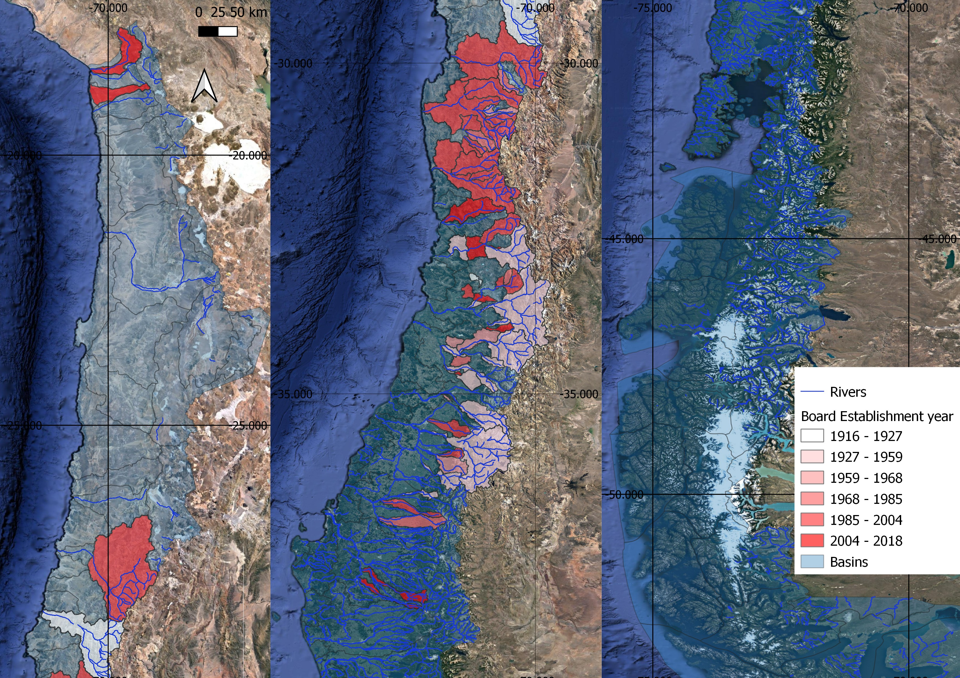

*Notes:* Left, center and right panels corresponds to the northern, central and southern areas of Chile. The colored areas represent each of the existing Water Boards jurisdictions, with their color reflecting the establishment year.

Figure 3: Administrative and legal hierarchy of institutions over water rights issues.

1. Administrative

Is within a Water

Board jurisdiction?

Yes

No

Appeals

DGA

Water Board

Dispute

1. Legal

Yes

Is within a Water

Board jurisdiction?

No

Appeals

Appeals

Appeals Courts

Ordinary Court

Water Board

Dispute

Supreme Court

Figure 4: Hydrological regime before 1985, by treatment assignment

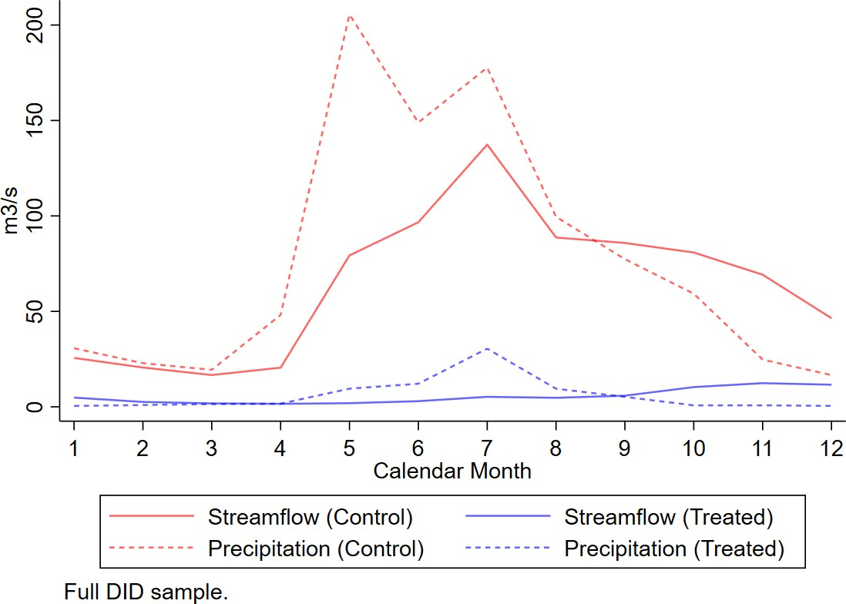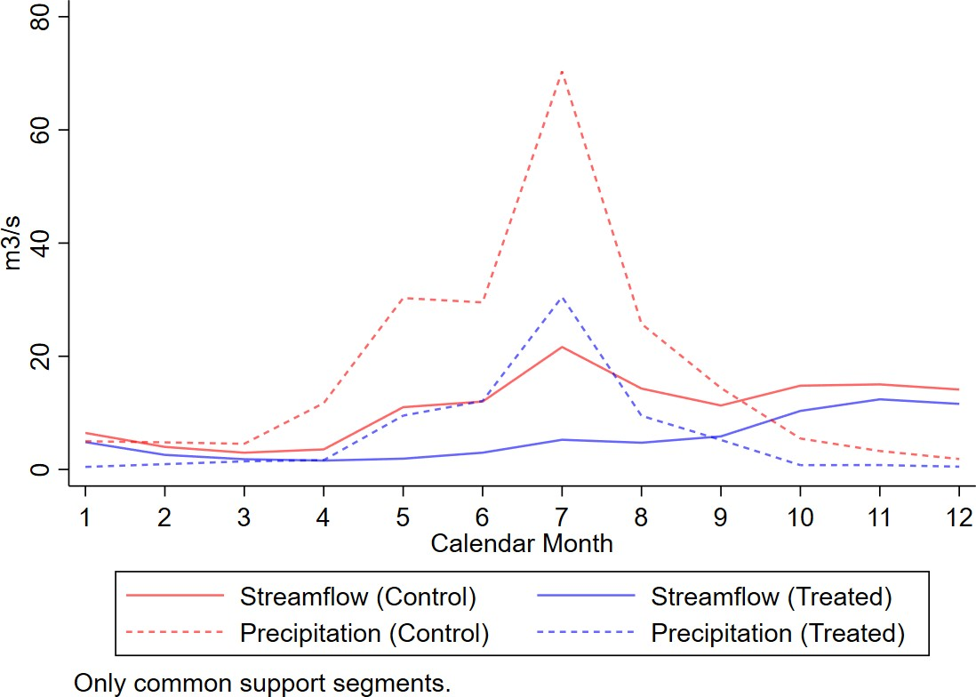

1. Hydrological regime before 1985, by treatment assignment. Full sample.
2. Hydrological regime before 1985, by treatment assignment. Study sample: only segments within the common support in average streamflow and pre- existing water rights in 1980, that eventually have Water Boards.

Figure 5: Climatic and geographic characteristics, by year of establishment

* 1. Average Precipitation

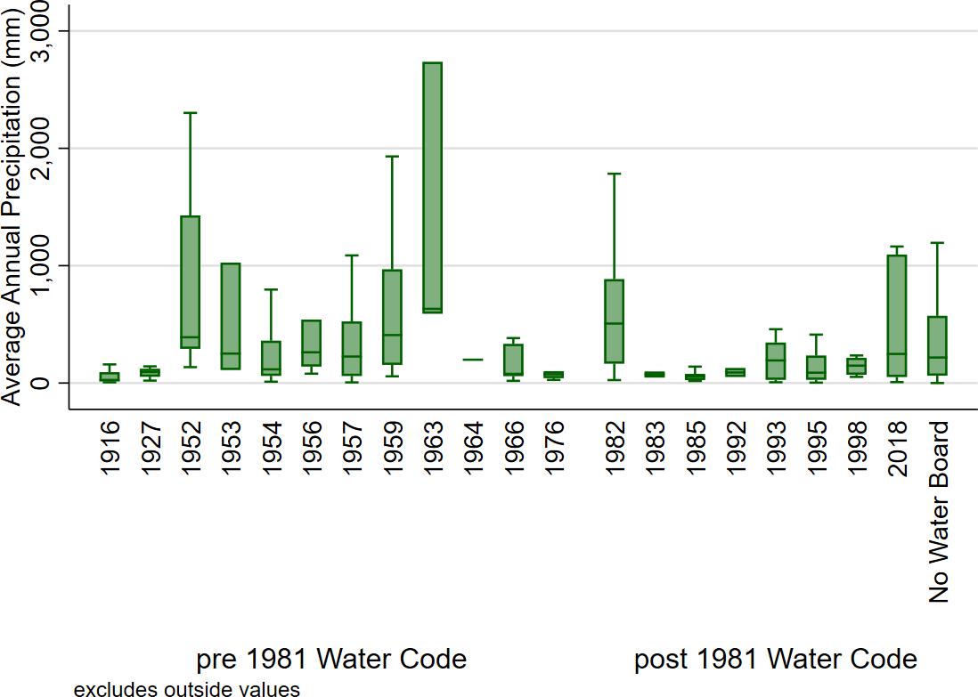

* 1. Streamflow

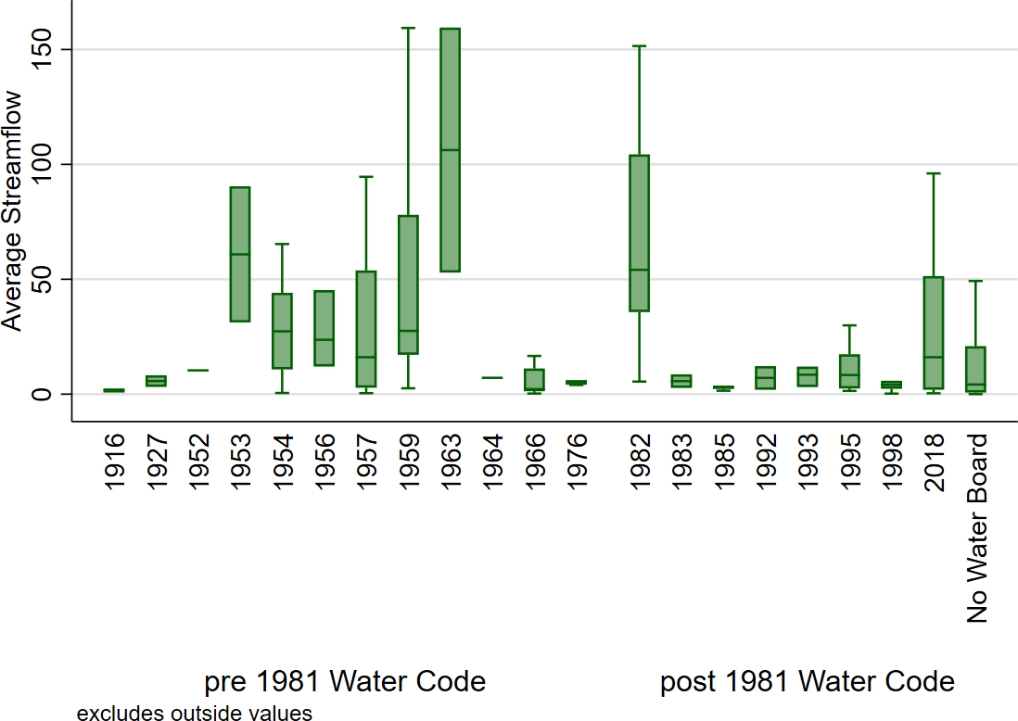

* 1. Glacier surface

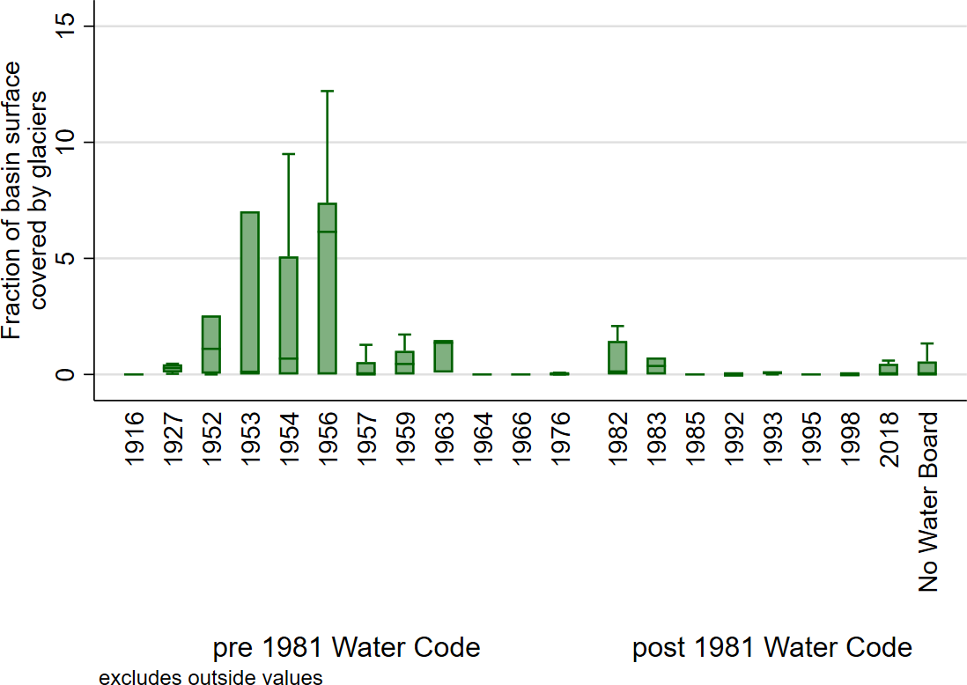

45

Figure 6: Effect of boards establishments on Water Rights issued in their jurisdictions, by source of the water (Poisson).

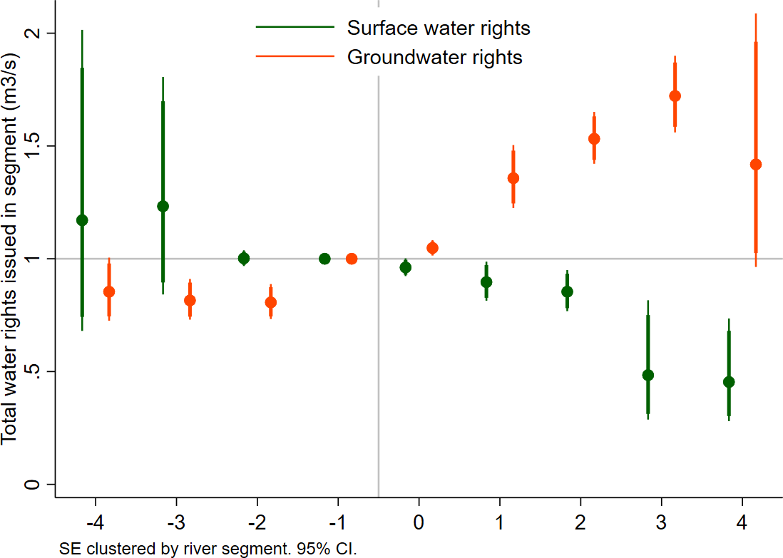

*Notes:* this figure present estimates of dynamic effects of water boards on water rights issued (measured in *m*3*/s*) separately by source: in green, the effect of water boards on surface water rights; in orange, the effect of water boards on groundwater rights. Using OLS, implemented using Stacked DID design by Cengiz, Dube, Lindner, and Zipperer (2019) design, considering *segment × event* and *year × event* fixed effects, climatic controls for January and February and also including 8 lags of precipitation and precipitation squared. Standard errors clustered at the river-segment level.

Figure 7: Effect of board establishments on streamflow within their jurisdiction, by month.

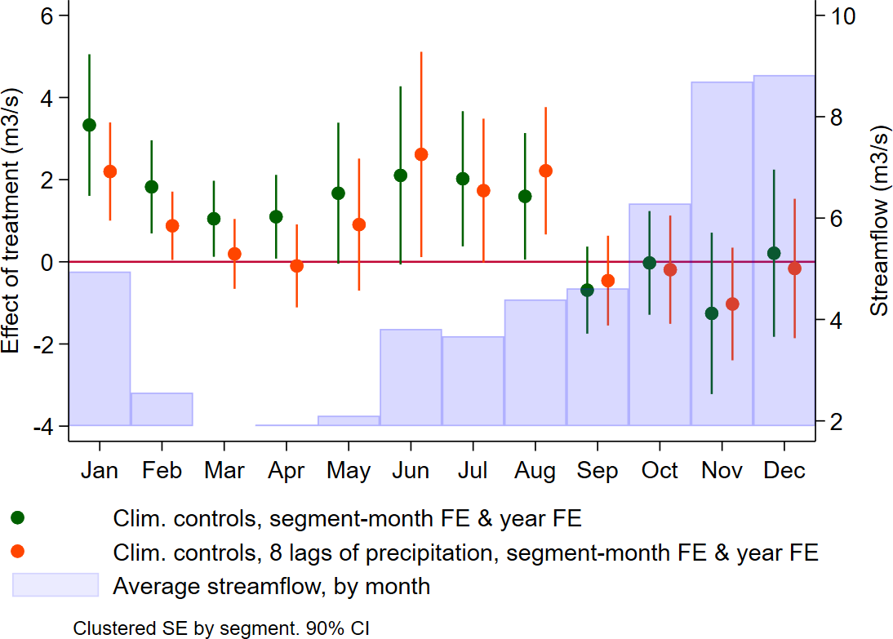

*Notes:* This table present heterogenous effects estimates of water boards on streamflows, by month. We interact the Board Establishment dummy variable with dummy variables indicating each month. Stacked DID design by Cengiz, Dube, Lindner, and Zipperer (2019). Controlling for contemporaneous temperature, precipitation and evapotranspiration, and 8 lags of precipitation and precipitation squared. Standard Errors clustered at the River Segment level.

Figure 8: Effect of board establishments on streamflow within their jurisdiction, by relative time (binned years) to the board establishment event.

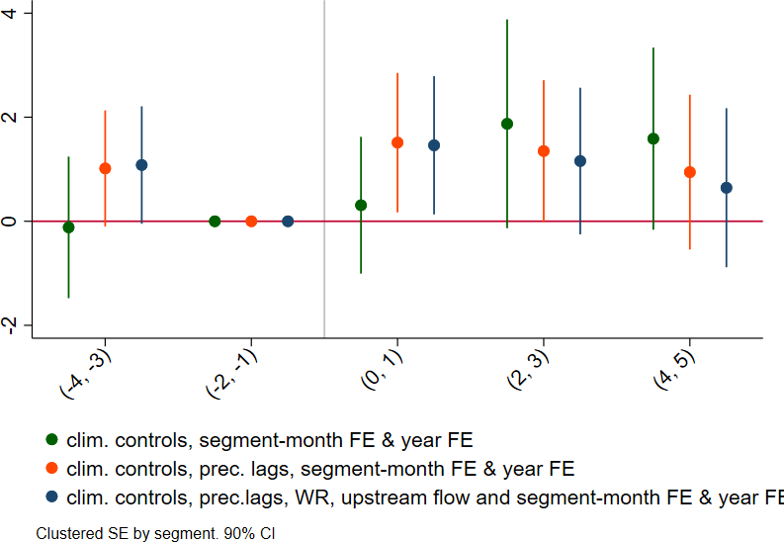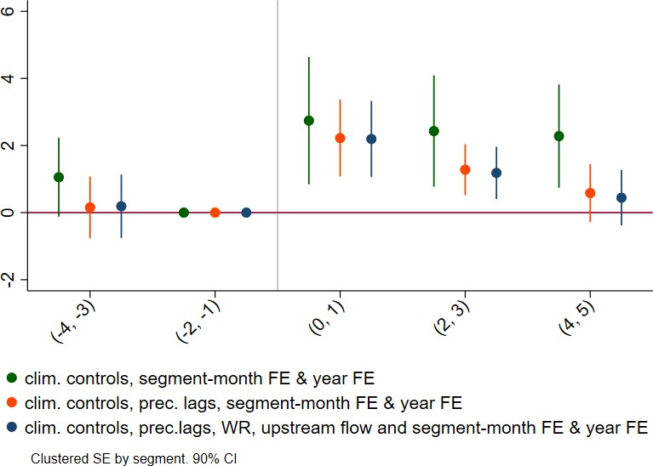

(a) Full year. (b) Dry season.

*Notes:* This table present dynamic effect estimates of water boards on streamflows, according to relative time to board establishment. We created 2-year bins, and consider the two years prior to the board establishment as the baseline period. Controlling for contemporaneous temperature, precipitation and evapotranspiration, and 8 lags of precipitation and precipitation squared, and water rights. Standard Errors clustered at the River Segment level.

Figure 9: Illustration: how streamflows measurement allows to recover impacts of enforcement by water boards on streamflow.

Andes (head of the river) Pacific Ocean (river mouth)

Upstream farms Downstream farms



Monitoring



1. No drought



stations



Andes (head of the river) Pacific Ocean (river mouth)

Upstream farms Downstream farms



Monitoring

stations



1. Drought, and no enforcement of water rights

Andes (head of the river) Pacific Ocean (river mouth)

Upstream farms Downstream farms



Monitoring

stations



1. Drought, and Water Boards enforce water rights

Figure 10: Kernel Regressions between Water Consumption measures and Basin Location (measured as Distance to the Coast), by Treatment Assignment

1. Average (per *m*2) Evapotranspiration during Summer vs farm location within basin

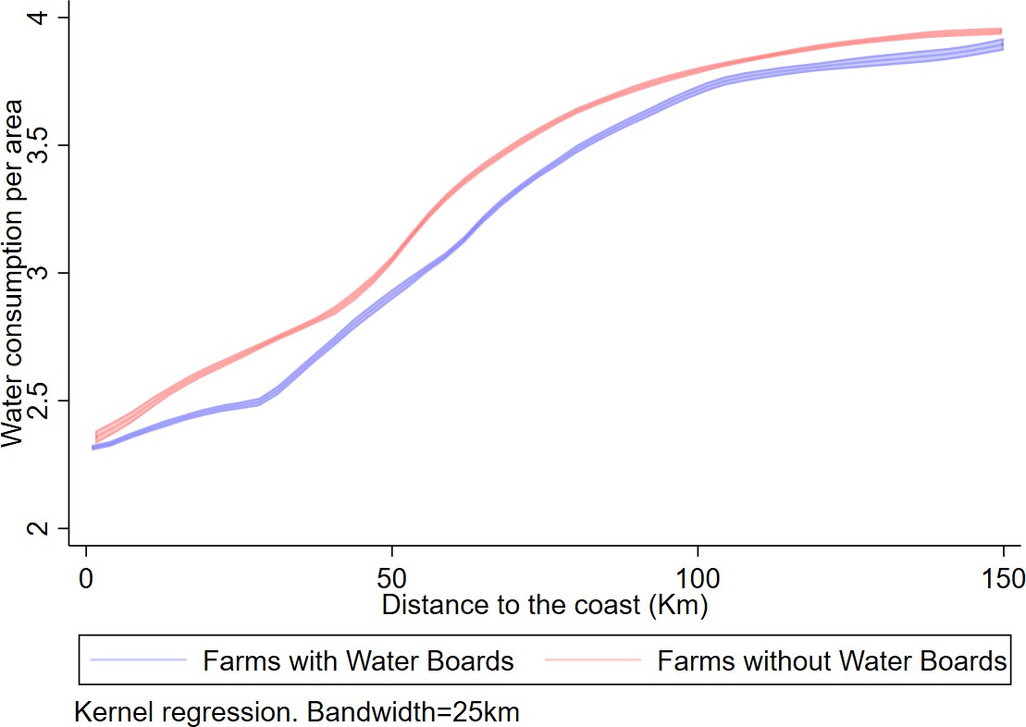

1. Total Evapotranspiration during Summer vs farm location within basin

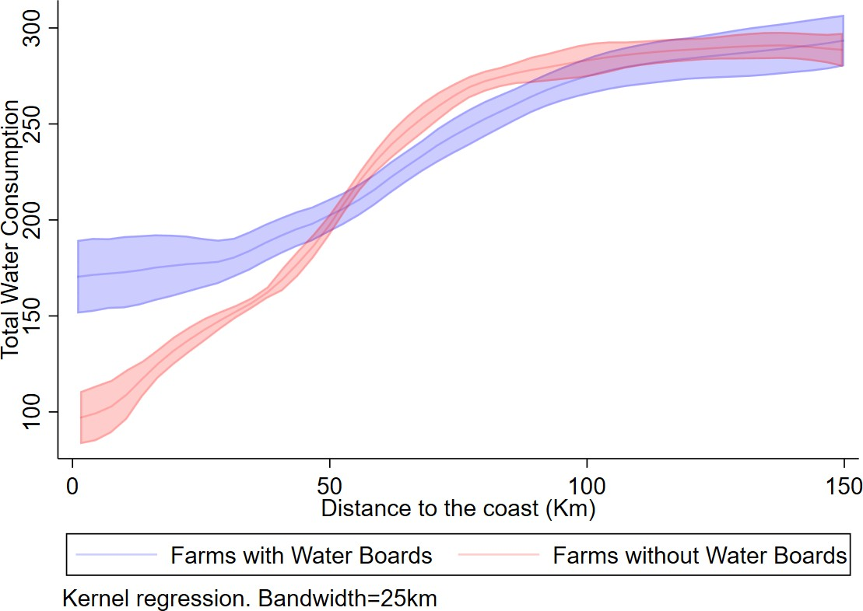

1. Water Availability Index vs farm location within basin

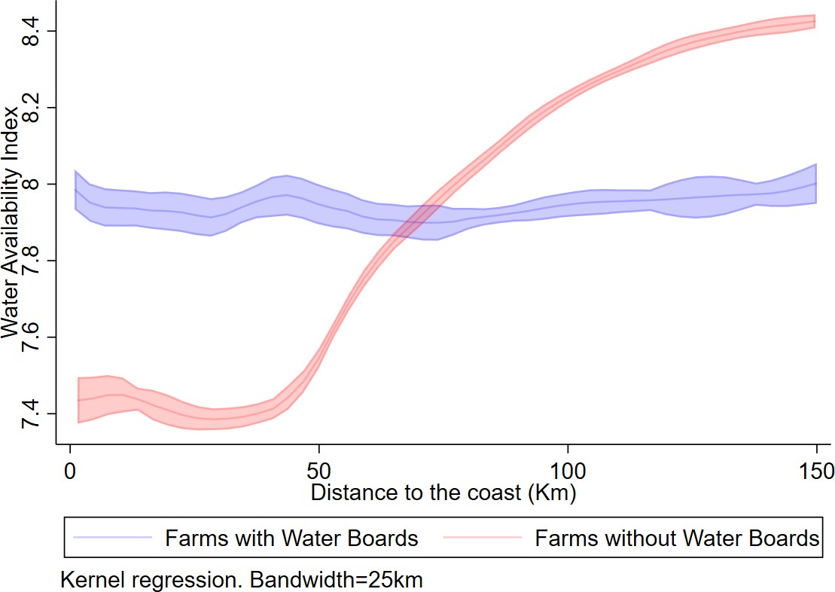

Figure 11: OLS regressions: water consumption and yield by treatment status and basin location.

(a) Water Consumption (Evapotranspiration) (b) Yield (EVI)

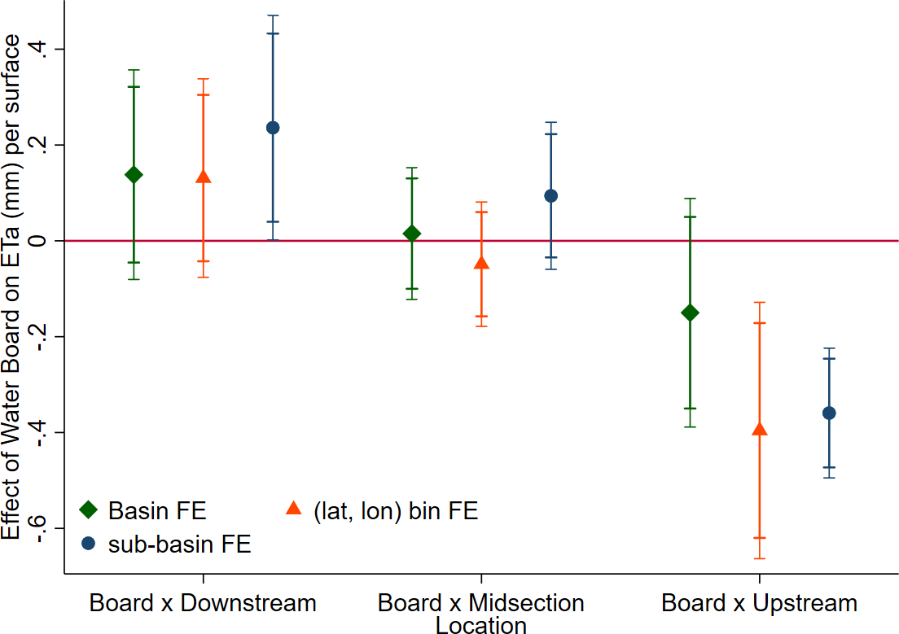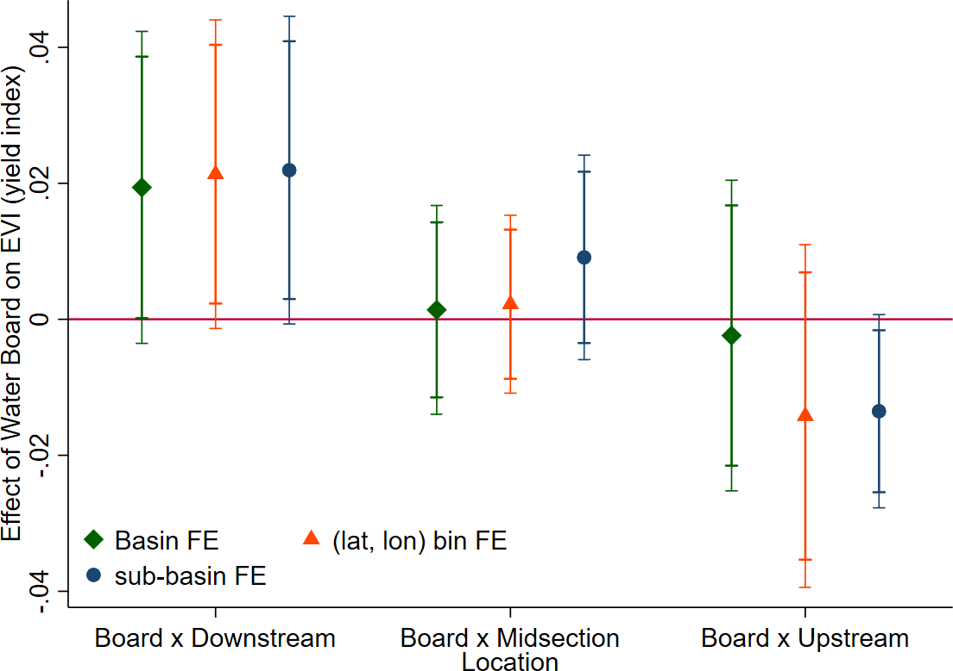

Figure 12: Heterogeneous effects: by location within canal .

(a) Water Consumption (b) Agricultural yield

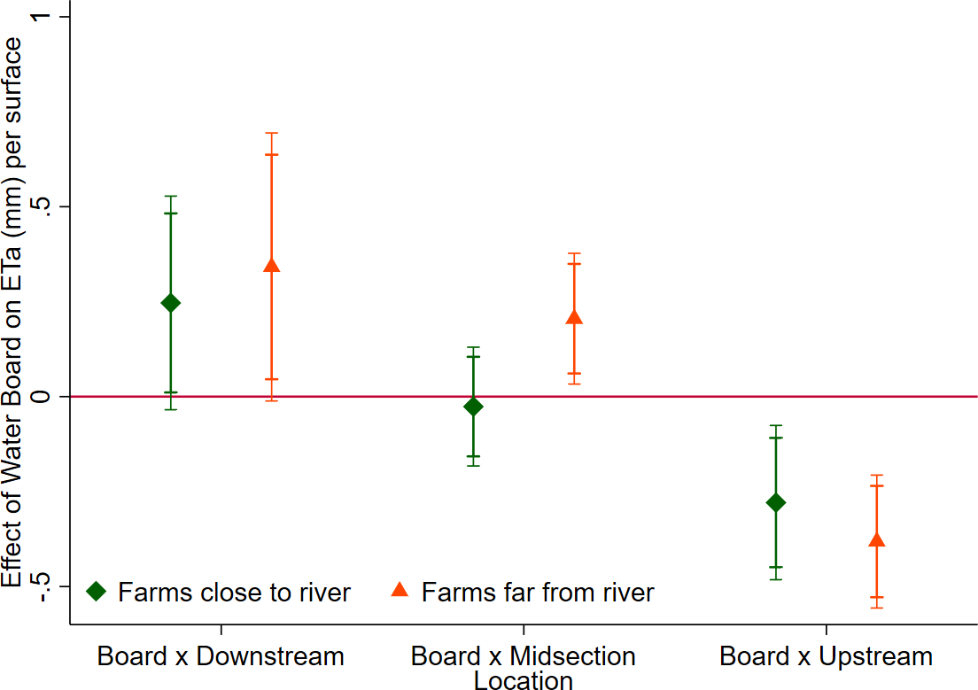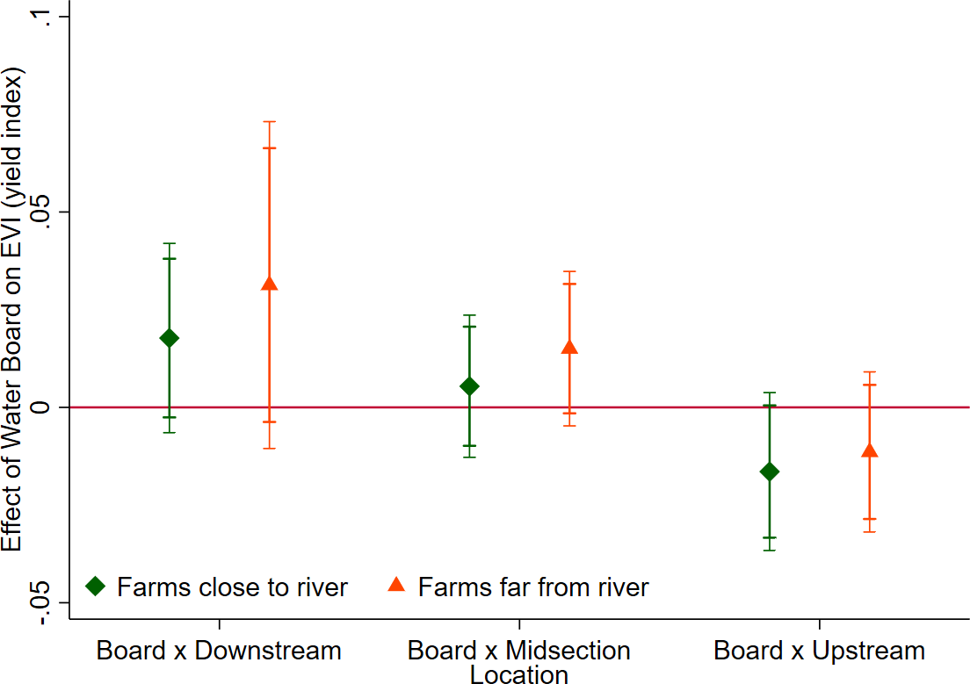

Figure 13: Heterogeneous effects: by farm size.

(a) Water Consumption (b) Agricultural yield

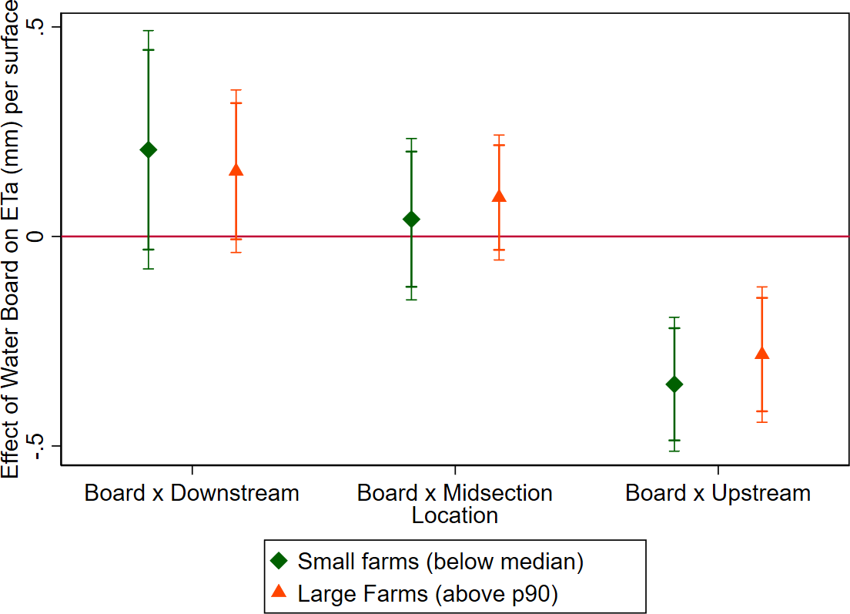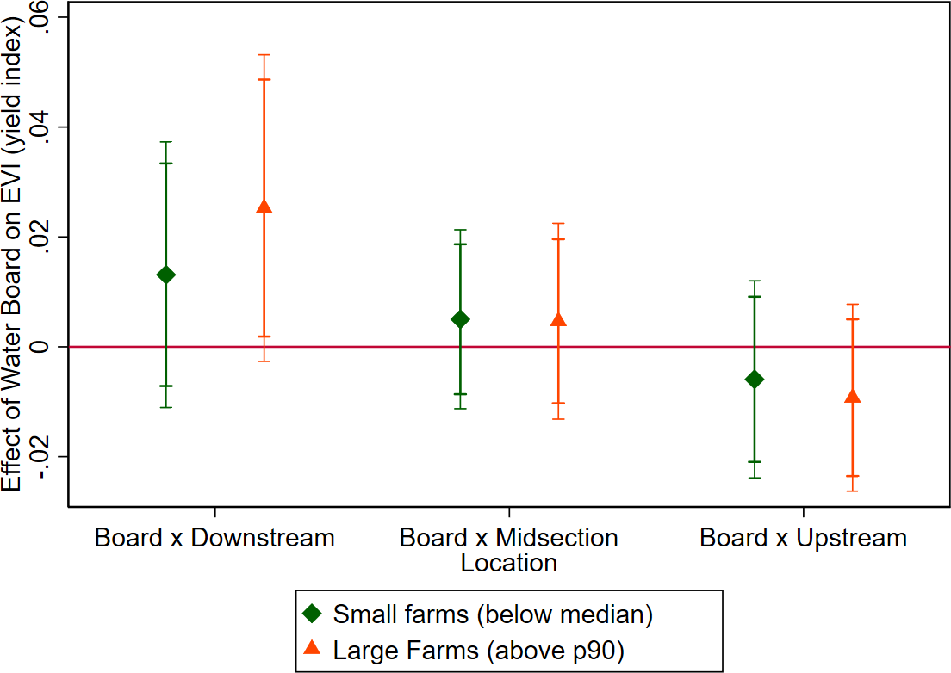

Figure 14: Illustration: farm level data and instrument

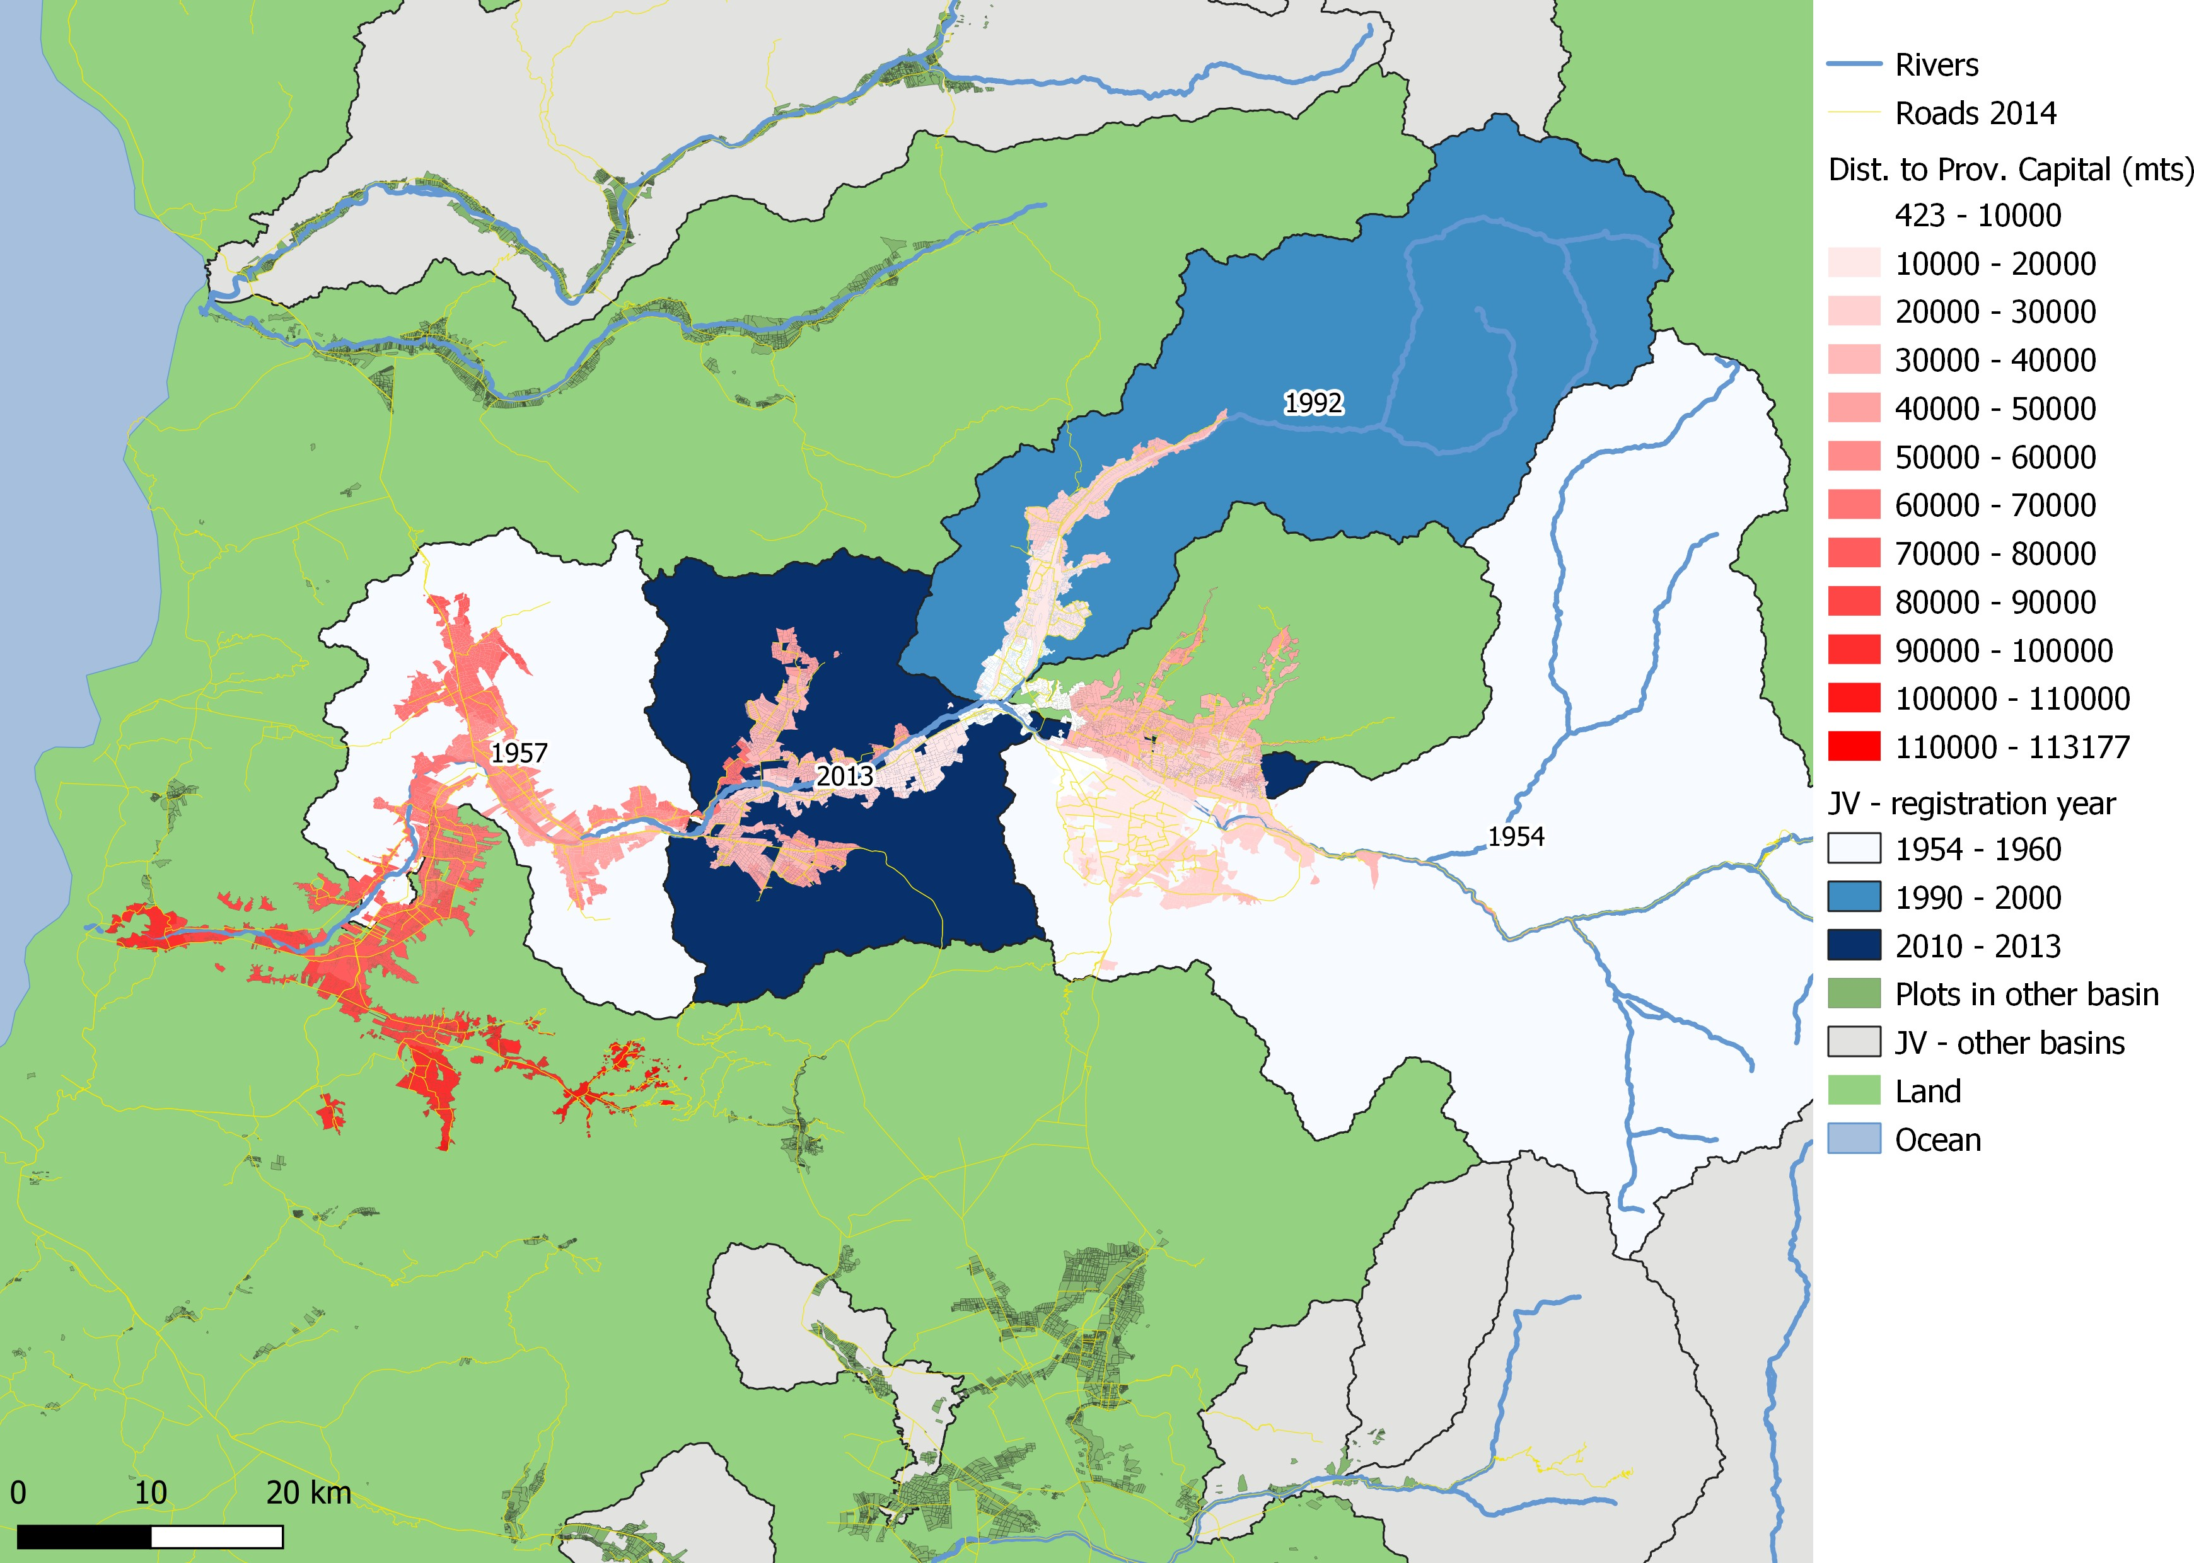

*Notes:* The map presents the Aconcagua Basin, illustrating the jurisdiction and ear of Establishment of its four Water Boards, our sample of irrigated farms and the river and road network. The color of each farm illustrates

Figure 15: Farm size distribution across locations

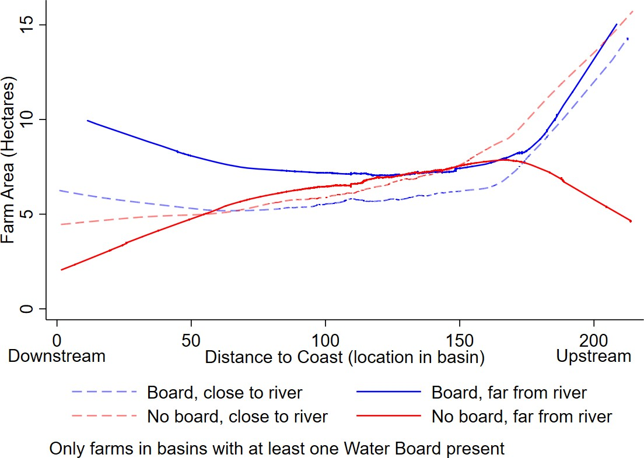

*Notes:*

Figure 16: Main results: effect on log(Production) of rainfall during the irrigation season by longitude and treatment status for irrigated parcels registered in canal associations.

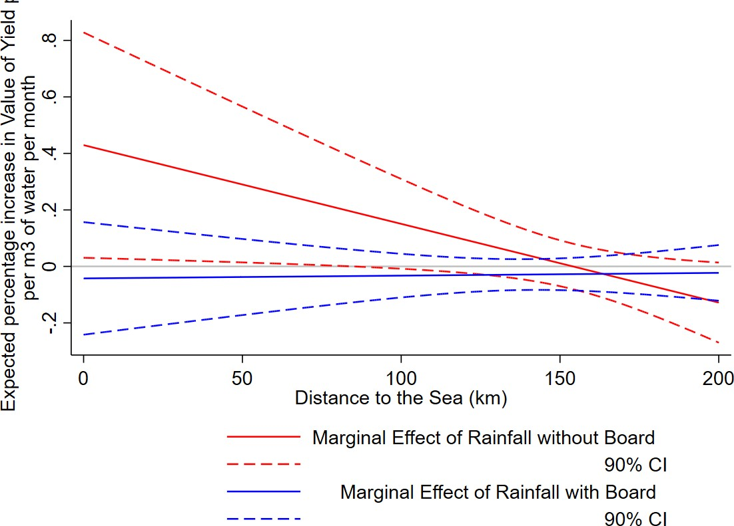

*Notes:* Graphical representation of results in Table 13.

Figure 17: Placebo exercise: effect on log(Production) of rainfall during the irrigation season by longitude and treatment status for rainfed parcels.

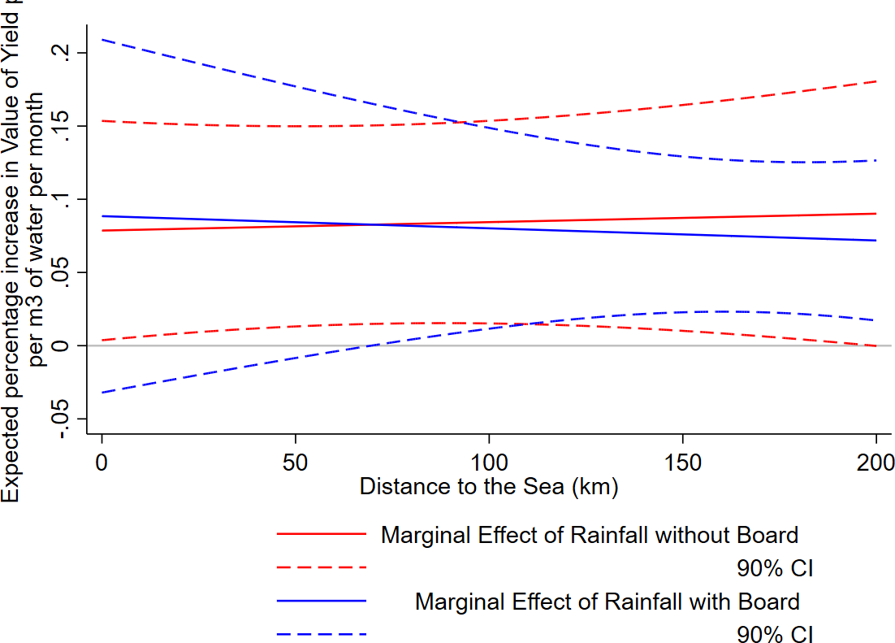

*Notes:* Graphical representation of results in Table 14 .

# A Model of Agricultural Production and Irrigation under Water Rights

This section discusses a model of agricultural production and irrigation under water rights, that provides the framework to interpret the results in presented in Section 6 as a misallocation test. The first part presents a model of agricultural production, that allows us to define the shadow value of water as the marginal productivity of irrigation water. The second part discusses briefly the problem of a Social Planner and shows that a Social Planner willing to maximize the value of pro- duction would equalize the shadow value of water across users. In this environment, an application of the First Welfare Theorem allows us to conclude that the solution of the Social Planner would be implemented as the Market Equilibrium under a well-functioning market.

The key insights from this section are that the partial derivative of the output with respect to rainfall is equal to the shadow value of water, times the marginal rate of technical substitution between rainfall and water from irrigation, and a definition of short-term misallocation.

## Environment

Consider the problem of allocating water across *N* agricultural users within a basin. Agricultural production follows a cycle over the year, with 3 seasons: a Planting season *s* = 0, a Growing season (*s* = 1) and Harvest time (*s* = 2). Water supply has different impacts depending on this stage; in what follows, we assume that irrigation is only useful in *s* = 1.

At stage *s* = 0 each farmer *i* ∈ *N* chooses crop *c*, capital *Ki* and land *Si*, which are fixed over the full production cycle. At each stage, the farmer chooses the flexible inputs, namely labor *Li* and effective irrigation *wi*. Effective irrigation is capped by the amount of water rights allocated

to the farmer *w*¯*i*. Rainfall *r* is a perfect substitute for irrigation water, up to a technical rate of substitution constant *θ*. Rainfall is a random variable with a distribution known by all agents. We assume that input and output prices are known in advance, and all markets are competitive.

There is a Social Planner who allocates Water Rights to each user; each user will extract after rainfall uncertainty is realized. The timeline of decisions is therefore:

**time**= **0** : Social planner allocates water rights. Farmers choose crops, capital and land. **time**= **1** : Farmers hire labor and apply irrigation water subject to their Water Rights caps **time**= **2** : Profits are realized

Finally, each production function *Fc* is continuous, strictly concave and monotone49.

49While the first two properties are assumed to keep the analysis simple (i.e. to guarantee that the demands for all factors are functions and not correspondences) and it is possible to replace them without loss of generality, the last assumption may be more controversial, as it rules out scenarios where excessive rainfall adversely affects production. While such a scenario is certainly realistic, in the area under study -with mostly dry Mediterranean weather with a well-marked rainfall season in the winter- is rare, and it did not take place in the period under analysis (2006-2007 Austral agricultural year).

Consider the case where irrigation increases production until a total water input threshold, after which water damages production: any rainfall that falls below this threshold will just affect the solution to the farmer’s problem by reducing irrigation, in which case the irrigation restriction is not binding. In this scenario, the shadow value of water is zero, and so the problem and the shadow value preserve their meaning.

## Farmers’ problem

We solve by backward induction: the problem of user *i* at stage *s* = 1 is to choose the optimal irrigation and labor quantities to maximize profits:

max

*pcFc*(*Si, Ki, Li, wi* + *θri*) − *λs*(*wi* − *w*¯*i*) − *cLLi*

*Li,wi i* *i*

*FOC*(*wi*) : *pcFc*′ *FOC*(*Li*) : *pcFc*′

*i w*

*i L*

= *λw*

= *cL*

*i*

Under the assumptions above, each farmer will just use the total amount of water rights allocated to them. The shadow value of water will be equal to the marginal productivity of irrigation water. In stage *s* = 0 the problem of the farmer is to choose the optimal Capital, Land, and crop:

The fixed inputs are chosen based on

max

*Ki,Si*

*i*

E*r* {*pFc* (*Si, Ki, Li* (*Ki, Si, w*¯*i*) *, wi* (*Ki, Si, w*¯*i*) + *θri*) − *cSSi* − *cKKi*|*I*0}

*FOC*(*Si*) : E*r* *pcFc*′ |*I*0 = *cS*

*i S*

*FOC*(*Ki*) : E*r* *pcFc*′ |*I*0 = *cK*

*i K*

where the Envelope Theorem rules out any indirect effects on any flexible inputs. Given the choices for each input, we can define the expected profits for farmer *i* conditional on choosing crop *c*:

*πc*(*w*¯*i*) ≡E*r* {*pcFc* (*Si* (*w*¯*i*) *, Ki* (*w*¯*i*) *, Li* (*w*¯*i*) *, wi* (*w*¯*i*) + *θri*)

*i* *i*

−*cSSi* (*w*¯*i*) − *cKKi* (*w*¯*i*) − *cLLi* (*w*¯*i*) − *λw* (*wi* (*w*¯*i*) − *w*¯*i*) |*I*0}

*i*

(11)

The farmers, therefore, will choose the crop with maximum expected profits. The farmer’s expected profits are therefore

*π*¯*i*(*w*¯*i*) ≡ max *k* : *πk*(*w*¯*i*) (12)

*i*

## Social Planners’ Problem

Let’s define the Social Welfare Function as the sum of the expected production of all farmers within the basin:

L

Ω (**w¯** ) ≡ *π*¯*i*(*w*¯*i*)

*i*

The problem of the social planner is to allocate water rights across users to maximize the total production value, subject to the total availability of water:

max

{*w*¯*i*}|*N*

L *π*¯*i*(*w*¯*i*) − *λW* L *w*¯*i* − *W*¯ (13)

*i*=1 *i* *i*

Note that the social planner’s objective function is just the sum of value functions of all farmers; therefore, as a consequence of the Maximum Theorem, the social planner’s objective function is continuous on each water right *w*¯*i*. The first order condition with respect to *w*¯*i* is

*∂*Ω

*∂w*¯*i*

= 0 ⇐⇒ *∂π*¯*i*

*∂w*¯*i*

= *λW* (14)

Therefore, the optimal allocation satisfies *∂π*¯*i*

*∂w*¯*i*

= *∂π*¯*j* . Note that:

*∂w*¯*j*

*∂π*¯*i*

E *K*

= *i* = E {*λw*|*I*0}

*∂ r* *pkF* |*I*0

*∂w*¯*i*

*∂w*¯*i* *i*

where the second equality is a consequence of the Envelope Theorem5051. In the socially optimal allocation, therefore, the expected shadow value of water is equal across farmers; any deviation from that implies the opportunity to increase expected welfare by redistributing water rights from users with a high shadow value of water to users with a low shadow value.

## The effect of a rainfall shock

Consider the effect on the welfare of an unexpected rainfall shock over farm *j*. As the water rights allocation is fixed, then:

*∂p Fk*′ [ ]

*∂*Ω

= E

*k*

*j w*

× *θ* = *θ*E

[*λ* ] = *θ*E

*λW*

*∂rj*

*r*

*∂wi*

*r*

*j*

*r*

where the second equality comes from the problem of farmer *j* and the third comes from the planner FOC. So the total effect of an unexpected rainfall shock on production is equal to the shadow value of water of the affected farmer, times the marginal rate of technical substitution between irrigation water and rainfall. Note that Rafey (2023b) estimate *θ* to be equal to 1*.*048 for annual irrigated crops52, which is approximately equal to 1.

We can conclude from the former discussion that

1. the optimal allocation of water rights equalizes the expected marginal productivity of irrigation water across users, and
2. The effect of an unexpected rainfall shock is equal to the marginal productivity of irrigation water.

50The application is direct in this case; a more general discussion can be found in Hsiang (2016); Deryugina and Hsiang (2017)

51The *K* index here denotes the crop chosen by the farmer; this choice is not affected by an unexpected rainfall shock.

52The estimates of *θ* for other crop choices are 1*.*081 for perennial crops, for annual non-irrigated crops is 0*.*591 and for dairy is 0*.*148.

# A Appendix

Figure 18: Example: water right title.

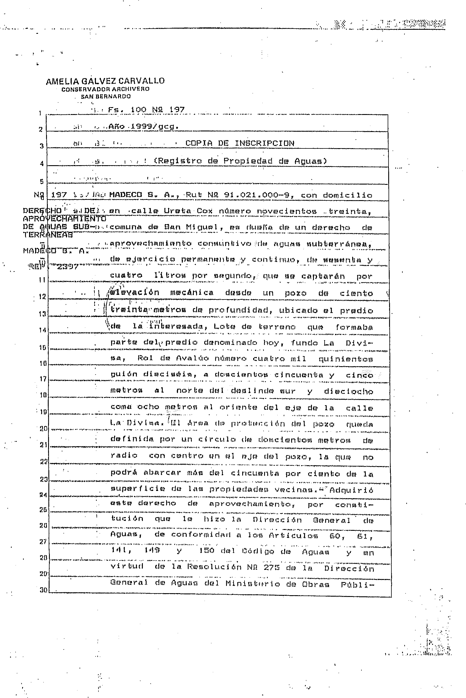59

Figure 19: Effect of boards establishments on Water Rights issued in their jurisdictions, by source of the water (OLS).

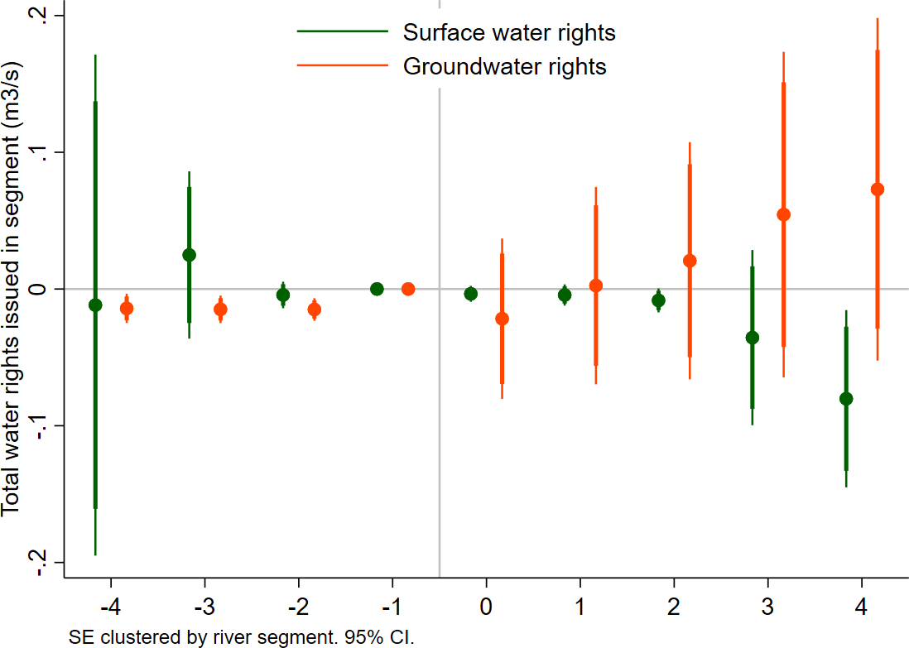

*Notes:* this figure present estimates of dynamic effects of water boards on water rights issued (measured in *m*3*/s*) separately by source: in green, the effect of water boards on surface water rights; in orange, the effect of water boards on groundwater rights. Using OLS, implemented using Stacked DID design by Cengiz, Dube, Lindner, and Zipperer (2019) design, considering *segment × event* and *year × event* fixed effects, climatic controls for January and February and also including 8 lags of precipitation and precipitation squared. Standard errors clustered at the river-segment level.

Figure 20: Climatic and geographic characteristics, by year of establishment (cont.)

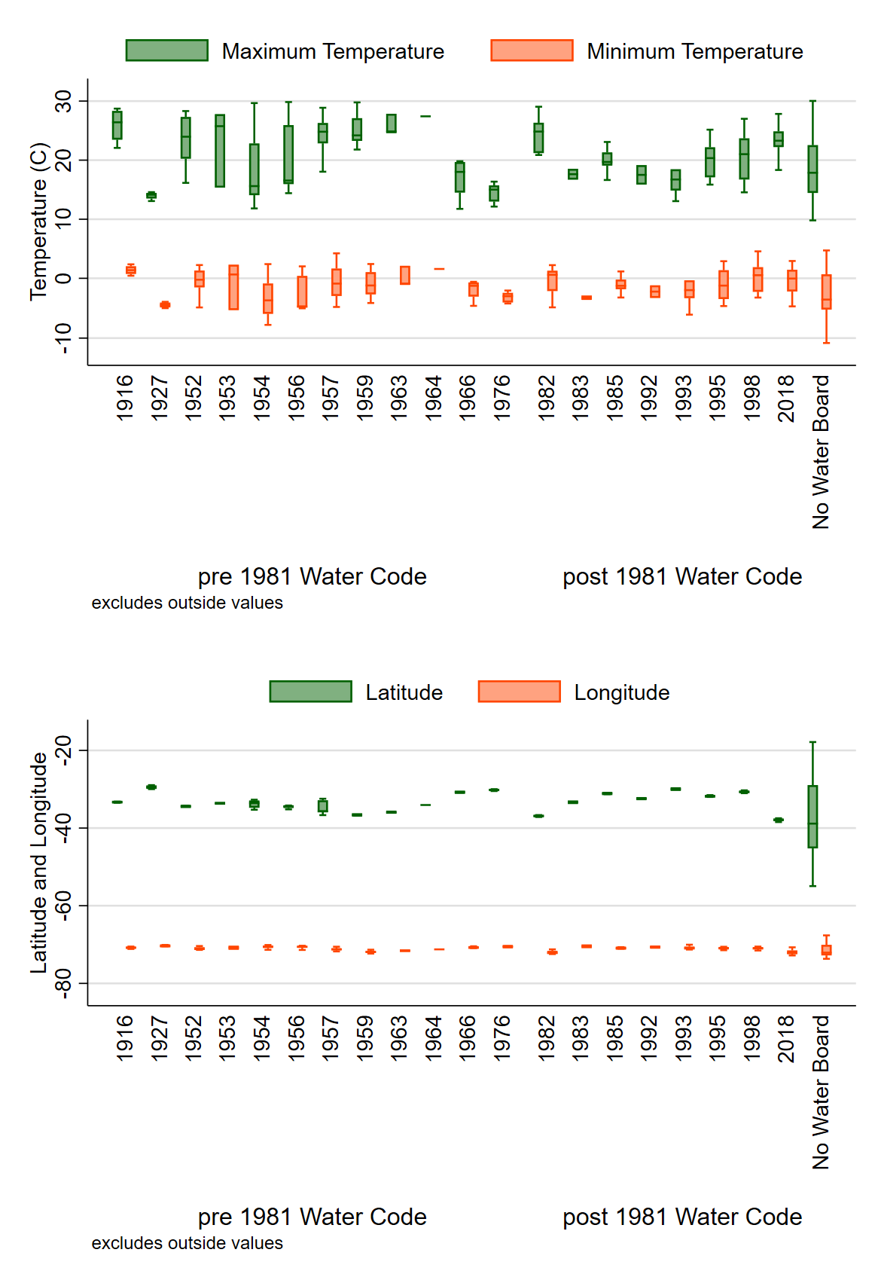

Figure 21: Climatic and geographic characteristics, by year of establishment

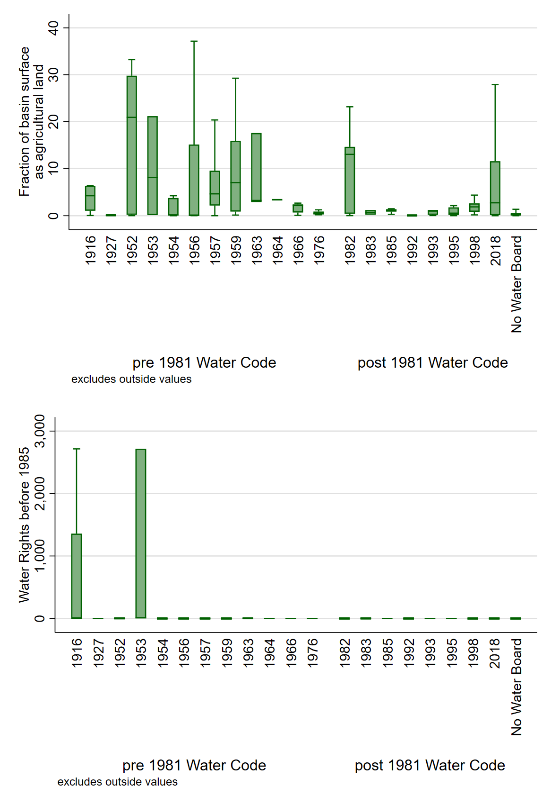

Figure 22: Effect of boards establishments on Water Rights issued per *km*2 in their jurisdictions, by source of the water.

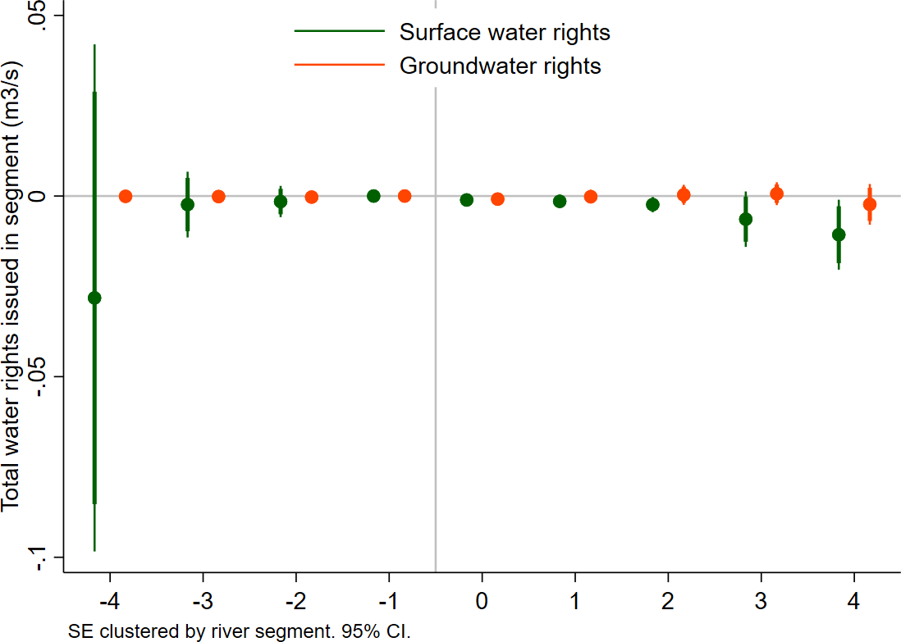

*Notes:* this figure present estimates of dynamic effects of water boards on water rights issued (measured in *m*3*/s*,) per *km*2 of surface of the basin, separately by source: in green, the effect of water boards on surface water rights; in orange, the effect of water boards on groundwater rights. Using OLS, implemented using Stacked DID design by Cengiz, Dube, Lindner, and Zipperer (2019) design, considering *segment × event* and *year × event* fixed effects, climatic controls for January and February and also including 8 lags of precipitation and precipitation squared. Standard errors clustered at the river-segment level.

Table 15: Years of Board Establishment, by river segment

(1)

Board establishment year

|  |  |  |  |
| --- | --- | --- | --- |
|  | *N* segments | percent | Cumulative perc. |
| 1916 | 4 | 0.78 | 0.78 |
| 1927 | 4 | 0.78 | 1.55 |
| 1952 | 6 | 1.16 | 2.71 |
| 1953 | 3 | 0.58 | 3.29 |
| 1954 | 43 | 8.33 | 11.63 |
| 1956 | 7 | 1.36 | 12.98 |
| 1957 | 38 | 7.36 | 20.35 |
| 1959 | 12 | 2.33 | 22.67 |
| 1963 | 3 | 0.58 | 23.26 |
| 1964 | 1 | 0.19 | 23.45 |
| 1966 | 7 | 1.36 | 24.81 |
| 1976 | 7 | 1.36 | 26.16 |
| 1982 | 11 | 2.13 | 28.29 |
| 1983 | 2 | 0.39 | 28.68 |
| 1985 | 8 | 1.55 | 30.23 |
| 1992 | 2 | 0.39 | 30.62 |
| 1993 | 5 | 0.97 | 31.59 |
| 1995 | 16 | 3.10 | 34.69 |
| 1998 | 16 | 3.10 | 37.79 |
| 2018 | 27 | 5.23 | 43.02 |
| No Board | 294 | 56.98 | 100.00 |
| Total | 516 | 100.00 |  |
| Observations | 516 |  |  |

*Notes:* This table shows the total number of monitoring stations available, and the establishment date of a water board (in case the river segment associated to a monitoring station is within a water board jurisdiction).

Stations in red are excluded from the study, as the creation of their water boards took place under a different institutional regime.

Figure 23: Effects by month, estimated using Poisson Regression.

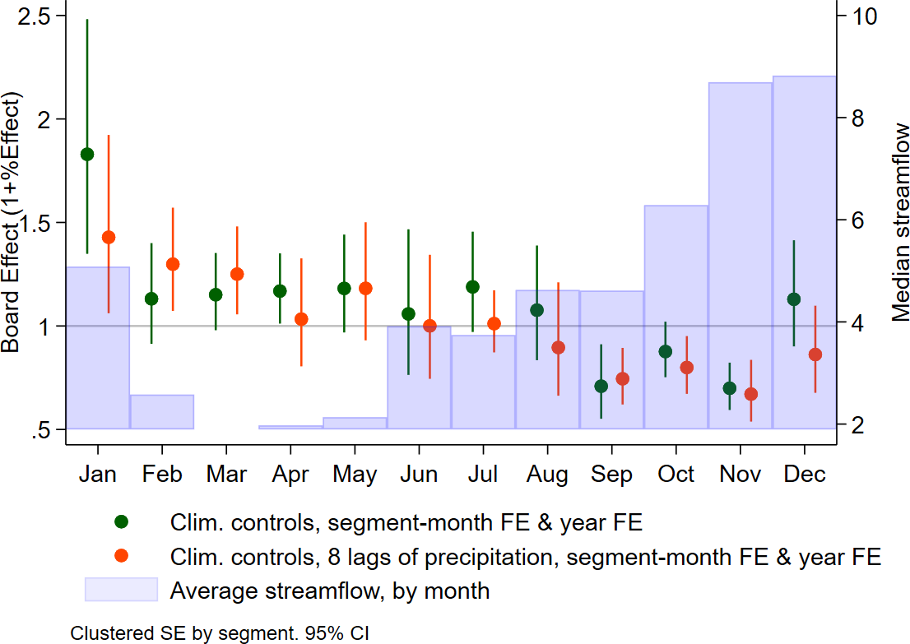

Water Rights created

Panel A: OLS Panel B: Poisson

Surface WR (m3/s) Groundwater WR (m3/s)

Surface WR (m3/s) Groundwater WR (m3/s)

(1) (2) (3) (4)

|  |  |  |  |  |  |  |
| --- | --- | --- | --- | --- | --- | --- |
|  | (1) | (2) |  | (3) | (4) |  |
| -4 | -0.0118 | -0.00571 |  | -0.0142 | -0.0125 |  |
|  | [-0.241, 0.117] | [-0.252, 0.116] |  | [-0.0250, -0.00276] | [-0.0271, 0.00212] |  |
|  | 0.923 | 0.947 |  | 0.0450  ∗∗ | 0.203  ∗ |  |
| -3 | 0.0249 | 0.00803 |  | -0.0149 | -0.0127 |  |
|  | [-0.0202, 0.0731] | [-0.0271, 0.0617] |  | [-0.0256, -0.00416] | [-0.0288, 0.00179] |  |
|  | 0.442 | 0.692 |  | 0.0190  ∗∗ | 0.109 |  |
| -2 | -0.00436 | -0.00358 |  | -0.0150 | -0.0147 |  |
|  | [-0.0172, 0.00350] | [-0.0264, 0.0157] |  | [-0.0246, -0.00488] | [-0.0284, -0.00528] |  |
|  | 0.432 | 0.635 |  | 0.0480  ∗∗∗ | 0.00100  ∗∗ |  |
| 0 | -0.00352 | -0.0254 |  | -0.0217 | -0.0123 |  |
|  | [-0.0110, 0.00113] | [-0.0581, 0.0246] |  | [-0.0722, 0.0263] | [-0.0591, 0.0306] |  |
|  | 0.183 | 0.473 |  | 0.588 | 0.728 |  |
| 1 | -0.00438 | 0.00480 |  | 0.00248 | 0.00153 |  |
|  | [-0.0126, 0.00345] | [-0.0231, 0.0272] |  | [-0.0805, 0.0716] | [-0.0640, 0.0719] |  |
|  | 0.311 | 0.706 |  | 0.936 | 0.968 |  |
| 2 | -0.00835 | -0.0229 |  | 0.0207 | 0.0245 |  |
|  | [-0.0163, 0.000501] | [-0.0295, -0.0134] |  | [-0.0670, 0.112] | [-0.0589, 0.113] |  |
|  | 0.112  ∗ | 0  ∗∗∗ |  | 0.613 | 0.605 |  |
| 3 | -0.0356 | -0.0252 |  | 0.0544 | 0.0562 |  |
|  | [-0.106, 0.0174] | [-0.100, 0.0224] |  | [-0.0850, 0.200] | [-0.0603, 0.200] |  |
|  | 0.278 | 0.539 |  | 0.431 | 0.356 |  |
| 4 | -0.0803 | -0.0786 |  | 0.0729 | 0.0680 |  |
|  | [-0.133, -0.0378] | [-0.171, 0.00387] |  | [-0.0761, 0.226] | [-0.0629, 0.215] |  |
|  | 0.0300  ∗∗ | 0.134 |  | 0.273 | 0.321 |  |
| Climatic controls | No | Yes |  | No | Yes |  |
| Segment FE | Yes | Yes |  | Yes | Yes |  |
| Year x experiment FE | Yes | Yes |  | Yes | Yes |  |
| Observations | 1,404 | 1,404 |  | 1,404 | 1,404 |  |
| R-squared | 0.893 | 0.896 |  | 0.751 | 0.753 |  |
| Outcome mean | 0.180 | 0.180 |  | 0.062 | 0.062 |  |
| Outcome SD | 0.686 | 0.686 |  | 0.170 | 0.170 |  |

|  |  |  |  |  |
| --- | --- | --- | --- | --- |
| main |  | | | |
| -4 | 0.158 | 0.184 | -0.158 | -0.101 |
|  | , | , | , | , |
|  | 0.548 | 0.499 | 0.0721  ∗ | 0.248 |
| -3 | 0.209 | 0.147 | -0.204 | -0.164 |
|  | , | , | , | , |
|  | 0.154 | 0.400 | 0.0511  ∗∗∗ | 0.236  ∗∗∗ |
| -2 | 0.00204 | 0.0691 | -0.215 | -0.154 |
|  | , | , | , | , |
|  | 0.853 | 0.366 | 0.0350  ∗∗∗ | 0.133  ∗∗∗ |
| 0 | -0.0391 | -0.0103 | 0.0467 | 0.0959 |
|  | , | , | , | , |
|  | 0.227  ∗ | 0.890 | 0.0501  ∗∗∗ | 0.474 |
| 1 | -0.109 | -0.0774 | 0.306 | 0.341 |
|  | , | , | , | , |
|  | 0.0310  ∗∗ | 0.338 | 0.0210  ∗∗∗ | 0.0651  ∗∗∗ |
| 2 | -0.158 | -0.110 | 0.426 | 0.412 |
|  | , | , | , | , |
|  | 0.00801  ∗∗∗ | 0.418 | 0.0420  ∗∗∗ | 0.0891  ∗∗∗ |
| 3 | -0.725 | -0.676 | 0.543 | 0.480 |
|  | , | , | , | , |
|  | 0.0811  ∗∗∗ | 0.0731  ∗∗∗ | 0.0490  ∗∗∗ | 0.105  ∗∗∗ |
| 4 | -0.790 | -0.823 | 0.350 | 0.435 |
|  | , | , | , | , |
|  | 0.0270  ∗∗∗ | 0.0340  ∗∗∗ | 0.395  ∗ | 0.0631  ∗∗∗ |
| Climatic controls | No | Yes | No | Yes |
| Segment FE | Yes | Yes | Yes | Yes |
| Year x experiment FE | Yes | Yes | Yes | Yes |
| Observations | 1,404 | 1,404 | 1,404 | 1,404 |
| R-squared |  |  |  |  |
| Outcome mean | 0.180 | 0.180 | 0.062 | 0.062 |
| Outcome SD | 0.686 | 0.686 | 0.170 | 0.170 |

Table 17: Dynamic effects of Water Boards on water rights. Baseline period correspond to the last two years before the boards establishment.

Water Rights per squared Kilometer

Panel A: OLS Panel B: Poisson

Surface WR per Area Groundwater WR per Area

Surface WR per Area Groundwater WR per Area

(1) (2) (3) (4)

|  |  |  |  |  |  |  |
| --- | --- | --- | --- | --- | --- | --- |
|  | (1) | (2) |  | (3) | (4) |  |
| -4 | -0.0282 | -0.0284 |  | -0.0000869 | 0.0000348 |  |
|  | [-0.126, 0.0110] | [-0.126, 0.0111] |  | [-0.000757, 0.000806] | [-0.000538, 0.00107] |  |
|  | 0.952 | 0.929 |  | 0.768 | 0.926 |  |
| -3 | -0.00237 | -0.00252 |  | -0.000141 | -0.0000798 |  |
|  | [-0.0140, 0.00336] | [-0.0143, 0.00484] |  | [-0.000518, 0.000412] | [-0.000517, 0.000549] |  |
|  | 0.983 | 0.861 |  | 0.493 | 0.691 |  |
| -2 | -0.00153 | -0.00162 |  | -0.000289 | -0.000166 |  |
|  | [-0.00706, 0.00100] | [-0.00798, 0.00157] |  | [-0.000462, -0.0000499] | [-0.000412, 0.000130] |  |
|  | 0.837 | 0.553 |  | 0.0410  ∗∗ | 0.338 |  |
| 0 | -0.00108 | -0.000222 |  | -0.000842 | -0.000866 |  |
|  | [-0.00313, 0.0000582] | [-0.00185, 0.00208] |  | [-0.00221, 0.000616] | [-0.00271, 0.000690] |  |
|  | 0.133 | 0.872 |  | 0.408 | 0.467 |  |
| 1 | -0.00147 | -0.00207 |  | -0.000172 | -0.000114 |  |
|  | [-0.00384, 0.000301] | [-0.00537, 0.000137] |  | [-0.00222, 0.00157] | [-0.00213, 0.00179] |  |
|  | 0.227 | 0.101  ∗ |  | 0.803 | 0.897 |  |
| 2 | -0.00237 | -0.00137 |  | 0.000325 | 0.000279 |  |
|  | [-0.00541, -0.000689] | [-0.00364, 0.00157] |  | [-0.00322, 0.00299] | [-0.00261, 0.00273] |  |
|  | 0.0470  ∗∗ | 0.322 |  | 0.846 | 0.829 |  |
| 3 | -0.00641 | -0.00662 |  | 0.000637 | 0.000656 |  |
|  | [-0.0146, 0.000119] | [-0.0147, -0.000537] |  | [-0.00307, 0.00367] | [-0.00333, 0.00360] |  |
|  | 0.0951 | 0.0671  ∗ |  | 0.662 | 0.673 |  |
| 4 | -0.0107 | -0.0126 |  | -0.00231 | -0.00191 |  |
|  | [-0.0200, -0.00504] | [-0.0219, -0.00618] |  | [-0.00892, 0.00310] | [-0.00747, 0.00285] |  |
|  | 0  ∗∗ | 0.00200  ∗∗ |  | 0.464 | 0.498 |  |
| Climatic controls | No | Yes |  | No | Yes |  |
| Segment FE | Yes | Yes |  | Yes | Yes |  |
| Year x experiment FE | Yes | Yes |  | Yes | Yes |  |
| Observations | 1,404 | 1,404 |  | 1,404 | 1,404 |  |
| R-squared | 0.882 | 0.882 |  | 0.666 | 0.667 |  |
| Outcome mean | 0.014 | 0.014 |  | 0.003 | 0.003 |  |
| Outcome SD | 0.062 | 0.062 |  | 0.008 | 0.008 |  |

|  |  |  |  |  |
| --- | --- | --- | --- | --- |
| main |  | | | |
| -4 | 0.158 | 0.184 | -0.158 | -0.101 |
|  | , | , | , | , |
|  | 0.515 | 0.519 | 0.0761  ∗ | 0.230 |
| -3 | 0.209 | 0.147 | -0.204 | -0.164 |
|  | , | , | , | , |
|  | 0.162 | 0.429 | 0.0420  ∗∗∗ | 0.232  ∗∗∗ |
| -2 | 0.00204 | 0.0691 | -0.215 | -0.154 |
|  | , | , | , | , |
|  | 0.858 | 0.405 | 0.0400  ∗∗∗ | 0.140  ∗∗∗ |
| 0 | -0.0391 | -0.0103 | 0.0467 | 0.0959 |
|  | , | , | , | , |
|  | 0.192  ∗ | 0.881 | 0.0440  ∗∗∗ | 0.501 |
| 1 | -0.109 | -0.0774 | 0.306 | 0.341 |
|  | , | , | , | , |
|  | 0.0581  ∗∗ | 0.333 | 0.0100  ∗∗∗ | 0.0591  ∗∗∗ |
| 2 | -0.158 | -0.110 | 0.426 | 0.412 |
|  | , | , | , | , |
|  | 0.00901  ∗∗∗ | 0.425 | 0.0400  ∗∗∗ | 0.0861  ∗∗∗ |
| 3 | -0.725 | -0.676 | 0.543 | 0.480 |
|  | , | , | , | , |
|  | 0.0931  ∗∗∗ | 0.0641  ∗∗∗ | 0.0591  ∗∗∗ | 0.0931  ∗∗∗ |
| 4 | -0.790 | -0.823 | 0.350 | 0.435 |
|  | , | , | , | , |
|  | 0.0270  ∗∗∗ | 0.0200  ∗∗∗ | 0.402  ∗ | 0.0671  ∗∗∗ |
| Climatic controls | No | Yes | No | Yes |
| Segment FE | Yes | Yes | Yes | Yes |
| Year x experiment FE | Yes | Yes | Yes | Yes |
| Observations | 1,404 | 1,404 | 1,404 | 1,404 |
| R-squared |  |  |  |  |
| Outcome mean | 0.180 | 0.180 | 0.062 | 0.062 |
| Outcome SD | 0.686 | 0.686 | 0.170 | 0.170 |

Table 18: Dynamic effects of Water Boards on water rights per unit of area. Baseline period correspond to the last two years before the boards establishment.

Streamflows

|  |  |  |  |  |  |  |  |  |
| --- | --- | --- | --- | --- | --- | --- | --- | --- |
|  |  | Full year |  |  |  | Dry season |  |  |
| (1) | (2) | (3) |  | (4) | (5) | (6) |
| (-4, -3) | -0.117 | 1.016 | 1.081 |  | 1.055 | 0.156 | 0.190 |  |
|  | (0.814) | (0.667) | (0.675) |  | (0.703) | (0.552) | (0.565) |  |
| (-2, -1) |  |  |  |  |  |  |  |  |
| (0, 1) | 0.309 | 1.512 | 1.460 |  | 2.742 | 2.222 | 2.194 |  |
|  | (0.786) | (0.802)∗ | (0.795)∗ |  | (1.137)∗∗ | (0.687)∗∗∗ | (0.678)∗∗∗ |  |
| (2, 3) | 1.873 | 1.350 | 1.157 |  | 2.430 | 1.279 | 1.184 |  |
|  | (1.201) | (0.814) | (0.843) |  | (0.993)∗∗ | (0.454)∗∗∗ | (0.467)∗∗ |  |
| (4, 5) | 1.587 | 0.945 | 0.644 |  | 2.280 | 0.583 | 0.443 |  |
|  | (1.047) | (0.891) | (0.914) |  | (0.922)∗∗ | (0.515) | (0.496) |  |
| Water Rights (m3/s) |  |  | -0.637 |  |  |  | -0.299 |  |
|  |  |  | (0.290)∗∗ |  |  |  | (0.308) |  |
| Climatic controls | Yes | Yes | Yes |  | Yes | Yes | Yes |  |
| Precipitation lags | No | Yes | Yes |  | No | Yes | Yes |  |
| Segment FE | No | No | No |  | Yes | Yes | Yes |  |
| Segment x Month FE | Yes | Yes | Yes |  | No | No | No |  |
| Year FE | Yes | Yes | Yes |  | Yes | Yes | Yes |  |
| Observations | 14,926 | 13,922 | 13,922 |  | 2,476 | 2,234 | 2,234 |  |
| R-squared | 0.680 | 0.763 | 0.763 |  | 0.448 | 0.705 | 0.706 |  |
| Outcome mean | 10.249 | 10.361 | 10.361 |  | 4.508 | 4.419 | 4.419 |  |
| Outcome SD | 20.575 | 20.684 | 20.684 |  | 9.220 | 9.206 | 9.206 |  |

Table 19: Dynamic effects of Water Boards on streamflows. Baseline period correspond to the last two years before the boards establishment.

Rainfall during the crop irrigation season

Full Sample Irrigated fields sample

|  |  |  |  |  |  |  |  |  |  |  |
| --- | --- | --- | --- | --- | --- | --- | --- | --- | --- | --- |
|  | (1) | (2) | (3) | (4) |  | (5) | (6) | (7) | (8) |  |
| Distance to coast (100km) | 0.107 | 0.0121 | 0.0171 | -0.0321 |  | -0.0323 | -0.313 | -0.240 | -0.372 |  |
|  | (0.0321)∗∗∗ | (0.0350) | (0.0208) | (0.0247) |  | (0.0910) | (0.138)∗∗ | (0.0630)∗∗∗ | (0.0943)∗∗∗ |  |
| Water Board | 0.127 | 0.0398 | 0.0138 | -0.0250 |  | 0.0833 | -0.146 | -0.142 | -0.233 |  |
|  | (0.0822) | (0.0544) | (0.0512) | (0.0456) |  | (0.164) | (0.236) | (0.105) | (0.155) |  |
| Water Board× Distance to coast (100km) | -0.106 | -0.0376 | -0.0174 | 0.0358 |  | -0.0689 | 0.0713 | 0.0775 | 0.141 |  |
|  | (0.0485)∗∗ | (0.0359) | (0.0318) | (0.0301) |  | (0.105) | (0.146) | (0.0694) | (0.101) |  |
| Constant | 0.0783 | 0.192 | 0.188 | 0.233 |  | 0.315 | 0.713 | 0.616 | 0.791 |  |
|  | (0.0523) | (0.0449)∗∗∗ | (0.0320)∗∗∗ | (0.0344)∗∗∗ |  | (0.158)∗∗ | (0.224)∗∗∗ | (0.101)∗∗∗ | (0.147)∗∗∗ |  |
| Agro-climate zone FE | Yes | Yes | Yes | Yes |  | Yes | Yes | Yes | Yes |  |
| Basin FE | Yes | No | Yes | No |  | Yes | No | Yes | No |  |
| 0.5 degree cell FE | No | Yes | No | Yes |  | No | Yes | No | Yes |  |
| Crop FE | No | No | Yes | Yes |  | No | No | Yes | Yes |  |
| Observations | 220,162 | 220,162 | 216,334 | 216,334 |  | 15,908 | 15,905 | 15,149 | 15,147 |  |
| R-squared | 0.238 | 0.296 | 0.879 | 0.900 |  | 0.302 | 0.356 | 0.922 | 0.945 |  |
| Outcome mean | 0.204 | 0.204 | 0.205 | 0.205 |  | 0.276 | 0.277 | 0.278 | 0.278 |  |
| Outcome SD | 0.314 | 0.314 | 0.316 | 0.316 |  | 0.301 | 0.301 | 0.304 | 0.304 |  |

Table 20: Balance table: outcome variable is precipitation fell during the irrigation season of the crop planted in the parcel

Table 21: Boards and redistribution of water across locations

|  |  |  |  |  |  |  |  |  |
| --- | --- | --- | --- | --- | --- | --- | --- | --- |
|  |  | Average ETa |  |  |  | log(total ETa) |  |  |
| (1) | (2) | (3) |  | (4) | (5) | (6) |
| Board x Downstream | 0.138 | 0.131 | 0.236 |  | 0.186 | 0.202 | 0.197 |  |
|  | (0.111) | (0.105) | (0.119)∗∗ |  | (0.0999)∗ | (0.0961)∗∗ | (0.0823)∗∗ |  |
| Board x Midsection | 0.0151 | -0.0488 | 0.0940 |  | 0.0437 | 0.0592 | 0.109 |  |
|  | (0.0697) | (0.0658) | (0.0778) |  | (0.0938) | (0.0952) | (0.0992) |  |
| Board x Upstream | -0.150 | -0.396 | -0.359 |  | 0.0793 | 0.00508 | 0.000482 |  |
|  | (0.121) | (0.136)∗∗∗ | (0.0687)∗∗∗ |  | (0.0713) | (0.0729) | (0.0730) |  |
| Midsection | 0.272 | 0.318 | 0.0897 |  | 0.246 | 0.262 | 0.164 |  |
|  | (0.0862)∗∗∗ | (0.0957)∗∗∗ | (0.0916) |  | (0.0844)∗∗∗ | (0.0878)∗∗∗ | (0.0906)∗ |  |
| Upstream | 0.0209 | 0.277 | -0.0258 |  | 0.257 | 0.352 | 0.237 |  |
|  | (0.127) | (0.120)∗∗ | (0.0880) |  | (0.0937)∗∗∗ | (0.0917)∗∗∗ | (0.0902)∗∗∗ |  |
| Area (polynomial) | Yes | Yes | Yes |  | Yes | Yes | Yes |  |
| Precipitation (pol.) | Yes | Yes | Yes |  | Yes | Yes | Yes |  |
| Prec. Summer (pol.) | Yes | Yes | Yes |  | Yes | Yes | Yes |  |
| Soil quality | Yes | Yes | Yes |  | Yes | Yes | Yes |  |
| Market Access | Yes | Yes | Yes |  | Yes | Yes | Yes |  |
| Basin FE | Yes | No | No |  | Yes | No | No |  |
| (lat, lon) grid FE | No | Yes | No |  | No | Yes | No |  |
| Sub-basin FE | No | No | Yes |  | No | No | Yes |  |
| Observations | 78,457 | 78,457 | 78,456 |  | 78,457 | 78,457 | 78,456 |  |
| R-squared | 0.456 | 0.462 | 0.528 |  | 0.564 | 0.564 | 0.571 |  |
| Mean Dependent Var. | 3.771 | 3.771 | 3.771 |  | 4.417 | 4.417 | 4.417 |  |

Table 22: Boards and redistribution of Agricultural Production

Yield (peak EVI) log(total yield)

|  |  |  |  |  |  |  |  |  |
| --- | --- | --- | --- | --- | --- | --- | --- | --- |
|  | (1) | (2) | (3) |  | (4) | (5) | (6) |  |
| Board x Downstream | 0.0179 | 0.0199 | 0.0182 |  | 0.190 | 0.206 | 0.178 |  |
|  | (0.0113) | (0.0110)∗ | (0.00887)∗∗ |  | (0.0899)∗∗ | (0.0925)∗∗ | (0.0695)∗∗ |  |
| Board x Midsection | -0.000572 | -0.0000164 | 0.00689 |  | 0.0435 | 0.0726 | 0.0959 |  |
|  | (0.00907) | (0.00716) | (0.00815) |  | (0.0902) | (0.0928) | (0.0918) |  |
| Board x Upstream | 0.00219 | -0.00372 | -0.00811 |  | 0.143 | 0.144 | 0.111 |  |
|  | (0.00783) | (0.00767) | (0.00635) |  | (0.0687)∗∗ | (0.0674)∗∗ | (0.0700) |  |
| Midsection | 0.00956 | 0.0125 | -0.00369 |  | 0.170 | 0.183 | 0.123 |  |
|  | (0.00776) | (0.00864) | (0.00760) |  | (0.0783)∗∗ | (0.0818)∗∗ | (0.0815) |  |
| Upstream | -0.00513 | 0.000119 | -0.0178 |  | 0.217 | 0.252 | 0.194 |  |
|  | (0.0125) | (0.0118) | (0.0101)∗ |  | (0.0858)∗∗ | (0.0840)∗∗∗ | (0.0839)∗∗ |  |
| Area (polynomial) | Yes | Yes | Yes |  | Yes | Yes | Yes |  |
| Precipitation (pol.) | Yes | Yes | Yes |  | Yes | Yes | Yes |  |
| Prec. Summer (pol.) | Yes | Yes | Yes |  | Yes | Yes | Yes |  |
| Soil quality | Yes | Yes | Yes |  | Yes | Yes | Yes |  |
| Market Access | Yes | Yes | Yes |  | Yes | Yes | Yes |  |
| Basin FE | Yes | No | No |  | Yes | No | No |  |
| (lat, lon) grid FE | No | Yes | No |  | No | Yes | No |  |
| Sub-basin FE | No | No | Yes |  | No | No | Yes |  |
| Observations | 78,469 | 78,469 | 78,468 |  | 78,469 | 78,469 | 78,468 |  |
| R-squared | 0.279 | 0.288 | 0.323 |  | 0.559 | 0.560 | 0.566 |  |
| Mean Dependent Var. | 0.510 | 0.510 | 0.510 |  | 0.253 | 0.253 | 0.253 |  |

Table 23: Heterogeneous effects: location within canal

Farms close to river Farms far from river

(1) (2) (3) (4) (5) (6) (7) (8)

ETa (mm) per surface log(total water consumption) ETa (mm) per surface log(total water consumption)

|  |  |  |  |  |  |  |  |  |
| --- | --- | --- | --- | --- | --- | --- | --- | --- |
| Board x Downstream | 0.107 | 0.267 | 0.180 | 0.300 | 0.265 | 0.398 | 0.359 | 0.282 |
|  | (0.145) | (0.154)∗ | (0.0882)∗∗ | (0.0893)∗∗∗ | (0.153)∗ | (0.200)∗∗ | (0.121)∗∗∗ | (0.132)∗∗ |
| Board x Midsection | -0.126 | -0.0260 | -0.160 | -0.117 | -0.0229 | 0.200 | 0.206 | 0.248 |
|  | (0.0958) | (0.0791) | (0.0752)∗∗ | (0.0748) | (0.101) | (0.0881)∗∗ | (0.157) | (0.153) |
| Board x Upstream | -0.302 | -0.302 | -0.0509 | -0.100 | -0.467 | -0.395 | 0.0526 | 0.0557 |
|  | (0.109)∗∗∗ | (0.110)∗∗∗ | (0.0888) | (0.0872) | (0.172)∗∗∗ | (0.0846)∗∗∗ | (0.0827) | (0.0910) |
| Midsection | 0.405 | 0.194 | 0.495 | 0.412 | 0.325 | 0.0524 | 0.181 | 0.0940 |
|  | (0.0981)∗∗∗ | (0.102)∗ | (0.0906)∗∗∗ | (0.0740)∗∗∗ | (0.137)∗∗ | (0.120) | (0.105)∗ | (0.113) |
| Upstream | 0.266 | 0.0339 | 0.434 | 0.358 | 0.344 | -0.0310 | 0.302 | 0.175 |
|  | (0.128)∗∗ | (0.120) | (0.101)∗∗∗ | (0.105)∗∗∗ | (0.167)∗∗ | (0.124) | (0.105)∗∗∗ | (0.107) |
| Area (polynomial) | Yes | Yes | Yes | Yes | Yes | Yes | Yes | Yes |
| Precipitation (pol.) | Yes | Yes | Yes | Yes | Yes | Yes | Yes | Yes |
| Prec. Summer (pol.) | Yes | Yes | Yes | Yes | Yes | Yes | Yes | Yes |
| Soil quality | Yes | Yes | Yes | Yes | Yes | Yes | Yes | Yes |
| Market Access | Yes | Yes | Yes | Yes | Yes | Yes | Yes | Yes |
| (lat, lon) cell FE | Yes | No | Yes | No | Yes | No | Yes | No |
| Sub-basin FE | No | Yes | No | Yes | No | Yes | No | Yes |
| Observations | 24,432 | 24,430 | 24,432 | 24,430 | 54,025 | 54,024 | 54,025 | 54,024 |
| R-squared | 0.468 | 0.505 | 0.568 | 0.580 | 0.463 | 0.552 | 0.567 | 0.572 |
| Mean Dependent Var. | 3.652 | 3.652 | 4.222 | 4.221 | 3.825 | 3.825 | 4.505 | 4.505 |

Farms close to river Farms far from river

(1) (2) (3) (4) (5) (6) (7) (8)

EVI per area log(total EVI) EVI per area log(total EVI)

|  |  |  |  |  |  |  |  |  |
| --- | --- | --- | --- | --- | --- | --- | --- | --- |
| Board x Downstream | 0.0107 | 0.0183 | 0.174 | 0.271 | 0.0424 | 0.0408 | 0.378 | 0.272 |
|  | (0.0121) | (0.0129) | (0.0833)∗∗ | (0.0753)∗∗∗ | (0.0189)∗∗ | (0.0248) | (0.115)∗∗∗ | (0.123)∗∗ |
| Board x Midsection | 0.00144 | 0.00566 | -0.124 | -0.0905 | 0.00269 | 0.0145 | 0.219 | 0.222 |
|  | (0.00839) | (0.00910) | (0.0710)∗ | (0.0754) | (0.0112) | (0.0105) | (0.156) | (0.151) |
| Board x Upstream | -0.0176 | -0.0193 | -0.00526 | -0.0560 | -0.0147 | -0.0140 | 0.192 | 0.167 |
|  | (0.0114) | (0.0108)∗ | (0.0847) | (0.0783) | (0.0159) | (0.00942) | (0.0722)∗∗∗ | (0.0860)∗ |
| Midsection | 0.0123 | -0.00259 | 0.386 | 0.332 | 0.0160 | -0.00656 | 0.116 | 0.0628 |
|  | (0.0106) | (0.0105) | (0.0864)∗∗∗ | (0.0727)∗∗∗ | (0.0121) | (0.0104) | (0.0986) | (0.104) |
| Upstream | 0.000384 | -0.0153 | 0.330 | 0.286 | 0.00842 | -0.0266 | 0.212 | 0.120 |
|  | (0.0132) | (0.0124) | (0.0952)∗∗∗ | (0.0959)∗∗∗ | (0.0159) | (0.0119)∗∗ | (0.0967)∗∗ | (0.0995) |
| Area (polynomial) | Yes | Yes | Yes | Yes | Yes | Yes | Yes | Yes |
| Precipitation (pol.) | Yes | Yes | Yes | Yes | Yes | Yes | Yes | Yes |
| Prec. Summer (pol.) | Yes | Yes | Yes | Yes | Yes | Yes | Yes | Yes |
| Soil quality | Yes | Yes | Yes | Yes | Yes | Yes | Yes | Yes |
| Market Access | Yes | Yes | Yes | Yes | Yes | Yes | Yes | Yes |
| (lat, lon) cell FE | Yes | No | Yes | No | Yes | No | Yes | No |
| Sub-basin FE | No | Yes | No | Yes | No | Yes | No | Yes |
| Observations | 24,437 | 24,435 | 24,437 | 24,435 | 54,032 | 54,031 | 54,032 | 54,031 |
| R-squared | 0.249 | 0.280 | 0.560 | 0.572 | 0.231 | 0.286 | 0.557 | 0.561 |
| Mean Dependent Var. | 0.448 | 0.448 | -0.048 | -0.049 | 0.457 | 0.457 | 0.202 | 0.202 |

Table 24: Heterogeneous effects: farm size

Small farms Large farms

(1) (2) (3) (4) (5) (6) (7) (8)

ETa (mm) per surface log(total water consumption) ETa (mm) per surface log(total water consumption)

|  |  |  |  |  |  |  |  |  |
| --- | --- | --- | --- | --- | --- | --- | --- | --- |
| Board x Downstream | 0.124 | 0.207 | 0.0339 | 0.0274 | 0.0934 | 0.156 | 0.0370 | 0.0198 |
|  | (0.126) | (0.144) | (0.0511) | (0.0592) | (0.0828) | (0.0984) | (0.0273) | (0.0306) |
| Board x Midsection | -0.118 | 0.0412 | 0.0233 | 0.0773 | 0.0137 | 0.0929 | -0.00343 | 0.0387 |
|  | (0.0949) | (0.0976) | (0.0496) | (0.0562) | (0.0747) | (0.0756) | (0.0276) | (0.0262) |
| Board x Upstream | -0.412 | -0.353 | -0.126 | -0.0648 | -0.312 | -0.282 | -0.139 | -0.0926 |
|  | (0.143)∗∗∗ | (0.0810)∗∗∗ | (0.0580)∗∗ | (0.0419) | (0.133)∗∗ | (0.0819)∗∗∗ | (0.0542)∗∗ | (0.0322)∗∗∗ |
| Midsection | 0.371 | 0.138 | 0.0667 | -0.00321 | 0.161 | -0.0373 | 0.0745 | -0.0251 |
|  | (0.0980)∗∗∗ | (0.0959) | (0.0501) | (0.0446) | (0.107) | (0.0976) | (0.0344)∗∗ | (0.0301) |
| Upstream | 0.329 | 0.00604 | 0.0999 | -0.0158 | 0.0675 | -0.198 | 0.0622 | -0.0682 |
|  | (0.117)∗∗∗ | (0.0944) | (0.0448)∗∗ | (0.0352) | (0.127) | (0.0951)∗∗ | (0.0455) | (0.0312)∗∗ |
| Area (polynomial) | Yes | Yes | Yes | Yes | Yes | Yes | Yes | Yes |
| Precipitation (pol.) | Yes | Yes | Yes | Yes | Yes | Yes | Yes | Yes |
| Prec. Summer (pol.) | Yes | Yes | Yes | Yes | Yes | Yes | Yes | Yes |
| Soil quality | Yes | Yes | Yes | Yes | Yes | Yes | Yes | Yes |
| Market Access | Yes | Yes | Yes | Yes | Yes | Yes | Yes | Yes |
| (lat, lon) cell FE | Yes | No | Yes | No | Yes | No | Yes | No |
| Sub-basin FE | No | Yes | No | Yes | No | Yes | No | Yes |
| Observations | 35,204 | 35,203 | 35,204 | 35,203 | 19,872 | 19,870 | 19,872 | 19,870 |
| R-squared | 0.455 | 0.528 | 0.829 | 0.844 | 0.509 | 0.565 | 0.799 | 0.816 |
| Mean Dependent Var. | 3.610 | 3.610 | 2.974 | 2.974 | 3.985 | 3.985 | 6.467 | 6.467 |

Small farms Large farms

(1) (2) (3) (4) (5) (6) (7) (8)

EVI per area log(total EVI) EVI per area log(total EVI)

|  |  |  |  |  |  |  |  |  |
| --- | --- | --- | --- | --- | --- | --- | --- | --- |
| Board x Downstream | 0.00925 | 0.00911 | 0.0250 | 0.00993 | 0.0285 | 0.0230 | 0.0646 | 0.0288 |
|  | (0.0115) | (0.00982) | (0.0273) | (0.0226) | (0.0105)∗∗∗ | (0.0106)∗∗ | (0.0217)∗∗∗ | (0.0211) |
| Board x Midsection | -0.00717 | 0.00447 | 0.0426 | 0.0758 | 0.000737 | -0.000946 | -0.00487 | 0.00938 |
|  | (0.00864) | (0.00874) | (0.0401) | (0.0432)∗ | (0.00702) | (0.00848) | (0.0207) | (0.0246) |
| Board x Upstream | -0.00686 | -0.00919 | 0.0156 | 0.0410 | 0.00416 | -0.000384 | -0.0174 | 0.00853 |
|  | (0.0105) | (0.00867) | (0.0290) | (0.0276) | (0.00765) | (0.00704) | (0.0261) | (0.0198) |
| Downstream | 0 | 0 | 0 | 0 | 0 | 0 | 0 | 0 |
|  | (.) | (.) | (.) | (.) | (.) | (.) | (.) | (.) |
| Midsection | 0.00855 | -0.0120 | -0.0309 | -0.0758 | 0.00803 | -0.000925 | 0.0322 | -0.0194 |
|  | (0.00983) | (0.00815) | (0.0425) | (0.0342)∗∗ | (0.00878) | (0.00851) | (0.0211) | (0.0193) |
| Upstream | -0.00118 | -0.0266 | -0.0227 | -0.0945 | -0.0132 | -0.0199 | 0.00193 | -0.0560 |
|  | (0.0134) | (0.0117)∗∗ | (0.0335) | (0.0254)∗∗∗ | (0.0129) | (0.0110)∗ | (0.0308) | (0.0241)∗∗ |
| Area (polynomial) | Yes | Yes | Yes | Yes | Yes | Yes | Yes | Yes |
| Precipitation (pol.) | Yes | Yes | Yes | Yes | Yes | Yes | Yes | Yes |
| Prec. Summer (pol.) | Yes | Yes | Yes | Yes | Yes | Yes | Yes | Yes |
| Soil quality | Yes | Yes | Yes | Yes | Yes | Yes | Yes | Yes |
| Market Access | Yes | Yes | Yes | Yes | Yes | Yes | Yes | Yes |
| (lat, lon) cell FE | Yes | No | Yes | No | Yes | No | Yes | No |
| Sub-basin FE | No | Yes | No | Yes | No | Yes | No | Yes |
| Observations | 35,211 | 35,210 | 35,211 | 35,210 | 19,873 | 19,871 | 19,873 | 19,871 |
| R-squared | 0.330 | 0.374 | 0.885 | 0.890 | 0.283 | 0.308 | 0.814 | 0.822 |
| Mean Dependent Var. | 0.497 | 0.497 | -1.167 | -1.167 | 0.522 | 0.522 | 2.267 | 2.267 |

Table 25: Heterogeneous effects: location within canal

Farms close to river Farms far from river

(1) (2) (3) (4) (5) (6) (7) (8)

ETa (mm) per surface log(total water consumption) ETa (mm) per surface log(total water consumption)

|  |  |  |  |  |  |  |  |  |
| --- | --- | --- | --- | --- | --- | --- | --- | --- |
| Board x Downstream | 0.107 | 0.267 | 0.180 | 0.300 | 0.265 | 0.398 | 0.359 | 0.282 |
|  | (0.145) | (0.154)∗ | (0.0882)∗∗ | (0.0893)∗∗∗ | (0.153)∗ | (0.200)∗∗ | (0.121)∗∗∗ | (0.132)∗∗ |
| Board x Midsection | -0.126 | -0.0260 | -0.160 | -0.117 | -0.0229 | 0.200 | 0.206 | 0.248 |
|  | (0.0958) | (0.0791) | (0.0752)∗∗ | (0.0748) | (0.101) | (0.0881)∗∗ | (0.157) | (0.153) |
| Board x Upstream | -0.302 | -0.302 | -0.0509 | -0.100 | -0.467 | -0.395 | 0.0526 | 0.0557 |
|  | (0.109)∗∗∗ | (0.110)∗∗∗ | (0.0888) | (0.0872) | (0.172)∗∗∗ | (0.0846)∗∗∗ | (0.0827) | (0.0910) |
| Midsection | 0.405 | 0.194 | 0.495 | 0.412 | 0.325 | 0.0524 | 0.181 | 0.0940 |
|  | (0.0981)∗∗∗ | (0.102)∗ | (0.0906)∗∗∗ | (0.0740)∗∗∗ | (0.137)∗∗ | (0.120) | (0.105)∗ | (0.113) |
| Upstream | 0.266 | 0.0339 | 0.434 | 0.358 | 0.344 | -0.0310 | 0.302 | 0.175 |
|  | (0.128)∗∗ | (0.120) | (0.101)∗∗∗ | (0.105)∗∗∗ | (0.167)∗∗ | (0.124) | (0.105)∗∗∗ | (0.107) |
| Area (polynomial) | Yes | Yes | Yes | Yes | Yes | Yes | Yes | Yes |
| Precipitation (pol.) | Yes | Yes | Yes | Yes | Yes | Yes | Yes | Yes |
| Prec. Summer (pol.) | Yes | Yes | Yes | Yes | Yes | Yes | Yes | Yes |
| Soil quality | Yes | Yes | Yes | Yes | Yes | Yes | Yes | Yes |
| Market Access | Yes | Yes | Yes | Yes | Yes | Yes | Yes | Yes |
| (lat, lon) cell FE | Yes | No | Yes | No | Yes | No | Yes | No |
| Sub-basin FE | No | Yes | No | Yes | No | Yes | No | Yes |
| Observations | 24,432 | 24,430 | 24,432 | 24,430 | 54,025 | 54,024 | 54,025 | 54,024 |
| R-squared | 0.468 | 0.505 | 0.568 | 0.580 | 0.463 | 0.552 | 0.567 | 0.572 |
| Mean Dependent Var. | 3.652 | 3.652 | 4.222 | 4.221 | 3.825 | 3.825 | 4.505 | 4.505 |

Farms close to river Farms far from river

(1) (2) (3) (4) (5) (6) (7) (8)

EVI per area log(total EVI) EVI per area log(total EVI)

|  |  |  |  |  |  |  |  |  |
| --- | --- | --- | --- | --- | --- | --- | --- | --- |
| Board x Downstream | 0.0107 | 0.0183 | 0.174 | 0.271 | 0.0424 | 0.0408 | 0.378 | 0.272 |
|  | (0.0121) | (0.0129) | (0.0833)∗∗ | (0.0753)∗∗∗ | (0.0189)∗∗ | (0.0248) | (0.115)∗∗∗ | (0.123)∗∗ |
| Board x Midsection | 0.00144 | 0.00566 | -0.124 | -0.0905 | 0.00269 | 0.0145 | 0.219 | 0.222 |
|  | (0.00839) | (0.00910) | (0.0710)∗ | (0.0754) | (0.0112) | (0.0105) | (0.156) | (0.151) |
| Board x Upstream | -0.0176 | -0.0193 | -0.00526 | -0.0560 | -0.0147 | -0.0140 | 0.192 | 0.167 |
|  | (0.0114) | (0.0108)∗ | (0.0847) | (0.0783) | (0.0159) | (0.00942) | (0.0722)∗∗∗ | (0.0860)∗ |
| Midsection | 0.0123 | -0.00259 | 0.386 | 0.332 | 0.0160 | -0.00656 | 0.116 | 0.0628 |
|  | (0.0106) | (0.0105) | (0.0864)∗∗∗ | (0.0727)∗∗∗ | (0.0121) | (0.0104) | (0.0986) | (0.104) |
| Upstream | 0.000384 | -0.0153 | 0.330 | 0.286 | 0.00842 | -0.0266 | 0.212 | 0.120 |
|  | (0.0132) | (0.0124) | (0.0952)∗∗∗ | (0.0959)∗∗∗ | (0.0159) | (0.0119)∗∗ | (0.0967)∗∗ | (0.0995) |
| Area (polynomial) | Yes | Yes | Yes | Yes | Yes | Yes | Yes | Yes |
| Precipitation (pol.) | Yes | Yes | Yes | Yes | Yes | Yes | Yes | Yes |
| Prec. Summer (pol.) | Yes | Yes | Yes | Yes | Yes | Yes | Yes | Yes |
| Soil quality | Yes | Yes | Yes | Yes | Yes | Yes | Yes | Yes |
| Market Access | Yes | Yes | Yes | Yes | Yes | Yes | Yes | Yes |
| (lat, lon) cell FE | Yes | No | Yes | No | Yes | No | Yes | No |
| Sub-basin FE | No | Yes | No | Yes | No | Yes | No | Yes |
| Observations | 24,437 | 24,435 | 24,437 | 24,435 | 54,032 | 54,031 | 54,032 | 54,031 |
| R-squared | 0.249 | 0.280 | 0.560 | 0.572 | 0.231 | 0.286 | 0.557 | 0.561 |
| Mean Dependent Var. | 0.448 | 0.448 | -0.048 | -0.049 | 0.457 | 0.457 | 0.202 | 0.202 |

Table 26: Heterogeneous effects: farm size

Small farms Large farms

(1) (2) (3) (4) (5) (6) (7) (8)

ETa (mm) per surface log(total water consumption) ETa (mm) per surface log(total water consumption)

|  |  |  |  |  |  |  |  |  |
| --- | --- | --- | --- | --- | --- | --- | --- | --- |
| Board x Downstream | 0.124 | 0.207 | 0.0339 | 0.0274 | 0.0934 | 0.156 | 0.0370 | 0.0198 |
|  | (0.126) | (0.144) | (0.0511) | (0.0592) | (0.0828) | (0.0984) | (0.0273) | (0.0306) |
| Board x Midsection | -0.118 | 0.0412 | 0.0233 | 0.0773 | 0.0137 | 0.0929 | -0.00343 | 0.0387 |
|  | (0.0949) | (0.0976) | (0.0496) | (0.0562) | (0.0747) | (0.0756) | (0.0276) | (0.0262) |
| Board x Upstream | -0.412 | -0.353 | -0.126 | -0.0648 | -0.312 | -0.282 | -0.139 | -0.0926 |
|  | (0.143)∗∗∗ | (0.0810)∗∗∗ | (0.0580)∗∗ | (0.0419) | (0.133)∗∗ | (0.0819)∗∗∗ | (0.0542)∗∗ | (0.0322)∗∗∗ |
| Midsection | 0.371 | 0.138 | 0.0667 | -0.00321 | 0.161 | -0.0373 | 0.0745 | -0.0251 |
|  | (0.0980)∗∗∗ | (0.0959) | (0.0501) | (0.0446) | (0.107) | (0.0976) | (0.0344)∗∗ | (0.0301) |
| Upstream | 0.329 | 0.00604 | 0.0999 | -0.0158 | 0.0675 | -0.198 | 0.0622 | -0.0682 |
|  | (0.117)∗∗∗ | (0.0944) | (0.0448)∗∗ | (0.0352) | (0.127) | (0.0951)∗∗ | (0.0455) | (0.0312)∗∗ |
| Area (polynomial) | Yes | Yes | Yes | Yes | Yes | Yes | Yes | Yes |
| Precipitation (pol.) | Yes | Yes | Yes | Yes | Yes | Yes | Yes | Yes |
| Prec. Summer (pol.) | Yes | Yes | Yes | Yes | Yes | Yes | Yes | Yes |
| Soil quality | Yes | Yes | Yes | Yes | Yes | Yes | Yes | Yes |
| Market Access | Yes | Yes | Yes | Yes | Yes | Yes | Yes | Yes |
| (lat, lon) cell FE | Yes | No | Yes | No | Yes | No | Yes | No |
| Sub-basin FE | No | Yes | No | Yes | No | Yes | No | Yes |
| Observations | 35,204 | 35,203 | 35,204 | 35,203 | 19,872 | 19,870 | 19,872 | 19,870 |
| R-squared | 0.455 | 0.528 | 0.829 | 0.844 | 0.509 | 0.565 | 0.799 | 0.816 |
| Mean Dependent Var. | 3.610 | 3.610 | 2.974 | 2.974 | 3.985 | 3.985 | 6.467 | 6.467 |

Small farms Large farms

(1) (2) (3) (4) (5) (6) (7) (8)

EVI per area log(total EVI) EVI per area log(total EVI)

|  |  |  |  |  |  |  |  |  |
| --- | --- | --- | --- | --- | --- | --- | --- | --- |
| Board x Downstream | 0.00925 | 0.00911 | 0.0250 | 0.00993 | 0.0285 | 0.0230 | 0.0646 | 0.0288 |
|  | (0.0115) | (0.00982) | (0.0273) | (0.0226) | (0.0105)∗∗∗ | (0.0106)∗∗ | (0.0217)∗∗∗ | (0.0211) |
| Board x Midsection | -0.00717 | 0.00447 | 0.0426 | 0.0758 | 0.000737 | -0.000946 | -0.00487 | 0.00938 |
|  | (0.00864) | (0.00874) | (0.0401) | (0.0432)∗ | (0.00702) | (0.00848) | (0.0207) | (0.0246) |
| Board x Upstream | -0.00686 | -0.00919 | 0.0156 | 0.0410 | 0.00416 | -0.000384 | -0.0174 | 0.00853 |
|  | (0.0105) | (0.00867) | (0.0290) | (0.0276) | (0.00765) | (0.00704) | (0.0261) | (0.0198) |
| Downstream | 0 | 0 | 0 | 0 | 0 | 0 | 0 | 0 |
|  | (.) | (.) | (.) | (.) | (.) | (.) | (.) | (.) |
| Midsection | 0.00855 | -0.0120 | -0.0309 | -0.0758 | 0.00803 | -0.000925 | 0.0322 | -0.0194 |
|  | (0.00983) | (0.00815) | (0.0425) | (0.0342)∗∗ | (0.00878) | (0.00851) | (0.0211) | (0.0193) |
| Upstream | -0.00118 | -0.0266 | -0.0227 | -0.0945 | -0.0132 | -0.0199 | 0.00193 | -0.0560 |
|  | (0.0134) | (0.0117)∗∗ | (0.0335) | (0.0254)∗∗∗ | (0.0129) | (0.0110)∗ | (0.0308) | (0.0241)∗∗ |
| Area (polynomial) | Yes | Yes | Yes | Yes | Yes | Yes | Yes | Yes |
| Precipitation (pol.) | Yes | Yes | Yes | Yes | Yes | Yes | Yes | Yes |
| Prec. Summer (pol.) | Yes | Yes | Yes | Yes | Yes | Yes | Yes | Yes |
| Soil quality | Yes | Yes | Yes | Yes | Yes | Yes | Yes | Yes |
| Market Access | Yes | Yes | Yes | Yes | Yes | Yes | Yes | Yes |
| (lat, lon) cell FE | Yes | No | Yes | No | Yes | No | Yes | No |
| Sub-basin FE | No | Yes | No | Yes | No | Yes | No | Yes |
| Observations | 35,211 | 35,210 | 35,211 | 35,210 | 19,873 | 19,871 | 19,873 | 19,871 |
| R-squared | 0.330 | 0.374 | 0.885 | 0.890 | 0.283 | 0.308 | 0.814 | 0.822 |
| Mean Dependent Var. | 0.497 | 0.497 | -1.167 | -1.167 | 0.522 | 0.522 | 2.267 | 2.267 |

Figure 24: Average Liters per second distributed by El Arrayan Water Board to Canals, by month

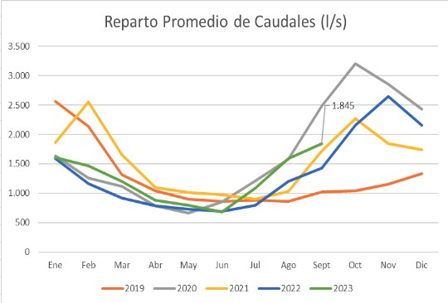

# Appendix: Instrumental Variable Analysis

## Tables

Table 27: Total Water Consumption: Instrumental Variables estimation at the parcel level.

|  |  |  |  |  |
| --- | --- | --- | --- | --- |
| Panel A: Evapotranspiration per pixel  IV, ETa (mm) per surface | | | | |
|  | (1) | (2) | (3) |  |
|  | Downstream | Mid section | Upstream |  |
| Board | 1.999 | 1.848 | -0.605 |  |
|  | (0.863)∗∗ | (1.517) | (0.149)∗∗∗ |  |
| Area (polynomial) | Yes | Yes | Yes |  |
| Precipitation (pol.) | Yes | Yes | Yes |  |
| Prec. Summer (pol.) | Yes | Yes | Yes |  |
| Soil quality | Yes | Yes | Yes |  |
| Market Access | Yes | Yes | Yes |  |
| (lat lon) bin FE | Yes | Yes | Yes |  |
| Observations | 26,780 | 26,138 | 25,539 |  |
| R-squared | 0.242 | 0.129 | 0.574 |  |
| Mean Dependent Var. | 3.545 | 4.085 | 3.665 |  |
| First Stage F-stat | 16.523 | 2.472 | 59.731 |  |
| p-value Under Id LM test | 0.001 | 0.131 | 0.002 |  |
| Effective F-stat | 16.523 | 2.472 | 59.731 |  |
| Panel B: log of total Evapotranspiration per farm  IV, log(Estimated total ETa)  76 | | | | |

|  |  |  |  |
| --- | --- | --- | --- |
|  | (1)  Downstream | (2)  Mid section | (3)  Upstream |
| Board | 0.985 | -1.402 | 0.168 |
|  | (0.605) | (1.351) | (0.170) |
| Area (polynomial) | Yes | Yes | Yes |

Table 28: Agricultural Production: Instrumental Variables estimation at the parcel level.

Panel A: EVI per pixel

IV, EVI (yield index)

|  |  |  |  |  |
| --- | --- | --- | --- | --- |
|  | (1) | (2) | (3) |  |
| Downstream | Mid section | Upstream |
| Board | 0.209 | 0.209 | -0.0365 |  |
|  | (0.0851)∗∗ | (0.159) | (0.0181)∗∗ |  |
| Area (polynomial) | Yes | Yes | Yes |  |
| Precipitation (pol.) | Yes | Yes | Yes |  |
| Prec. Summer (pol.) | Yes | Yes | Yes |  |
| Soil quality | Yes | Yes | Yes |  |
| Market Access | Yes | Yes | Yes |  |
| (lat lon) bin FE | Yes | Yes | Yes |  |
| Observations | 26,792 | 26,138 | 25,539 |  |
| R-squared | -0.017 | -0.146 | 0.315 |  |
| Mean Dependent Var. | 0.445 | 0.470 | 0.438 |  |
| First Stage F-stat | 16.509 | 2.472 | 59.731 |  |
| p-value Under Id LM test | 0.001 | 0.131 | 0.002 |  |
| Effective F-stat | 16.509 | 2.472 | 59.731 |  |
| Panel B: log of total EVI per farm  IV, log(total EVI) | | | | |
|  | (1) | (2) | (3) |  |
|  | Downstream | Mid section | Upstream |  |
| Board | 0.542 | -1.436 | 0.341 |  |
|  | (0.535) | (1.395) | (0.175)∗ |  |
| Area (polynomial) | Yes | Yes | Yes |  |
| Precipitation (pol.) | Yes | Yes | Yes |  |
| Prec. Summer (pol.) | Yes | Yes | Yes |  |
| Soil quality | Yes | Yes | Yes |  |
| Market Access | Yes | Yes | Yes |  |
| (lat lon) bin FE | Yes | Yes | Yes |  |
| Observations | 26,792 | 26,138 | 25,539 |  |
| R-squared | 0.582 | 0.474 | 0.564 |  |
| Mean Dependent Var. | 0.004 | 0.343 | 0.318 |  |
| First Stage F-stat | 16.509 | 2.472 | 59.731 |  |
| p-value Under Id LM test | 0.001 | 0.131 | 0.002 |  |
| Effective F-stat | 16.509 | 2.472 | 59.731 |  |

*Notes:*

Table 29: Inequality and Average Water Consumption: Instrumental Variables estimation at the parcel level.

|  |  |  |  |  |  |  |  |  |  |  |  |
| --- | --- | --- | --- | --- | --- | --- | --- | --- | --- | --- | --- |
| Smaller Farms, ETa (mm) per surface Larger Farms, ETa (mm) per surface | | | | | | | | | | | |
|  |  | | (1) | (2) | (3) |  | (4) | (5) | (6) |  |  |
|  |  | | Downstream | Mid section | Upstream |  | Downstream | Mid section | Upstream |  |  |
|  | Board | | 1.711 | 3.490 | -0.770 |  | 3.375 | 1.082 | -0.278 |  |  |
|  |  | | (0.956)∗ | (3.558) | (0.191)∗∗∗ |  | (1.506)∗∗ | (0.863) | (0.149)∗ |  |  |
|  | Area (polynomial) | | Yes | Yes | Yes |  | Yes | Yes | Yes |  |  |
|  | Precipitation (pol.) | | Yes | Yes | Yes |  | Yes | Yes | Yes |  |  |
|  | Prec. Summer (pol.) | | Yes | Yes | Yes |  | Yes | Yes | Yes |  |  |
|  | Soil quality | | Yes | Yes | Yes |  | Yes | Yes | Yes |  |  |
|  | Market Access | | Yes | Yes | Yes |  | Yes | Yes | Yes |  |  |
|  | (lat lon) bin FE | | Yes | Yes | Yes |  | Yes | Yes | Yes |  |  |
|  | Observations | | 14,561 | 12,021 | 11,386 |  | 6,270 | 7,427 | 7,447 |  |  |
|  | R-squared | | 0.286 | -0.759 | 0.561 |  | -0.252 | 0.396 | 0.626 |  |  |
|  | Mean Dependent Var. | | 3.279 | 3.963 | 3.585 |  | 4.031 | 4.295 | 3.833 |  |  |
|  | First Stage F-test | | 10.968 | 1.285 | 55.657 |  | 8.423 | 3.765 | 61.042 |  |  |
|  | p-value Under Id LM test | | 0.004 | 0.255 | 0.003 |  | 0.009 | 0.091 | 0.001 |  |  |
|  | Effective F-stat | | 10.968 | 1.285 | 55.657 |  | 8.423 | 3.765 | 61.042 |  |  |
| Smaller Farms, log(Estimated total ETa) Larger Farms, log(Estimated total ETa) | | | | | | | | | | | |
|  | | (1) | | (2) | (3) |  | (4) | (5) | (6) | |  |
|  | | Downstream | | Mid section | Upstream |  | Downstream | Mid section | Upstream | |  |
| Board | | 0.719 | | 0.174 | -0.150 |  | 1.127 | 0.166 | -0.141 | |  |
|  | | (0.387)∗ | | (0.548) | (0.0792)∗ |  | (0.519)∗∗ | (0.162) | (0.0436)∗∗∗ | |  |
| Area (polynomial) | | Yes | | Yes | Yes |  | Yes | Yes | Yes | |  |
| Precipitation (pol.) | | Yes | | Yes | Yes |  | Yes | Yes | Yes | |  |
| Prec. Summer (pol.) | | Yes | | Yes | Yes |  | Yes | Yes | Yes | |  |
| Soil quality | | Yes | | Yes | Yes |  | Yes | Yes | Yes | |  |
| Market Access | | Yes | | Yes | Yes |  | Yes | Yes | Yes | |  |
| (lat lon) bin FE | | Yes | | Yes | Yes |  | Yes | Yes | Yes | |  |
| Observations | | 14,561 | | 12,021 | 11,386 |  | 6,270 | 7,427 | 7,447 | |  |
| R-squared | | 0.746 | | 0.872 | 0.862 |  | 0.530 | 0.827 | 0.806 | |  |
| Mean Dependent Var. | | 2.842 | | 3.124 | 3.176 |  | 6.486 | 6.555 | 6.422 | |  |
| First Stage F-test | | 10.968 | | 1.285 | 55.657 |  | 8.423 | 3.765 | 61.042 | |  |
| p-value Under Id LM test | | 0.004 | | 0.255 | 0.003 |  | 0.009 | 0.091 | 0.001 | |  |
| Effective F-stat | | 10.968 | | 1.285 | 55.657 |  | 8.423 | 3.765 | 61.042 | |  |

*Notes:*

Table 30: Inequality and Average Water Consumption: Instrumental Variables estimation at the parcel level.

Smaller Farms, EVI (yield index) Larger Farms, EVI (yield index)

|  |  |  |  |  |  |  |  |  |  |  |  |
| --- | --- | --- | --- | --- | --- | --- | --- | --- | --- | --- | --- |
|  | (1) | (2) | (3) | |  | | (4) | (5) | (6) | |  |
| Downstream | Mid section | Upstream | |  | | Downstream | Mid section | Upstream | |
| Board | 0.163 | 0.319 | -0.0497 | |  | | 0.356 | 0.158 | -0.00750 | |  |
|  | (0.0952)∗ | (0.333) | (0.0172)∗∗∗ | |  | | (0.152)∗∗ | (0.106) | (0.0207) | |  |
| Area (polynomial) | Yes | Yes | Yes | |  | | Yes | Yes | Yes | |  |
| Precipitation (pol.) | Yes | Yes | Yes | |  | | Yes | Yes | Yes | |  |
| Prec. Summer (pol.) | Yes | Yes | Yes | |  | | Yes | Yes | Yes | |  |
| Soil quality | Yes | Yes | Yes | |  | | Yes | Yes | Yes | |  |
| Market Access | Yes | Yes | Yes | |  | | Yes | Yes | Yes | |  |
| (lat lon) bin FE | Yes | Yes | Yes | |  | | Yes | Yes | Yes | |  |
| Observations | 14,571 | 12,021 | 11,386 | |  | | 6,270 | 7,427 | 7,447 | |  |
| R-squared | 0.084 | -0.592 | 0.323 | |  | | -0.589 | 0.016 | 0.358 | |  |
| Mean Dependent Var. | 0.425 | 0.460 | 0.433 | |  | | 0.482 | 0.483 | 0.443 | |  |
| First Stage F-test | 10.970 | 1.285 | 55.657 | |  | | 8.423 | 3.765 | 61.042 | |  |
| p-value Under Id LM test | 0.004 | 0.255 | 0.003 | |  | | 0.009 | 0.091 | 0.001 | |  |
| Effective F-stat | 10.970 | 1.285 | 55.657 | |  | | 8.423 | 3.765 | 61.042 | |  |
| Smaller Farms, log(total EVI) Larger Farms, log(total EVI) | | | | | | | | | | | |
|  | (1) | (2) | (3) |  | | (4) | | (5) | (6) |  |  |
|  | Downstream | Mid section | Upstream |  | | Downstream | | Mid section | Upstream |  |  |
| Board | 0.256 | -0.0365 | 0.0339 |  | | 0.580 | | 0.161 | -0.0123 |  |  |
|  | (0.205) | (0.540) | (0.0494) |  | | (0.303)∗ | | (0.132) | (0.0545) |  |  |
| Area (polynomial) | Yes | Yes | Yes |  | | Yes | | Yes | Yes |  |  |
| Precipitation (pol.) | Yes | Yes | Yes |  | | Yes | | Yes | Yes |  |  |
| Prec. Summer (pol.) | Yes | Yes | Yes |  | | Yes | | Yes | Yes |  |  |
| Soil quality | Yes | Yes | Yes |  | | Yes | | Yes | Yes |  |  |
| Market Access | Yes | Yes | Yes |  | | Yes | | Yes | Yes |  |  |
| (lat lon) bin FE | Yes | Yes | Yes |  | | Yes | | Yes | Yes |  |  |
| Observations | 14,571 | 12,021 | 11,386 |  | | 6,270 | | 7,427 | 7,447 |  |  |
| R-squared | 0.887 | 0.892 | 0.887 |  | | 0.741 | | 0.831 | 0.802 |  |  |
| Mean Dependent Var. | -1.197 | -1.095 | -0.970 |  | | 2.301 | | 2.277 | 2.219 |  |  |
| First Stage F-test | 10.970 | 1.285 | 55.657 |  | | 8.423 | | 3.765 | 61.042 |  |  |
| p-value Under Id LM test | 0.004 | 0.255 | 0.003 |  | | 0.009 | | 0.091 | 0.001 |  |  |
| Effective F-stat | 10.970 | 1.285 | 55.657 |  | | 8.423 | | 3.765 | 61.042 |  |  |

*Notes:*